Tropical Cyclone Report
Tropical Storm Arthur
(AL012008)
31 May- 1 June 2008

Eric S. Blake
National Hurricane Center
28 July 2008

Arthur was a short-lived tropical cyclone that made landfall in northeastern Belize as a tropical storm. The storm produced devastating floods and killed five people in Belize, causing an estimated 78 million dollars worth of damage in that country.

- Synoptic History

The genesis of Arthur occurred as the lower- to middle-level remnants of eastern Pacific tropical storm Alma combined with a tropical wave over the northwestern Caribbean Sea. The tropical wave moved into the eastern Caribbean Sea on 27 May, entering the western Caribbean Sea three days later. On 30 May, Alma’s remnants moved across Honduras into the northwestern Caribbean Sea, likely causing a large increase in showers and thunderstorms near the wave and the development of a new surface low about 75 n mi southeast of Belize. QuikSCAT and ship data suggest the low quickly became organized into a tropical storm around 0000 UTC 31 May, centered about 45 n mi east of Belize City, Belize. The “best track” chart of the tropical cyclone’s path is given in Fig. 1, with the wind and pressure histories shown in Figs. 2 and 3, respectively. The best track positions and intensities are listed in Table 1.

Arthur moved slowly west-northwestward and made landfall as a 40 kt tropical storm around 0900 UTC in northeastern Belize about midway between Belize City and Chetumal Mexico. The storm continued to produce tropical storm-force winds in bands northeast of the center for almost a day after the center moved inland. Arthur weakened to a tropical depression by 1200 UTC 1 June, about 15 n mi north of the northern border of Guatemala and Mexico. Twelve hours later, the system lost organized deep convection and degenerated into a broad low pressure area. The remnants of the system continued moving slowly westward, producing areas of heavy rainfall over southern Mexico for the next couple of day.

- Meteorological Statistics

Observations in Arthur (Figs. 2 and 3) include satellite-based Dvorak technique intensity estimates from the Tropical Analysis and Forecast Branch (TAFB) and the Satellite Analysis Branch (SAB). Microwave satellite imagery from NOAA polar-orbiting satellites, the NASA Tropical Rainfall Measuring Mission (TRMM), the NASA QuikSCAT, and Defense Meteorological Satellite Program (DMSP) satellites, among others, were also useful in tracking the storm.

The initial development of Arthur was rather quick. Six hours before the cyclone developed, only a broad low pressure area was noted. A QuikSCAT pass just before 0000 UTC 31 May suggested that the low had become better-defined at the surface, with winds of tropical storm force, but Dvorak satellite intensity estimates were considerably lower. Around 0300 UTC, the ship H3VT reported sustained winds of 44 kt about 60 n mi northeast of the center. However an examination of the ship’s history suggested that these winds were slightly inflated. Therefore, the maximum intensity of 40 kt is based on a blend of QuikSCAT data and surface observations. Subsequent QuikSCAT passes and data from NOAA buoy 42056 were also useful in determining when tropical storm force winds had subsided over the Caribbean Sea.

Very heavy rains associated with Arthur were noted in Belize. Although specific totals are not available, amounts of up to 15 inches of rain were reported in that country. A map of the estimated rainfall from the TRMM satellite associated with the storm and Alma from the eastern Pacific is found in Fig. 4.

- Casualty and Damage Statistics

Five deaths were directly associated with Arthur, all in Belize due to floods. The Belize National Emergency Management Organization estimated that total damages caused by the storm were about 78 million U.S. dollars. Many bridges and roads were washed out because of the excessive rainfall, and a total of 714 homes were damaged by Arthur. The villages that were impacted the hardest were immediately along the coast and next to rivers in Belize.

- Forecast and Warning Critique

The genesis of Arthur was not well-forecast. In a pair of Special Disturbance Statements that were issued for this system prior to when advisories were initiated, development was deemed not likely due to proximity of land.

The average official track errors for Arthur were 36 and 89 n mi for the 12 and 24 h forecasts, respectively. These forecast errors were a little higher than the average long-term official track errors. A meaningful comparison of the various models is not possible due to the small number of forecasts, ranging from four at 12 h to two at 36 h. Average official intensity errors were 3 and 0 kt for the 12 and 24 h forecasts, respectively. These errors are quite low, but there were few cases and the system was over land for most of the time where intensification is unusual.

Table 3 lists the tropical cyclone warnings that were issued for Arthur. The warnings were issued as soon as the system was considered operationally to be a tropical cyclone. There have been no reports of tropical storm winds on land.

- Acknowledgements

Hal Pierce of SSAI/NASA's Goddard Space Flight Center supplied the rainfall graphic and Ethan Gibney with the I.M. Systems Groups at NHC produced the track map.

Table 1. Best track for Tropical Storm Arthur, 31 May- 1 June 2008.

Date/Time  (UTC) | Latitude  (°N) | Longitude  (°W) | Pressure  (mb) | Wind Speed  (kt) | Stage
31 / 0000 | 17.5 | 87.5 | 1005 | 35 | tropical storm
31 / 0600 | 17.8 | 88.0 | 1004 | 40 | "
31 / 1200 | 18.0 | 88.4 | 1005 | 35 | "
31 / 1800 | 18.2 | 88.8 | 1005 | 35 | "
01 / 0000 | 18.3 | 89.2 | 1006 | 35 | "
01 / 0600 | 18.2 | 89.8 | 1006 | 35 | "
01 / 1200 | 18.0 | 90.4 | 1006 | 30 | tropical depression
01 / 1800 | 17.8 | 90.8 | 1006 | 30 | "
02 / 0000 | 17.6 | 91.1 | 1006 | 25 | low
02 / 0600 | - | - | - | - | dissipated
31 / 0600 | 17.8 | 88.0 | 1004 | 40 | minimum pressure
31 / 0900 | 17.9 | 88.2 | 1004 | 40 | landfall in northeastern Belize

Table 2. Watch and warning summary for Tropical Storm Arthur, 31 May- 1 June 2008.

Date/Time (UTC) | Action | Location
31/1700 | Tropical Storm Warning issued | All of Belize northward to Cabo Catoche, Mexico
01/1500 | All warnings discontinued | Belize and Mexico

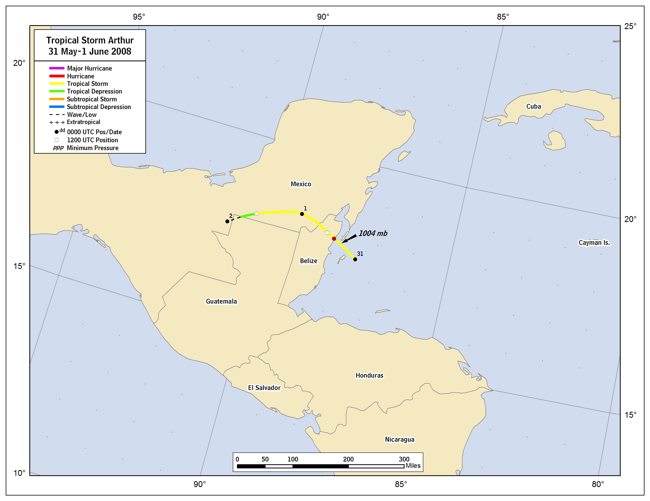

Figure 1. Best track positions for Tropical Storm Arthur, 31 May- 1 June 2008.
Figure 2. Selected wind observations and best track maximum sustained surface wind speed curve for Tropical Storm Arthur, 31 May- 1 June 2008. The black vertical line indicates the time of landfall in Belize.

Figure 3. Selected pressure observations and best track minimum central pressure curve for Tropical Storm Arthur, 31 May- 1 June 2008. The black vertical line indicates the time of landfall in Belize.

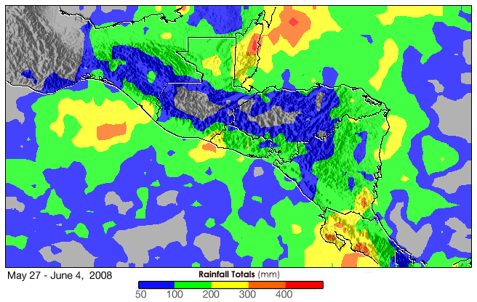

Figure 4. Estimated precipitation from TRMM over Central America from May 27- June 4, mostly associated with Tropical Storms Arthur and Alma. Gray areas indicate precipitation estimates of less than 50 mm during the period. Figure courtesy of Hal Pierce of SSAI/NASA's Goddard Space Flight Center.

