Tropical Cyclone Report
Tropical Storm Cristobal
(AL032008)
19-23 July 2008

Lixion A. Avila
National Hurricane Center
15 December 2008 (revised)

- Synoptic History

A trough of low pressure associated with an old frontal zone became nearly stationary along the east coast of the United States on 15 July. The trough extended southwestward across Florida and the eastern Gulf of Mexico and on 16 July, an area of low pressure formed on the southern portion of the trough near the southwest coast of Florida. The low moved northeastward across Florida, producing heavy rains, and it became better defined just off the Georgia coast on 17 July. The shower activity around the low gradually increased and became more concentrated, with ample mid-level rotation. A well-defined surface circulation center then developed, and is estimated that a tropical depression formed at 0000 UTC 19 July about 60 n mi east of the Georgia/South Carolina border. The depression moved slowly toward the northeast with most of the shower activity located to the east of the center. The surface circulation and convection continued to become better organized and it is estimated that by 1200 UTC 19 July the depression strengthened to a tropical storm. Cristobal moved northeastward very close to the Outer Banks of North Carolina but the strongest winds remained over water to the east of the center.

The cloud pattern was unimpressive at times with very limited convection while Cristobal continued to move toward the northeast. The cyclone encountered a more favorable atmospheric environment and strengthened, reaching a peak intensity of 55 knots with a minimum pressure of 998 mb at 1200 UTC 22 July. An eye feature was observed in microwave data around that time as shown in Fig. 1. By then, Cristobal was located about 180 n mi southeast of Cape Cod, Massachusetts. Thereafter, Cristobal encountered cooler waters and began to weaken. By 1200 UTC 23 July, Cristobal was absorbed by a large extratropical cyclone.

The “best track” chart of the tropical cyclone’s path is given in Fig. 2, with the wind and pressure histories shown in Figs. 3 and 4, respectively. The best track positions and intensities are listed in Table 1.

- Meteorological Statistics

Observations in Cristobal (Figs. 3 and 4) include satellite-based Dvorak technique intensity estimates from the Tropical Analysis and Forecast Branch (TAFB), the Satellite Analysis Branch (SAB), as well as flight-level, Stepped Frequency Microwave Radiometer (SFMR) and dropwindsonde observations from flights of the 53rd Weather Reconnaissance Squadron of the U. S. Air Force Reserve Command (AFRC). Microwave satellite imagery from NOAA polar-orbiting satellites, the NASA Tropical Rainfall Measuring Mission (TRMM), the NASA QuikSCAT, and Defense Meteorological Satellite Program (DMSP) satellites, among others, were also useful in tracking the storm. In particular, a QuikSCAT pass at 1115 UTC 21 July was very useful for determining the intensity of Cristobal after reconnaissance flights were terminated.

- Casualty and Damage Statistics

There are no reports of casualties associated with Cristobal. According to Environment Canada, while the center of Cristobal was still more than a day away from the Maritimes, rains moved out well ahead of the cyclone and became enhanced by a stalled frontal system over Nova Scotia. The result was intense rainfalls with the highest accumulations confined to the Atlantic coast of Nova Scotia. Although strong winds remained offshore and were confined to a tight core around the storm, the East Scotia Slope NOMAD buoy (44137) reported a wind gust of 50 kt. Following that report the buoy stopped reporting, implying that it sustained some damage from the storm.

- Forecast and Warning Critique

A description of the weather system from which Cristobal originated was included in Tropical Weather Outlook (TWO) products beginning at 1800 UTC 17 July. The possibility of tropical cyclone formation was included in the TWO issued at 0000 UTC 18 June, about 24 h prior to genesis. However, the experimental genesis forecast probability did not reach the high category (> 50%) until six hours before formation.

The average official track errors for Cristobal (with number of cases in parenthesis) were 28 (16), 50 (14), 70 (12), 96 (10) and 99 (6) n mi for the 12, 24, 36, 48 and 72 h forecasts, respectively. These errors are lower than the average long-term official track errors as indicated in Table 2.

Average official intensity errors were 6, 7, 6, 8 and 11 kt for the 12, 24, 36, 48 and 72h forecasts, respectively. For comparison, the average long-term official intensity errors are 7, 10, 12, 14 and 18 kt respectively.

Due to Cristobal’s proximity to the coast and the extension of the 34-knot wind radii a tropical storm warning was issued for a portion of the U.S. coast from South Santee River South Carolina to the North Carolina/Virginia Border, including Pamlico Sound, at 0300 UTC 19 July. The warning was discontinued at 0300 UTC 20 July when Cristobal moved away from the coast. There were no reports of tropical storm winds on land.

Table 1. Best track for Tropical Storm Cristobal, 19-23 July 2008.

Date/Time  (UTC) | Latitude  (°N) | Longitude  (°W) | Pressure  (mb) | Wind Speed  (kt) | Stage
19 / 0000 | 31.7 | 79.8 | 1010 | 25 | tropical depression
19 / 0600 | 32.2 | 79.4 | 1009 | 25 | "
19 / 1200 | 32.4 | 78.8 | 1007 | 35 | tropical storm
19 / 1800 | 32.8 | 78.2 | 1006 | 45 | "
20 / 0000 | 33.2 | 77.8 | 1006 | 45 | "
20 / 0600 | 33.7 | 77.4 | 1006 | 45 | "
20 / 1200 | 34.1 | 76.7 | 1006 | 45 | "
20 / 1800 | 34.5 | 76.1 | 1007 | 45 | "
21 / 0000 | 34.9 | 75.4 | 1005 | 50 | "
21 / 0600 | 35.6 | 74.3 | 1004 | 55 | "
21 / 1200 | 36.2 | 73.2 | 1000 | 55 | "
21 / 1800 | 36.8 | 72.0 | 1000 | 55 | "
22 / 0000 | 37.4 | 70.7 | 1000 | 55 | "
22 / 0600 | 38.4 | 69.2 | 1000 | 55 | "
22 / 1200 | 40.0 | 67.0 | 998 | 55 | "
22 / 1800 | 41.7 | 64.2 | 1000 | 50 | "
23 / 0000 | 43.3 | 60.7 | 1001 | 45 | "
23 / 0600 | 44.4 | 57.5 | 1004 | 40 | "
23 / 1200 |  |  |  |  | absorbed
22 / 1200 | 40.0 | 67.0 | 998 | 55 | Minimum pressure

Table 2. Track forecast evaluation (heterogeneous sample) for Tropical Storm Cristobal 19-23 July 2008. Forecast errors (n mi) are followed by the number of forecasts in parentheses. Errors smaller than the NHC official forecast are shown in boldface type.

Forecast Technique | Forecast Period (h)
Forecast Technique | 12 | 24 | 36 | 48 | 72 | 96
CLP5 | 34 (16) | 76 (14) | 117 (12) | 159 (10) | 250 ( 6) | 478 ( 2)
GFNI | 45 (13) | 84 (11) | 127 ( 9) | 184 ( 4)
GFDI | 36 (16) | 63 (14) | 93 (12) | 105 ( 6) | 191 ( 2)
HWFI | 35 (16) | 63 (14) | 96 (12) | 137 ( 9) | 176 ( 5) | 219 ( 1)
GFSI | 32 (15) | 59 (14) | 91 (12) | 119 (10) | 212 ( 4)
AEMI | 44 (16) | 70 (14) | 92 (12) | 117 ( 9) | 199 ( 1)
NGPI | 30 (15) | 64 (13) | 103 (11) | 148 ( 9) | 219 ( 2)
UKMI | 29 (13) | 36 (11) | 64 ( 9) | 118 ( 7) | 374 ( 3) | 379 ( 1)
BAMD | 40 (16) | 66 (14) | 83 (12) | 123 (10) | 327 ( 6) | 780 ( 2)
BAMM | 39 (16) | 57 (14) | 85 (12) | 111 (10) | 257 ( 6) | 622 ( 2)
BAMS | 49 (16) | 71 (14) | 100 (12) | 114 (10) | 272 ( 6) | 686 ( 2)
TVCN | 30 (16) | 50 (14) | 73 (12) | 93 (10) | 142 ( 5) | 163 ( 1)
GUNA | 31 (11) | 51 ( 9) | 83 ( 8) | 136 ( 2)
FSSE | 31 (13) | 55 (11) | 87 ( 9) | 119 ( 7) | 178 ( 3)
OFCL | 28 (16) | 50 (14) | 70 (12) | 96 (10) | 99 ( 6)
NHC Official  (2003-2007 mean) | 34.0 (1742) | 58.2 (1574) | 82.2 (1407) | 106.2 (1254) | 154.2 (996) | 207.5 (787) | 272.5 (627)

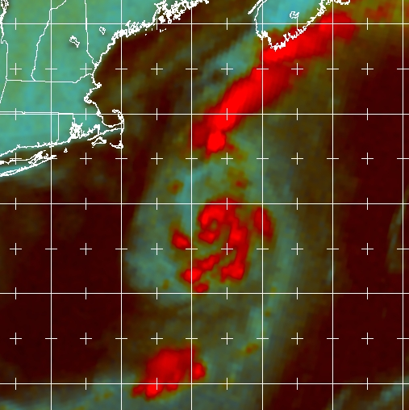

Figure 1. Composite SSMIS 91 GHz passive microwave images of Tropical Storm Cristobal at 1013 UTC 22 July 2008. The image shows the eye feature marked by an arrow. Image courtesy of the Navy Research Laboratory (NRL)
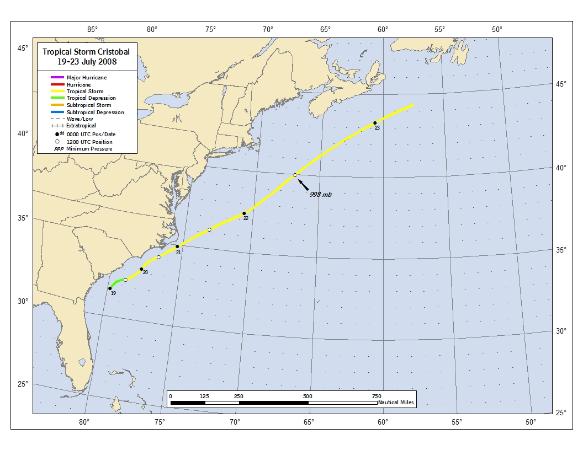

Figure 2. Best track positions for Tropical Storm Cristobal, 19-23 July 2008.

Figure 3. Selected wind observations and best track maximum sustained surface wind speed curve for Tropical Storm Cristobal, 19-23 July 2008.

Figure 4. Selected pressure observations and best track minimum central pressure curve for Tropical Storm Cristobal, 19-23 July 2008.

