Tropical Cyclone Report
Hurricane Dolly
(AL042008)
20-25 July 2008

Richard J. Pasch and Todd B. Kimberlain
National Hurricane Center
22 January 2009

Dolly made landfall in extreme southern Texas as a category 1 hurricane on the Saffir-Simpson Hurricane Scale and caused some significant wind and flood damage.

- Synoptic History

Dolly had its origins in a tropical wave that crossed the west coast of Africa early on 11 July. The system moved rapidly westward and generated a surface low pressure area about 1400 n mi east of the southern Windward Islands on 13 July. This low moved generally westward over the next several days, and while the associated deep convection became fairly well organized at times (and in fact briefly garnering Dvorak classifications of T2.5), there was little overall development. The system crossed the Windward Islands and entered the eastern Caribbean Sea early on 17 July. Observations from Air Force Reserve Command 53rd Weather Reconnaissance Squadron (53WRS) Hurricane Hunter aircraft showed that there was a broad low-level circulation, but no definite center of circulation, as the wave traversed the eastern and central Caribbean. However, the wave was producing squalls with winds to tropical storm force. On 20 July, when the system reached the western Caribbean Sea, the Hurricane Hunters found a well-defined circulation center, indicating the formation of a tropical storm at around 1200 UTC centered about 270 n mi east of Chetumal, Mexico. At the time of genesis, maximum winds were already near 40 kt. The “best track” chart of the tropical cyclone’s path is given in Fig. 1, with the wind and pressure histories shown in Figs. 2 and 3, respectively. The best track positions and intensities are listed in Table 1.

The storm moved northwestward and, for unknown reasons, soon became disorganized. Although the circulation center temporarily became difficult to track, surface data suggest that Dolly passed near the northeastern tip of the Yucatan Peninsula of Mexico around 0600 21 July. A little later that day, Dolly’s circulation quickly re-organized just to the north of the Yucatan Peninsula, and the steering flow associated with a mid-tropospheric high pressure area over the southeastern United States drove the storm west-northwestward, and then northwestward, toward the western Gulf of Mexico coast. An upper-level cyclone over the Bay of Campeche inhibited upper-tropospheric outflow over the southern semicircle of Dolly on 21-22 July. By late on 22 July, however, the upper-level cyclone moved farther away from the tropical cyclone and weakened, allowing an expansion of the outflow pattern, and Dolly strengthened into a hurricane by 0000 UTC 23 July. Meanwhile, a short wave trough digging southward from the Great Lakes began to erode the mid-tropospheric ridge to the north of Dolly. The hurricane slowed its northwestward motion and strengthened as it approached the coast of extreme southern Texas and northeastern Mexico. Dolly reached its peak intensity of 85 kt, category 2 on the Saffir-Simpson Hurricane Scale, around 1400 UTC 23 July while it was centered a little less than 20 n mi east of the mouth of the Rio Grande River.

Over the ensuing 4 h prior to landfall, the hurricane weakened a little. Radar imagery showed that Dolly’s eyewall, which was generally closed during the few hours before maximum intensity, became open over the northern semicircle just before and during the time the eye crossed the Texas coast. This structural change is consistent with weakening, and it is possible that the erosion of the eyewall was the result of drier air, which had moved off of Mexico, wrapping around the southern part of the cyclone’s circulation and penetrating the northern part of the core of the hurricane. Another possible contributor to weakening may have been the interaction of the slow-moving hurricane with cooler shelf waters along the coastline. Dolly made landfall at South Padre Island just after 1800 UTC 23 July as a category 1 hurricane with estimated maximum winds of 75 kt. The center then made landfall on the Texas mainland 2 h later about 10 n mi south of Port Mansfield with an estimated intensity of 70 kt.

After landfall, Dolly weakened and became a tropical storm by 0600 UTC 24 July. Moving on a heading between northwest and west-northwest, the cyclone center crossed the Rio Grande River around 1800 UTC 24 July. Dolly weakened to a tropical depression over extreme northern Mexico by 0600 25 July. The system degenerated into a remnant low around 0000 UTC 26 July and then turned northward and crossed the Mexico-United States border near El Paso, Texas around 1800 UTC 26 July. Although the low lost its surface identity over New Mexico early on 27 July, Dolly’s upper-level remnant disturbance continued to produce locally heavy rainfall along its path over New Mexico for another day or so.

- Meteorological Statistics

Observations in Dolly (Figs. 2 and 3) include satellite-based Dvorak technique intensity estimates from the Tropical Analysis and Forecast Branch (TAFB) and the Satellite Analysis Branch (SAB), as well as flight-level, stepped frequency microwave radiometer (SFMR), and dropwindsonde observations from flights of the 53WRS and NOAA. Data and imagery from NOAA polar-orbiting satellites, the NASA Tropical Rainfall Measuring Mission (TRMM), the NASA QuikSCAT, and Defense Meteorological Satellite Program (DMSP) satellites, among others, were also useful in tracking Dolly. The highest wind measured by aircraft reconnaissance was 92 kt just after 1200 UTC 23 July at a flight level of 700 mb by the AFRES, corresponding to a surface wind speed estimate of 83 kt using a 90 percent adjustment factor. This is the basis for the maximum intensity estimate of 85 kt for Dolly. Near the time of Dolly’s landfall in Texas, the maximum flight level wind was 85 kt which corresponds to a surface wind speed of 77 kt. WSR-88D data from Brownsville showed that the maximum Doppler velocity around the time of landfall in Texas was 93 kt at an elevation of 1900 ft. Using a 75 percent adjustment factor for the altitude yields a surface wind speed estimate of 70 kt. Based on the aircraft-measured winds and the Doppler data, 75 kt is the estimate for Dolly’s intensity at landfall in Texas. It cannot be determined, however, whether category 2 winds impacted the Texas coast during the few hours prior to landfall.

Ship reports of winds of tropical storm force associated with Dolly are given in Table 2, and selected surface observations from land stations and data buoys are given in Table 3. A mast-mounted anemometer on a vehicle located at the coastline 21 n mi east of Matamoros, Mexico, measured a peak 1-min average wind of 83 kt with a gust to 103 kt at an elevation of about 3 m AGL. These peak values occurred around the time of Dolly’s maximum intensity (i.e., about 4 h prior to landfall of the center in Texas) when the observing site appeared to be near the radius of maximum winds. A Texas Tech University tower deployed on a sand dune on South Padre Island, Texas, measured a peak 1-min average wind of 68 kt with a gust to 93 kt at an elevation of 2.25 m AGL.

The minimum pressure in Dolly is estimated to be 963 mb around 1400 UTC 23 July, based on a dropsonde measurement in the eye of 964 mb with 20 kt surface winds. Subsequent dropsonde data indicate that the central pressure rose slightly prior to the center crossing the coast, and the hurricane’s minimum pressure at landfall is estimated to be 967 mb.

As is typical for a slow-moving tropical cyclone, Dolly deposited heavy rains along its track. Rainfall totals of 5 to 10 inches or more were recorded over portions of the lower Rio Grande Valley with a maximum total of 15 inches at Harlingen, Texas; see the analysis in Fig. 4. These rains resulted in extensive inland flooding over the Rio Grande Valley region.

Storm surges of up to 4 feet were observed at South Padre Island, Port Mansfield, and the Port of Brownsville, Texas. Water flowed eastward from the Laguna Madre, inundating the bay side of South Padre Island with 3 to 4 feet of water.

In Texas, two weak (EF0) tornadoes and a possible tornado were reported in Cameron County. Two EF0 tornadoes were also observed in San Patricio County and an EF0 tornado was also reported in Jim Wells County. None of these tornadoes produced much damage. A waterspout was sighted over Corpus Christi Bay.

- Casualty and Damage Statistics

One death has been attributed to Dolly, a drowning in rough surf in the Florida Panhandle.

Dolly caused mainly moderate structural damage, primarily to roofs, on South Padre Island. Some buildings of modest construction such as warehouses or industrial-type structures experienced significant wind damage. Damage in Brownsville was minor and consisted mainly of lost roofing material. Widespread power outages and extensive tree damage were reported throughout Cameron County, Texas. Utility poles were damaged or snapped across much of eastern and northern Cameron County. Significant wind damage to trees was reported across southern and central Willacy County, Texas, and widespread power outages occurred county wide.

Based on information provided by the Property Claim Services of the Insurance Services Office, Dolly caused $525 million in insured losses in the United States. Doubling this figure, as is customarily done, gives a rough estimate of $1.05 billion for the total U.S. damage due to Dolly. Damage estimates from Mexico are not available.

- Forecast and Warning Critique

The formation of Dolly was anticipated to occur much sooner than it did in reality. The Tropical Weather Outlook (TWO) at 1800 UTC 13 July noted the low pressure area that would eventually develop into Tropical Storm Dolly and indicated its potential for development into a tropical cyclone. This TWO was issued when the pre-Dolly disturbance was located about 1300 n mi east of the southern Windward Islands, nearly a week before genesis. Subsequent TWOs were more or less emphatic about development, with the experimental genesis probabilities fluctuating between 30% and 90%, i.e. in the “medium” to “high” categories.

A verification of official and guidance model track forecasts is given in Table 4. Average official track errors for Dolly were 30, 43, 53, 51, 95, 144, and 236 n mi for the 12, 24, 36, 48, 72, 96, and 120 h forecasts, respectively. The number of forecasts ranged from 18 at 12 h to 2 at 120 h. These errors are lower than the long-term average official track errors (Table 4) at all forecast intervals. The mean official track forecasts for Dolly were about as good or better than any available track model for the 12- through 48-h forecast intervals. From 72 through 120 h, several models were better than the official forecasts; e.g., HWFI was better than the official forecasts for 72 h through 120 h, and all of the BAM models had smaller mean errors than the official forecasts for that period.

Official forecasts of Dolly’s intensity were, overall, very good. The forecasts correctly anticipated that the cyclone would strengthen into a hurricane, but it was noted in the Tropical Cyclone Discussions that it was not likely for Dolly to become a major hurricane before striking Texas. The mean official intensity errors were 4, 4, 5, 6, 8, 6, and 5 kt for the 12, 24, 36, 48, 72, 96, and 120 h forecasts, respectively. For comparison, the average long-term official intensity errors are 7, 10, 12, 14, 18, 20, and 22 kt, respectively. Table 5 lists the mean errors of several objective intensity forecast techniques.

Watches and warnings associated with Dolly are given in Table 6. A hurricane watch was issued for the lower Texas coast (Brownsville to Port O’Connor) a little over 51 h before landfall of the center in that area, and a hurricane warning was issued for the same portion of the Texas coast a little over 39 h before landfall.

Acknowledgements.

WFO Brownsville and WFO Corpus Christi provided most of the observations included in this report as well as information on impacts in their respective County Warning Areas. Rex Hervey of NCDC provided buoy and C-MAN station data. David Roth of the Hydrometeorological Prediction Center produced the rainfall analysis.
Table 1. Best track for Hurricane Dolly, 20-25 July 2008.

Date/Time  (UTC) | Latitude  (°N) | Longitude  (°W) | Pressure  (mb) | Wind Speed  (kt) | Stage
20 / 1200 | 17.8 | 83.6 | 1008 | 40 | tropical storm
20 / 1800 | 18.6 | 84.6 | 1008 | 40 | "
21 / 0000 | 19.8 | 85.8 | 1007 | 45 | "
21 / 0600 | 20.9 | 87.2 | 1007 | 45 | "
21 / 1200 | 21.8 | 88.8 | 1005 | 45 | "
21 / 1800 | 22.8 | 90.4 | 1005 | 45 | "
22 / 0000 | 23.0 | 92.0 | 1000 | 45 | "
22 / 0600 | 23.2 | 93.3 | 999 | 45 | "
22 / 1200 | 23.7 | 94.1 | 993 | 55 | "
22 / 1800 | 24.3 | 94.9 | 990 | 60 | "
23 / 0000 | 24.9 | 95.7 | 982 | 65 | hurricane
23 / 0600 | 25.4 | 96.2 | 982 | 70 | "
23 / 1200 | 25.9 | 96.7 | 967 | 85 | "
23 / 1400 | 26.0 | 96.8 | 963 | 85 | "
23 / 1800 | 26.4 | 97.2 | 967 | 75 | "
24 / 0000 | 26.5 | 97.8 | 976 | 65 | "
24 / 0600 | 26.7 | 98.3 | 986 | 55 | tropical storm
24 / 1200 | 27.2 | 98.9 | 992 | 45 | "
24 / 1800 | 27.9 | 100.0 | 995 | 35 | "
25 / 0000 | 28.3 | 101.4 | 1000 | 25 | tropical depression
25 / 0600 | 28.5 | 102.7 | 1004 | 25 | "
25 / 1200 | 28.8 | 104.0 | 1008 | 25 | "
25 / 1800 | 29.4 | 105.0 | 1009 | 25 | "
26 / 0000 | 30.0 | 105.7 | 1012 | 20 | low
26 / 0600 | 30.5 | 106.0 | 1011 | 20 | "
26 / 1200 | 31.0 | 106.3 | 1010 | 20 | "
26 / 1800 | 31.9 | 106.7 | 1014 | 20 | "
27 / 0000 | 32.9 | 106.3 | 1016 | 20 | "
27 / 0600 |  |  |  |  | dissipated
23 / 1400 | 26.0 | 96.8 | 963 | 85 | minimum pressure
21 / 0530 | 20.8 | 87.0 | 1007 | 45 | landfall near Cancun, Mexico
23 / 1820 | 26.4 | 97.2 | 967 | 75 | landfall on South Padre Island, about 15 n mi southeast of Port Mansfield, Texas
23 / 2000 | 26.4 | 97.4 | 967 | 70 | landfall on Texas mainland about 10 n mi south of Port Mansfield

Table 2. Selected ship reports with winds of at least 34 kt for Hurricane Dolly, 20-25 July 2008.

Date/Time (UTC) | Ship/Buoy ID | Latitude  (°N) | Longitude  (°W) | Wind  dir/speed (kt) | Pressure  (mb)
21 / 2300 | 3FPQ9 | 24.6 | 88.7 | 130/37 | 1011.0
21 / 1500 | ELSV2 | 25.3 | 91.4 | 140/40 | 1010.2
23 / 0000 | H3GR | 23.7 | 90.4 | 150/35 | 1012.0

Table 3. Selected surface observations for Hurricane Dolly, 20-25 July 2008.

Location | Minimum Sea Level Pressure |  | Maximum Surface  Wind Speed |  |  | Storm surge  (ft)^{c} | Storm  tide  (ft)^{d} | Total  rain  (in)
Location | Date/  time  (UTC) | Press.  (mb) | Date/  time  (UTC)ª | Sustained  (kt)^{b} | Gust  (kt) | Storm surge  (ft)^{c} | Storm  tide  (ft)^{d} | Total  rain  (in)
Texas
Alice (KALI) | 24/0953 | 1003.3 | 24/1153 | 32 | 55
Aransas County Airport (KRKP) | 23/2253 | 1006.4 | 23/1947 | 29 | 40
Beeville (KBEA) |  |  | 24/1905 | 22 | 30
Brooks (KBKS) | 24/0645 | 994.2 | 24/0325 | 31 | 45
Brownsville (KBRO) | 23/1933 | 994.2 | 23/1819 | 44 | 59 |  |  | 7.02
Corpus Christi (KCRP) | 23/2251 | 1004.6 | 23/2051 | 29 | 51
Corpus Christi NAS (KNGP) | 23/2356 | 1004.5 | 23/2256 | 34 | 45
Cotulla La Salle (KCOT) | 24/1253 | 1005.6 | 24/1653 | 29 | 43 |  |  | 0.56
Edinburg (KEBG) |  |  | 24/0005 | 40 | 52
Falfurrias (FAFT2) |  |  |  |  |  |  |  | 6.90
Harlingen (KHRL) | 23/2152 | 982.9 | 23/1913 | 49 | 64 |  |  | 12.00
Hebbronville (KHBV) |  |  | 24/1405 | 33 | 47
Kingsville NAS (KNQI) | 24/2156 | 1010.1 | 24/1006 | 30 | 50
Laredo (KLRD) | 24/1356 | 998.2 | 24/1256 | 27 | 37
McAllen (KMFE) | 24/0053 | 994.1 | 24/0013 | 30 | 45
McCook (MCOT2) |  |  |  |  |  |  |  | 8.28
Port Isabel (KPIL) | 23/1553 | 991.3 | 23/1603 | 50 | 69
Port Lavaca (KPKV) |  |  | 24/1845 | 23 | 29
Rockport (KRKP) | 23/2253 | 1006.4 | 23/1947 | 29 | 40
Victoria (KVCT) | 23/2251 | 1008.9 | 24/1751 | 25 | 37
Weslaco (KT65) | 24/0205 | 987.9 | 24/0005 | 40 | 62
Texas Tech Hurricane Research Team – Hurricanes at Landfall Project
0105A–26.27ºN 97.46ºW |  |  | 23/2036 | 53 | 67
0107A–26.19ºN 97.38ºW |  |  | 23/1904 | 49 | 63
0109A–26.24ºN 97.56ºW |  |  | 23/2112 | 57 | 67
0111A–26.07ºN 97.16ºW |  |  | 23/1858 | 43 | 62
0112A–26.16ºN 97.17ºW |  |  | 23/1820 | 68 | 81
0213A–25.98ºN 97.19ºW |  |  | 23/1342 | 50 | 62
0214B–25.91ºN 97.37ºW |  |  | 23/2016 | 44 | 62
0215B–25.96ºN 97.28ºW |  |  | 23/1514 | 40 | 67
0217A–26.04ºN 97.24ºW |  |  | 23/1737 | 43 | 59
0218B–26.10ºN 97.4ºW |  |  | 23/1821 | 43 | 53
0219A–26.13ºN 97.6ºW |  |  | 23/2058 | 49 | 62
0221A–26.16ºN 97.47ºW |  |  | 23/2005 | 43 | 57
0222B–26.02ºN 97.49ºW |  |  | 23/2043 | 47 | 57
0223A–26.06ºN 97.47ºW |  |  | 24/0345 | 45 | 67
Remote Automated Weather Stations (RAWS)
AFWT2 – Aransas Wildlife RAWS |  |  | 23/2059 | 15 | 29
GWRT2- George West RAWS |  |  | 24/1806 | 14 | 30
MIRT2- Matagorda Island RAWS |  |  | 24/0412 | 24 | 39
VCRT2 – Victoria RAWS |  |  | 23/2004 | 19 | 29
Buoy/C-Man
42020 – 50NM SE of Corpus Christi | 23/1750 | 997.9 | 23/1750 | 39 | 50
RSJT2 – Rincon Del San Jose | 23/2100 | 990.3 | 23/1800 | 55 | 66
PTIT2 – Port Isabel | 23/1712 | 984.8 | 23/1812 | 44
PTAT2 – Port Aransas | 23/2300 | 1005.7 | 23/2010 | 38 | 47
BABT2 – Baffin Bay |  |  | 23/2300 | 38 | 48
Baffin Bay Toon |  |  | 23/2330 | 41 | 50
Bob Hall Pier NOS |  |  | 23/2200 | 40 | 51
CC Bay Platform TCOON |  |  | 23/2030 | 34 | 43
Nueces Delta Watershed TCOON | 23/2048 | 1006.1 | 24/1024 | 28 | 37
Ingleside TCOON | 23/2024 | 1006.4 | 24/1100 | 29 | 36
Packery Channel TCOON |  |  | 23/2200 | 36 | 44
Port Aransas C-MAN | 23/2300 | 1005.7 | 24/0300 | 37 | 42
Port Aransas TCOON |  |  | 23/2000 | 28 | 41
Port O’Connor TCOON |  |  | 24/1100 | 30 | 36
Rockport NOS | 23/2324 | 1005.8 | 23/2042 | 28 | 38
Sea Drift TCOON |  |  | 24/1848 | 23 | 34
White Point TCOON | 23/2200 | 1003.0 | 24/0900 | 26 | 41
42057 – Western Caribbean  16.8ºN 81.5ºW (NDBC) | 20/0002 | 1007.6 | 20/1224 | 39 | 45
42056 – Yucatan Basin  19.9ºN 85.1ºW (NDBC) | 21/0037 | 1008.2 | 21/0236 | 33 | 37
42055 Bay of Campeche  22.0ºN 94.1ºW (NDBC) | 22/0850 | 1006.1 | 22/0930 | 26 | 37
42002 Western Gulf  25.8ºN 93.7ºW (NDBC) | 22/1050 | 1007.8 | 23/0510 | 32 | 39
Public/Other
Alamo 1.5 NE (HD6)  26.20ºN 98.10ºW |  |  |  |  |  |  |  | 8.18
1 ESE Beeville (TX-BEE-1)  28.39ºN 97.73ºW |  |  |  |  |  |  |  | 1.72
4 NE Beeville (BEET2)  28.45ºN 97.71ºW |  |  |  |  |  |  |  | 2.15
Bishop (BSPT2)  27.58ºN 97.80ºW |  |  |  |  |  |  |  | 3.58
Bishop 1 ENE (TX-NU-22)  27.59ºN 97.78ºW |  |  |  |  |  |  |  | 3.35
Brownsville 4.6 NNW (CM27)  25.98ºN 97.51ºW |  |  |  |  |  |  |  | 8.62
Brownsville 3.5 N (CM16)  25.97ºN 97.48ºW |  |  |  |  |  |  |  | 9.02
Brownsville 2.8 N (CM28)  25.96ºN 97.48ºW |  |  |  |  |  |  |  | 7.58
Brownsville 4.1E (CM17)  25.92ºN 97.42ºW |  |  |  |  |  |  |  | 8.29
Brownsville 6.4 SE (CM8)  25.85ºN 97.41ºW |  |  |  |  |  |  |  | 7.35
CC NAS 7 W (TX-NU-9)  27.68ºN 97.39ºW |  |  |  |  |  |  |  | 4.91
CC NAS 4 WNW (TX-NU-20)  27.70ºN 97.35ºW |  |  |  |  |  |  |  | 3.28
3 NW Calliham (CALT2)  28.49ºN 98.39ºW |  |  |  |  |  |  |  | 2.02
1 NE Charco (TX-GD-4)  28.74ºN 97.61ºW |  |  |  |  |  |  |  | 1.10
2 ESE Clegg (TX-LO-8)  28.11ºN 98.26ºW |  |  |  |  |  |  |  | 1.92
Copano Bay |  |  |  |  |  | 2.03 | 2.31
Corpus Christi 7 ESE (TX-NU-24)  27.73ºN 97.39ºW |  |  |  |  |  |  |  | 6.25
Corpus Christi 1 NNW (CRPT2)  27.77ºN 97.50ºW |  |  |  |  |  |  |  | 5.04
Dinero 3 NW (TX-LO-6)  28.24ºN 97.97ºW |  |  |  |  |  |  |  | 4.93
Edroy 7 N (TX-SP-6)  28.02ºN 97.67ºW |  |  |  |  |  |  |  | 4.60
1 SSE Encinal (ENCT2)  28.02ºN 99.35ºW |  |  |  |  |  |  |  | 0.98
14 SSE Encinal (TX-WB-5)  27.85ºN 99.26ºW |  |  |  |  |  |  |  | 0.88
3 ENE Fannin (CKDT2)  28.71ºN 97.17ºW |  |  |  |  |  |  |  | 1.78
Falcon Dam 4 N (FALT2)  26.60ºN 99.13ºW |  |  |  |  |  |  |  | 6.60
Flour Bluff 5 WNW (TX-NU-18)  27.67ºN 97.38ºW |  |  |  |  |  |  |  | 5.45
1 N Fowlerton (FWTT2)  28.46ºN 98.82ºW |  |  |  |  |  |  |  | 1.94
2 W Fulton (TX-AR-3)  28.06ºN 97.06ºW |  |  |  |  |  |  |  | 2.90
George West (TX-LO-2)  28.32ºN 98.12ºW |  |  |  |  |  |  |  | 4.31
Goliad (TX-GD-6)  28.67ºN 97.40ºW |  |  |  |  |  |  |  | 0.82
1 SE Goliad (GOIT2)  28.66ºN 97.39ºW |  |  |  |  |  |  |  | 0.65
2 SE Goliad (TX-GD-3)  28.64ºN 97.36ºW |  |  |  |  |  |  |  | 0.71
4 NW Goliad (TX-GD-8)  28.71ºN 97.44 W |  |  |  |  |  |  |  | 0.96
Harlingen 1.7 W (CM18)  26.19ºN 97.71ºW |  |  |  |  |  |  |  | 6.37
Harlingen 2 NE (HGNT2)  26.21ºN 97.66ºW |  |  |  |  |  |  |  | 15.00
Ingleside |  |  |  |  |  | 2.23 | 2.49
2 NNE Kingsville (KGST2)  27.53ºN 97.85ºW |  |  |  |  |  |  |  | 3.04
La Joya 11 N (HD5)  26.40ºN 98.48ºW |  |  |  |  |  |  |  | 7.84
2 NNW Laredo (LRET2)  27.56ºN 99.50ºW |  |  |  |  |  |  |  | 1.80
2 N Laredo (TX-WB-12)  27.56ºN 99.48ºW |  |  |  |  |  |  |  | 1.08
2 S Laredo (TX-WB-6)  27.49ºN 99.48ºW |  |  |  |  |  |  |  | 1.71
Los Fresnos (CM21)  26.07ºN 97.48ºW |  |  |  |  |  |  |  | 7.55
McAllen 2.6 NW  26.24ºN 98.27ºW |  |  |  |  |  |  |  | 8.59
McAllen 2.6 NE (HD1)  26.24ºN 98.21ºW |  |  |  |  |  |  |  | 8.53
Mercedes 5.9 SSE  26.06ºN 97.89ºW |  |  |  |  |  |  |  | 6.94
Mission  26.21ºN 98.32ºW |  |  |  |  |  |  |  | 8.00
Mission 1.9 ENE (HD9)  26.22ºN 98.29ºW |  |  |  |  |  |  |  | 6.90
5 W Nursery (TX-VC-1)  28.91ºN 97.18ºW |  |  |  |  |  |  |  | 0.69
Odem (TX-SP3)  27.94ºN 97.59ºW |  |  |  |  |  |  |  | 4.64
8 WNW Orange Grove (TX-JW-3)  27.99ºN 98.06ºW |  |  |  |  |  |  |  | 1.86
3 SE Orvil (TX-WB-3)  27.60ºN 99.46ºW |  |  |  |  |  |  |  | 1.43
16 ENE Orvil (TX-WB-14)  27.68ºN 99.24ºW |  |  |  |  |  |  |  | 1.80
Packery Channel |  |  |  |  |  | 1.71 | 1.75
4 N Placedo (TX-VC-3)  28.72ºN 96.83ºW |  |  |  |  |  |  |  | 1.55
Port Aransas |  |  |  |  |  | 2.02 | 2.49
Port of Brownsville |  |  |  |  |  | 4.00 | 5.00
Port Isabel |  |  |  |  |  | 3.00 | 4.00
Port Lavaca |  |  |  |  |  | 2.30 | 2.80
1 WSW Port Lavaca (PVAT2)  28.60ºN 96.64ºW |  |  |  |  |  |  |  | 1.88
Port Mansfield |  |  |  |  |  | 4.00 | 5.00
Progreso  26.09ºN 97.96ºW |  |  |  |  |  |  |  | 8.14
Pharr 8 SE  26.09ºN 98.10ºW |  |  |  |  |  |  |  | 6.77
Rancho Viejo (CM1)  26.03ºN 97.56ºW |  |  |  |  |  |  |  | 6.39
Rancho Viejo 3 SE (CM6)  26.00ºN 97.52ºW |  |  |  |  |  |  |  | 9.67
Raymondville 31 N (ARTM2)  26.92ºN 97.78ºW |  |  |  |  |  |  |  | 4.70
2 NW Refugio (RFOT2)  28.32ºN 97.29ºW |  |  |  |  |  |  |  | 0.78
Ricardo 2 E (TX-KL-2)  27.42ºN 97.82ºW |  |  |  |  |  |  |  | 5.80
Ricardo 5 E (TX-KL-7)  27.42ºN 97.77ºW |  |  |  |  |  |  |  | 5.71
Robstown 1 SSW (ROBT2)  27.79ºN 97.66ºW |  |  |  |  |  |  |  | 4.70
Rockport 1 SSW (RPTT2)  28.02ºN 97.06ºW |  |  |  |  |  |  |  | 4.73
Rockport |  |  |  |  |  | 1.92 | 2.16
Roma  26.41ºN 99.0ºW |  |  |  |  |  |  |  | 3.50
San Benito 5 SSE (CM19)  26.06ºN 97.61ºW |  |  |  |  |  |  |  | 8.23
San Manuel (SMLT2)  26.57ºN 98.12ºW |  |  |  |  |  |  |  | 12.00
8 S Sandia (TX-NU-12)  27.90ºN 97.88ºW |  |  |  |  |  |  |  | 3.17
Sarita 7 E (SRTT2)  27.21ºN 97.69ºW |  |  |  |  |  |  |  | 4.88
1 NE Schroeder (TX-GD-1)  28.81ºN 97.20ºW |  |  |  |  |  |  |  | 1.12
4 SW Schroeder (TX-GD-9)  28.75ºN 97.25ºW |  |  |  |  |  |  |  | 1.08
Seadrift |  |  |  |  |  | 1.89 | 2.15
South Padre Island |  |  |  |  |  | 2.00 | 3.00
South Padre Island |  |  |  |  |  | 4.00 | 4.00
4 W Three Rivers (TX-LO-5)  28.46ºN 98.25º W |  |  |  |  |  |  |  | 3.16
Texas State Aquarium |  |  |  |  |  | 2.75 | 3.03
4 W Three Rivers (CHOT2)  28.46ºN 98.25ºW |  |  |  |  |  |  |  | 2.86
Tuloso 4 NW (TX-NU-19)  27.85ºN 97.60ºW |  |  |  |  |  |  |  | 4.22
White Point |  |  |  |  |  | 3.15 | 3.48
1 E Victoria (TX-VC-4)  28.82ºN 96.96ºW |  |  |  |  |  |  |  | 1.13
4 ENE Victoria (VRAT2)  28.84ºN 96.92ºW |  |  |  |  |  |  |  | 0.88
Zapata 22 NE (ECBT2)  27.11ºN 99.01ºW |  |  |  |  |  |  |  | 4.70
Mexico
Cancun, Quintana Roo |  |  |  |  |  |  |  | 2.07
Matamoros, Tamulipas |  |  |  |  |  |  |  | 6.39
Sabinas, Coahuila |  |  |  |  |  |  |  | 3.46
Public/Other
21 n mi east of Matamoros - Cyclone Research 2 | 23/1400 | 985.0 | 23/1355 | 83 | 103
ª Date/time is for sustained wind when both sustained and gust are listed.
^{b} Except as noted, sustained wind averaging periods for C-MAN and land-based ASOS reports are 2 min; buoy averaging periods are 8 min.
^{c} Storm surge is water height above normal astronomical tide level.
^{d} Storm tide is water height above National Geodetic Vertical Datum (1929 mean sea level).

Table 4. Track forecast evaluation (heterogeneous sample) for Hurricane Dolly, 20-25 July 2008. Forecast errors (n mi) are followed by the number of forecasts in parentheses. Errors smaller than the NHC official forecast are shown in boldface type.

Forecast Technique | Forecast Period (h)
Forecast Technique | 12 | 24 | 36 | 48 | 72 | 96 | 120
CLP5 | 53 (18) | 99 (18) | 129 (16) | 145 (14) | 183 (10) | 359 ( 6) | 479 ( 2)
GFNI | 42 (16) | 81 (16) | 83 (14) | 109 (12) | 201 ( 8) | 224 ( 4)
GFDI | 34 (18) | 54 (18) | 64 (16) | 81 (14) | 92 (10) | 157 ( 6) | 350 ( 2)
HWFI | 33 (18) | 52 (18) | 67 (16) | 70 (14) | 77 (10) | 128 ( 6) | 230 ( 2)
GFSI | 26 (18) | 44 (18) | 55 (16) | 82 (14) | 159 (10) | 214 ( 5) | 329 ( 2)
AEMI | 29 (18) | 45 (15) | 59 (15) | 79 (14) | 133 (10) | 180 ( 6) | 168 ( 1)
NGPI | 48 (18) | 85 (18) | 108 (16) | 120 (14) | 142 ( 9) | 175 ( 6) | 364 ( 1)
UKMI | 35 (17) | 55 (17) | 67 (15) | 100 (13) | 141 ( 9) | 169 ( 5) | 72 ( 1)
EGRI | 31 (17) | 45 (14) | 62 (14) | 70 (10) | 62 ( 4) | 73 ( 4)
EMXI | 27 (13) | 43 (13) | 64 (12) | 87 (11) | 132 ( 8) | 107 ( 4) | 24 ( 1)
BAMD | 44 (18) | 68 (18) | 82 (16) | 91 (14) | 108 (10) | 112 ( 6) | 209 ( 2)
BAMM | 41 (17) | 67 (17) | 83 (15) | 92 (13) | 122 ( 9) | 89 ( 5) | 205 ( 2)
BAMS | 40 (17) | 62 (17) | 76 (15) | 86 (13) | 130 ( 9) | 127 ( 5) | 136 ( 2)
LBAR | 41 (17) | 60 (17) | 66 (15) | 68 (13) | 77 ( 9) | 145 ( 5) | 195 ( 2)
TVCN | 30 (18) | 48 (18) | 58 (16) | 72 (14) | 112 (10) | 130 ( 6) | 248 ( 2)
GUNA | 31 (17) | 43 (14) | 57 (14) | 66 (10) | 73 ( 4) | 154 ( 4)
FSSE | 31 (14) | 54 (14) | 73 (14) | 103 (13) | 123 ( 9) | 153 ( 4)
OFCL | 30 (18) | 43 (18) | 53 (16) | 51 (10) | 95 ( 9) | 144 ( 5) | 236 ( 2)
NHC Official  (2003-2007 mean) | 34.0 (1742) | 58.2 (1574) | 82.2 (1407) | 106.2 (1254) | 154.2 (996) | 207.5 (787) | 272.5 (627)

Table 5. Intensity forecast evaluation (heterogeneous sample) for Hurricane Dolly, 20-25 July 2008. Forecast errors (kt) are followed by the number of forecasts in parentheses. Errors smaller than the NHC official forecast are shown in boldface type.

Forecast Technique | Forecast Period (h)
Forecast Technique | 12 | 24 | 36 | 48 | 72 | 96 | 120
OCD5 | 5.2 (18) | 9.9 (18) | 13.2 (16) | 13.1 (14) | 10.2 (10) | 11.2 ( 6) | 11.0 ( 2)
GHMI | 5.9 (18) | 7.8 (18) | 6.3 (16) | 5.9 (14) | 11.2 (10) | 10.2 ( 6) | 9.5 ( 2)
HWFI | 6.0 (18) | 8.9 (18) | 12.9 (16) | 13.1 (14) | 12.0 (10) | 6.5 ( 6) | 2.5 ( 2)
LGEM | 4.6 (17) | 7.6 (17) | 8.4 (15) | 9.2 (13) | 6.3 ( 9) | 8.4 ( 5) | 4.0 ( 2)
DSHP | 4.6 (17) | 6.9 (17) | 7.7 (15) | 8.2 (13) | 6.2 ( 9) | 6.8 ( 5) | 3.5 ( 2)
FSSE | 3.5 (14) | 7.5 (14) | 6.5 (14) | 6.5 (13) | 6.4 ( 9) | 8.0 ( 4)
ICON | 3.8 (17) | 6.1 (17) | 6.5 (15) | 7.5 (13) | 6.8 ( 9) | 6.2 ( 5) | 2.0 ( 2)
OFCL | 4.2 (18) | 4.2 (18) | 5.0 (16) | 5.5 (10) | 8.3 ( 9) | 6.0 ( 5) | 5.0 ( 2)
NHC Official  (2003-2007 mean) | 6.7 (1742) | 10.0 (1574) | 12.3 (1407) | 14.3 (1254) | 18.2 (996) | 19.7 (787) | 21.8 (627)

Table 6. Watch and warning summary for Hurricane Dolly, 20-25 July 2008.

Date/Time (UTC) | Action | Location
20 / 1600 | Tropical Storm Warning issued | Mex/Bel Border to Campeche
20 / 1800 | Tropical Storm Watch issued | Belize City to Mex/Bel Border
21 / 1200 | Tropical Storm Watch discontinued | All
21 / 1500 | Tropical Storm Watch issued | La Pesca to Rio San Fernando
21 / 1500 | Tropical Storm Watch issued | Port O’Connor to San Luis Pass
21 / 1500 | Hurricane Watch issued | Brownsville to Port O’Connor
21 / 1500 | Hurricane Watch issued | Rio San Fernando to Mex/US Border
21 / 1800 | Tropical Storm Warning discontinued | All
22 / 0300 | Tropical Storm Watch changed to Tropical Storm Warning | La Pesca to Rio San Fernando
22 / 0300 | Tropical Storm Watch changed to Hurricane Watch | La Pesca to Rio San Fernando
22 / 0300 | Tropical Storm Watch changed to Tropical Storm Warning | Port O’Connor to San Luis Pass
22 / 0300 | Hurricane Watch changed to Hurricane Warning | Brownsville to Port O’Connor
22 / 0300 | Hurricane Watch changed to Hurricane Warning | Rio San Fernando to Mex/US Border
22 / 1500 | Tropical Storm Warning modified to | Corpus Christi to San Luis Pass
22 / 1500 | Hurricane Warning modified to | Brownsville to Corpus Christi
23 / 1500 | Tropical Storm Warning modified to | Corpus Christi to Port O’Connor
23 / 2100 | Tropical Storm Warning discontinued | La Pesca to Rio San Fernando
23 / 2100 | Tropical Storm Warning modified to | Baffin Bay to Port O’Connor
23 / 2100 | Hurricane Watch discontinued | All
23 / 2100 | Hurricane Warning modified to | Brownsville to Baffin Bay
24 / 0300 | Tropical Storm Warning discontinued | Baffin Bay to Port O’Connor
24 / 0300 | Tropical Storm Warning issued | Brownsville to Port Aransas
24 / 0300 | Hurricane Warning discontinued | All
24 / 1500 | Tropical Storm Warning discontinued | All

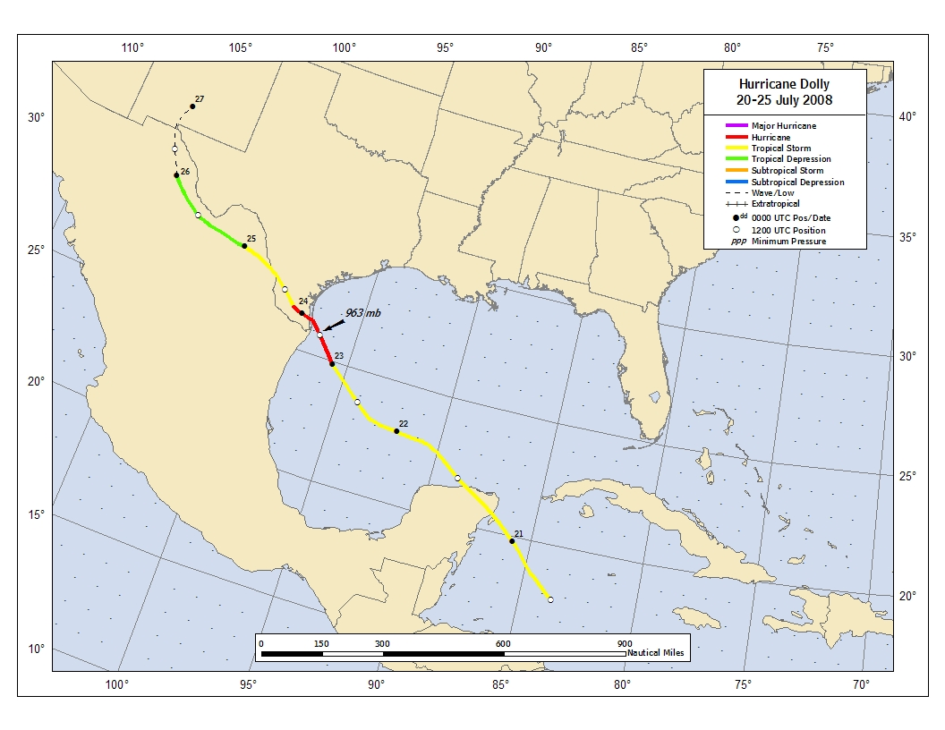
Figure 1. Best track positions for Hurricane Dolly, 20-25 July 2008. Track during the inland tropical depression stage is based partially on analyses from the NOAA Hydrometeorological Prediction Center.
Figure 2. Selected wind observations and best track maximum sustained surface wind speed curve for Hurricane Dolly, 20-25 July 2008. Aircraft observations have been adjusted for elevation using 90%, 80%, and 80% adjustment factors for observations from 700 mb, 850 mb, and 1500 ft, respectively. Dropwindsonde observations include actual 10 m winds (sfc), as well as surface estimates derived from the mean wind over the lowest 150 m of the wind sounding (LLM), and rom the sounding boundary layer mean (MBL). Dashed vertical lines correspond to 0000 UTC. Landfalls in Mexico and Texas are indicated by thin solid vertical lines.
Figure 3. Selected pressure observations and best track minimum central pressure curve for Hurricane Dolly, 20-25 July 2008. Dashed vertical lines correspond to 0000 UTC. Landfalls in Mexico and Texas are indicated by thin solid vertical lines.

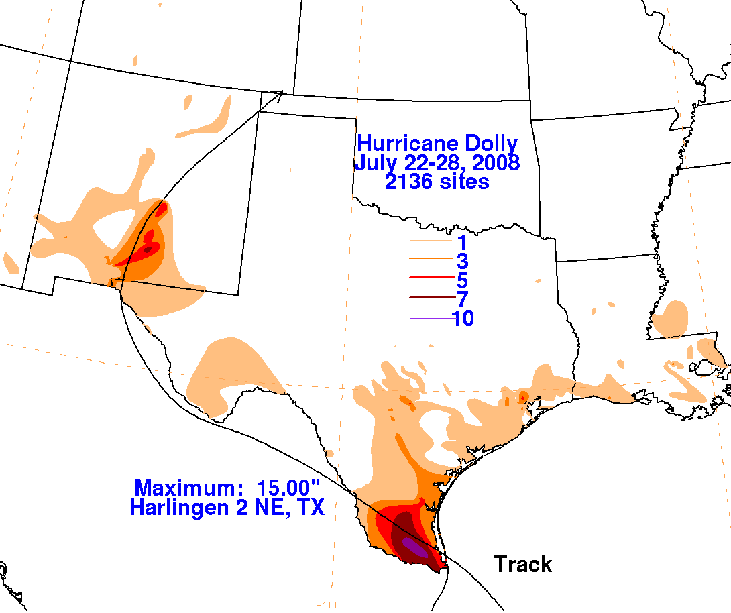
Figure 4. Rainfall totals and approximate track for Hurricane Dolly. Figure was produced by David Roth, NOAA/NWS/Hydrometeorological Prediction Center.

A digital record of the complete best track, including wind radii, can be found on line at ftp://ftp.nhc.noaa.gov/atcf. Data for the current year’s storms are located in the btk directory, while previous year’s data are located in the archive directory.

