Tropical Cyclone Report
Hurricane Gustav
(AL072008)
25 August – 4 September 2008

John L. Beven II and Todd B. Kimberlain
National Hurricane Center
22 January 2009
Revised 15 September 2009 for peak intensity and to add new data

Gustav moved erratically through the Greater Antilles into the Gulf of Mexico, eventually making landfall on the coast of Louisiana. It briefly became a category 4 hurricane on the Saffir-Simpson Hurricane Scale and caused many deaths and considerable damage in Haiti, Cuba, and Louisiana.

- Synoptic History

Gustav formed from a tropical wave that moved westward from the coast of Africa on 13 August. The wave continued westward across the tropical Atlantic, with the associated shower activity first showing signs of organization on 18 August. Westerly vertical wind shear, however, prevented significant development for the next several days. The wave moved through the Windward Islands on 23 August with a broad area of low pressure accompanied by disorganized shower activity. Organization increased late on 24 August as the system moved northwestward across the southeastern Caribbean Sea, and it is estimated that a tropical depression formed near 0000 UTC 25 August about 95 n mi northeast of Bonaire in the Netherland Antilles. The “best track” chart of the tropical cyclone’s path is given in Fig. 1, with the wind and pressure histories shown in Figs. 2 and 3, respectively. The best track positions and intensities are listed in Table 1.

The depression formed a small inner wind core during genesis with a radius of maximum winds of less than 10 n mi. Subsequently, it rapidly intensified. It became a tropical storm near 1200 UTC 25 August and a hurricane just after 0000 UTC 26 August. Gustav reached an intensity of 80 kt later on 26 August, then weakened slightly before making landfall on the southwestern peninsula of Haiti near 1800 UTC that day. The center of Gustav crossed the peninsula into the Canal du Sud, and the cyclone weakened to a tropical storm by early 27 August.

A low- and mid-level ridge built over the western Atlantic and Florida on 27 August, and Gustav turned westward in response. Although the center was over water on 27 August, enough of the circulation was interacting with Hispañiola to prevent re-intensification. Indeed, Gustav weakened further to an intensity of 40 kt by late that day. Early on 28 August the storm moved southward, possibly due to a reformation of the center. During this change of course, the maximum winds increased to 60 kt. Little change in strength occurred before the center moved westward over Jamaica around 1800 UTC that day. The storm then turned west-northwestward early on 29 August and emerged from the western end of Jamaica about 1200 UTC that day. Later that day, Gustav entered an area of stronger southeasterly low and mid-level flow on the southwestern side of the ridge. As a result, the cyclone began a northwestward motion at about 15 kt that would continue until its final landfall.

The cyclone intensified over the warm water of the northwestern Caribbean Sea. Gustav regained hurricane status late on 29 August, then became a Category 2 hurricane as it moved through the Cayman Islands early on 30 August. It rapidly intensified to a Category 4 hurricane before it made landfall on the eastern coast of the Isle of Youth, Cuba, near 1800 UTC that day. Gustav reached a peak intensity of 135 kt as it made landfall in the Pinar del Rio province of western Cuba near 2200 UTC 30 August. The eye of Gustav emerged into the southeastern Gulf of Mexico early on 31 August.

Gustav weakened over Cuba, and it continued to weaken over the Gulf of Mexico on 31 August. An upper-level trough west of Gustav caused some southerly vertical wind shear, and satellite imagery suggested that mid- to upper-level dry air became entrained into the cyclone. This combination appears to have prevented strengthening over the warm Gulf waters. However, the hurricane grew in size as it crossed the Gulf. By 1 September, tropical-storm-force winds extended roughly 200 n mi from the center in the northeastern quadrant and hurricane-force winds extended roughly 70 n mi from the center in the same quadrant. Gustav made its final landfall near Cocodrie, Louisiana, around 1500 UTC 1 September with maximum winds near 90 kt (Category 2).

The hurricane weakened to a tropical storm and its forward motion slowed as it crossed southern and western Louisiana later on 1 September. It became a tropical depression on 2 September over northwestern Louisiana. Gustav then meandered over southwestern Arkansas, extreme northeastern Texas, and extreme southeastern Oklahoma on 3 September as it encountered weak steering currents at the western end of the Atlantic ridge. An approaching mid- to upper-level trough and accompanying cold front caused Gustav to accelerate northeastward on 4 September, with the cyclone becoming extratropical due to merging with the front. The extratropical remnants of Gustav were absorbed by another extratropical low on 5 September as it moved through the Great Lakes.

- Meteorological Statistics

Observations in Gustav (Figs. 2 and 3) include satellite-based Dvorak technique intensity estimates from the Tropical Analysis and Forecast Branch (TAFB) and the Satellite Analysis Branch (SAB), as well as flight-level, stepped frequency microwave radiometer (SFMR), and dropwindsonde observations from flights of the 53rd Weather Reconnaissance Squadron (53rd WRS) of the U. S. Air Force Reserve Command. Data and imagery from NOAA polar-orbiting satellites, the NASA Tropical Rainfall Measuring Mission (TRMM), the NASA QuikSCAT, and Defense Meteorological Satellite Program (DMSP) satellites, among others, were also useful in tracking Gustav.

The 53rd WRS and NOAA Hurricane Hunter aircraft flew 29 missions in association with Gustav. These included 15 53rd WRS operational flights, 5 NOAA research missions, and 6 synoptic surveillance missions of the NOAA G-IV jet. There was also one NOAA mission to deploy aircraft expendable bathythermographs, one 53rd WRS mission to deploy drifting buoys, and one NOAA mission to study oceanic changes caused by the hurricane. During the flights, the maximum observed 700-mb flight-level winds were 143 kt at 2014 UTC 30 August, with a 141-kt wind reported at 1654 UTC that day. The maximum surface wind estimated in Stepped Frequency Microwave Radiometer (SFMR) data was 108 kt at 1658 UTC 30 August, and an eyewall dropsonde reported a surface wind of 108 kt nine minutes earlier. It should be noted that SFMR winds near the time of Gustav’s landfall in Cuba were unreliable due to shoaling issues. The lowest central pressure reported by aircraft was 941 mb at 2154 UTC 30 August.

Ship reports of winds of tropical storm force associated with Gustav are given in Table 2. The only observation of hurricane-force winds was from the Bona Foam (call sign C6CL6), which reported 68 kt at 2100 UTC 31 August. However, this report appears a little high compared to aircraft data and other nearby reports.

Selected surface observations from land stations and data buoys are given in Table 3. Gustav brought hurricane conditions to portions of western Cuba, with the strongest
winds reported at Paso Real de San Diego in Pinar del Rio province. This station
(elevation 10 m) reported a 1-minute wind of 135 kt at 2235 UTC 30 August with a peak
gust of 184 kt. The World Meteorological Organization investigated the report
(See wmo.asu.edu/world-maximum-surface-wind-gust-TC for more information) and
determined a) that the data were valid and, b) the gust was a world record for a wind
gust associated with a tropical cyclone. The sustained wind at Paso Real de San Diego is the basis for the peak intensity of 135 kt.. Hurricane conditions also occurred over portions of southern Louisiana. The National Ocean Service station at the Southwest Pass of the Mississippi River (elevation 24 m) reported 6-minute winds of 79 kt at 0918 UTC 1 September with a gust to 102 kt. An offshore oil rig (elevation 122 m) reported sustained winds of 90 kt at 0505 UTC 1 September with a gust to 108 kt. Strong winds accompanied Gustav well inland, with wind gusts of tropical-storm force occurring as far north as central Arkansas. Gustav also brought hurricane conditions to the southwestern Peninsula of Haiti. However, no observations are available from this area.

The lowest pressure reported in western Cuba was 939.9 mb at La Fe on the Isle of Youth at 1845 UTC 30 August. This pressure appears to be a little low compared to other nearby observations, and the 943 mb Isle of Youth landfall pressure is based on aircraft data. In Louisiana, the lowest observed pressures were 951.6 mb at the United States Geological Survey (USGS) station at Caillou Lake, 953.5 and 953.7 mb at portable USGS stations in Terrebonne Parish, and 954.5 mb at the Louisiana Marine Consortium (LUMCOM) laboratory in Cocodrie. The Caillou Lake reading also appears somewhat low compared to other nearby measurements, and the Louisiana landfall pressure of 954 mb is based on the LUMCOM pressure, the portable USGS pressures, and aircraft data. In Jamaica, the lowest observed pressure was 988.7 mb at an amateur radio station in Stoney Hill.

Gustav likely caused a significant storm surge in western Cuba. No surge observations, however, are available from this area. The hurricane caused a widespread storm surge along the northern Gulf coast, with above normal tides reported from the Florida Panhandle to the upper Texas coast, including Lake Ponchartrain (Table 3). Surges of 12-13 feet occurred along the Louisiana coast in the Mississippi Delta southeast of New Orleans, with surges of 9-10 ft in other portions of southeastern Louisiana. The storm surge overtopped the levees and floodwalls in a few parts of the New Orleans metropolitan area. However, it did not cause widespread inundation of the city and its surburbs.

Heavy rainfall and widespread freshwater flooding occurred along the path of Gustav. Camp Perrin, Haiti reported a storm total rainfall of 10.75 in, while Baharona, Dominican Republic reported a storm total rainfall of 9.71 in. In Cuba, Central René Fraga and Perico in Matanzas province reported 24 h totals of 10.70 and 10.69 in respectively. In Louisiana, Larto Lake reported a storm total of 21.00 in. The rainfall distribution elsewhere in the United States is shown in Fig. 4. The rains over Louisiana and Arkansas caused moderate flooding along many rivers.

Gustav is known to have produced 41 tornadoes – 21 in Mississippi, 11 in Louisiana, 6 in Florida, 2 in Arkansas, and 1 in Alabama. The strongest tornado was an EF2 in Evangeline Parish, Louisiana.

- Casualty and Damage Statistics

As of this writing, reports from relief agencies and the media indicate that Gustav was directly responsible for 112 deaths – 77 in Haiti, 15 in Jamaica, 8 in the Dominican Republic, 7 in Louisiana, 4 in Florida, and 1 at sea. The deaths in the Dominican Republic were due to a landslide or mudslide. Five deaths in Louisiana were due to falling trees, while the other two were caused by the EF2 tornado in Evangeline Parish. The deaths in Florida were drownings in rip currents that were caused by high surf produced by the hurricane. In addition, there are 41 deaths indirectly associated with Gustav in Louisiana.

Gustav was the second of four tropical cyclones (along with Fay, Hanna, and Ike) to affect the Greater Antilles in quick succession. Because of the timing of these events, it is very difficult to separate the impacts of the individual storms in the region using the reports from relief agencies and the media. Therefore, the true death toll from Gustav will probably never be known.

Gustav caused considerable casualties and damages along its track. Significant property damages occurred in Haiti and the Dominican Republic, although monetary damage figures are not available. The storm caused $210 million (U. S.) in damages in Jamaica. Gustav’s winds and tides caused major damages in western Cuba, particularly in the provinces of Pinar del Río and the Isle of Youth. However, monetary damage figures are not available. In the United States, the Insurances Services Office reports that the hurricane caused an estimated $2.15 billion in damages to insured property, of which $2.045 billion occurred in Louisiana. Doubling this figure to account for uninsured losses results in estimated U. S. damages of $4.3 billion.

- Forecast and Warning Critique

Forecasting the genesis of Gustav was somewhat problematic. The pre-Gustav disturbance was first mentioned in the Tropical Weather Outlook (TWO) on 18 August, when it first showed signs of organization. Over the next two days, it was correctly forecast that vertical wind shear would slow development, and the probabilities associated with an experimental genesis forecast were in the “medium” (20-50% chance of tropical cyclone formation within 48 h) and “low” (less than 20% chance of tropical cyclone formation within 48 h) categories. On 22 August, the TWOs noted that the upper-level wind would become more favorable for development. However, it was not until early on 24 August (about 18 h before genesis) that the TWO mentioned the possibility of a depression forming, and the experimental genesis forecast did not reach the “high” (greater than 50% chance of tropical cyclone formation within 48 h) category until the time of genesis.

A verification of official and guidance model track forecasts is given in Table 4. Average official track errors for Gustav were 23, 42, 65, 85, 124, 137, and 149 n mi for the 12, 24, 36, 48, 72, 96, and 120 h forecasts, respectively. The number of forecasts ranged from 32 at 12 h to 20 at 120 h. These errors are significantly lower than the average long-term official track errors (Table 4) and were almost 50% lower at 120 h. While the average errors are very good, examination of the individual forecasts (Figure 5) suggests two areas where they could have been better. First, the southward motion that resulted in Gustav hitting Jamaica was not anticipated. Second, the forecasts of Gustav’s track across the Gulf of Mexico had a westward and slow bias, with the actual track along the eastern edge of the forecasts and moving faster than forecast.

Average official intensity errors were 14, 18, 19, 21, 22, 21, and 37 kt for the 12, 24, 36, 48, 72, 96, and 120 h forecasts, respectively (Table 5). These errors are significantly higher than the average long-term official intensity errors of 7, 10, 12, 14, 18, 20, and 22 kt, respectively. Examination of the individual forecasts (Figure 6) shows several factors that contributed to the large errors. First, the forecasts early in Gustav’s life anticipated that the storm would not interact with land as much as it did, resulting in the forecast intensities being too high. Second, as is often the case, Gustav’s rapid intensification on 30 August was underforecast. Third, Gustav’s weakening over the Gulf of Mexico was not well anticipated. Finally, several forecasts had Gustav making landfall in Louisiana 24 hr after it actually did, which caused the forecast intensities to be well above the observed intensities.

Watches and warnings associated with Gustav are given in Table 6. A tropical storm warning was issued for Haiti on the first advisory 27 h before landfall, with a hurricane warning issued in a special advisory 3 h later. A tropical storm watch was issued for Jamaica 63 h before the center of Gustav reached the island, with that watch being replaced by a hurricane watch 6 h later. A tropical storm warning was issued for Jamaica 33 h before Gustav made landfall, with a hurricane warning issued for the island about 6 h before landfall. In western Cuba, a hurricane watch was issued 45 h before the center reached the Isle of Youth, while a hurricane warning was issued 30 h before the center arrived. A hurricane watch was issued for the northern Gulf coast 42 h prior to Gustav’s Louisiana landfall, and a hurricane warning was issued 30 h before that final landfall. One warning issue was a westward extension of the hurricane warning to the upper Texas coast on 31 August. This was due to a leftward shift in the forecast guidance and forecast track on that date, which did not verify.

Acknowledgements

Data from the Cayman Islands, Cuba, the Dominican Republic, and Jamaica was provided by their respective national meteorological services. In the U. S., data were provided by the National Weather Service forecast offices in Key West, FL, Miami, FL, Tallahassee, FL, Mobile, AL, Slidell, LA, Lake Charles, LA, Shreveport, LA, Jackson, MS, and Little Rock, AR. Rex Hervey of the National Data Buoy Center provided much of the marine data. David Roth of the Hydrometeorological Prediction Center in Camp Springs, MD provided the rainfall graphic and much of the U. S. rainfall data. Rainfall data in Haiti was provided by Mousson Pierre of the Organization for the Rehabilitation of the Environment.

Table 1. Best track for Hurricane Gustav, 25 August – 4 September 2008.

Date/Time  (UTC) | Latitude  (°N) | Longitude  (°W) | Pressure  (mb) | Wind Speed  (kt) | Stage
25 / 0000 | 13.5 | 67.4 | 1008 | 25 | tropical depression
25 / 0600 | 14.4 | 68.5 | 1005 | 30 | "
25 / 1200 | 15.1 | 69.6 | 1002 | 35 | tropical storm
25 / 1800 | 15.8 | 70.5 | 996 | 50 | "
26 / 0000 | 16.4 | 71.2 | 991 | 60 | "
26 / 0600 | 16.9 | 71.7 | 986 | 75 | hurricane
26 / 1200 | 17.5 | 72.1 | 981 | 80 | "
26 / 1800 | 18.1 | 72.8 | 992 | 70 | "
27 / 0000 | 18.4 | 73.1 | 995 | 50 | tropical storm
27 / 0600 | 18.6 | 73.4 | 999 | 45 | "
27 / 1200 | 18.7 | 73.7 | 998 | 45 | "
27 / 1800 | 18.9 | 74.0 | 999 | 45 | "
28 / 0000 | 18.8 | 75.1 | 999 | 40 | "
28 / 0600 | 18.1 | 75.4 | 995 | 45 | "
28 / 1200 | 17.9 | 75.7 | 984 | 60 | "
28 / 1800 | 18.0 | 76.2 | 984 | 60 | "
29 / 0000 | 17.8 | 77.0 | 987 | 60 | "
29 / 0600 | 18.0 | 77.7 | 990 | 55 | "
29 / 1200 | 18.3 | 78.4 | 989 | 50 | "
29 / 1800 | 18.8 | 79.2 | 984 | 65 | hurricane
30 / 0000 | 19.2 | 80.0 | 975 | 75 | "
30 / 0600 | 19.7 | 80.8 | 968 | 85 | "
30 / 1200 | 20.7 | 81.6 | 955 | 110 | "
30 / 1800 | 21.6 | 82.6 | 943 | 125 | "
31 / 0000 | 22.7 | 83.4 | 950 | 120 | "
31 / 0600 | 23.6 | 84.4 | 960 | 105 | "
31 / 1200 | 24.8 | 85.5 | 961 | 100 | "
31 / 1800 | 25.9 | 86.7 | 960 | 95 | "
01 / 0000 | 26.9 | 87.7 | 953 | 95 | "
01 / 0600 | 27.9 | 89.0 | 954 | 95 | "
01 / 1200 | 28.8 | 90.3 | 955 | 95 | "
01 / 1800 | 29.8 | 91.4 | 958 | 85 | "
02 / 0000 | 30.7 | 92.3 | 971 | 60 | tropical storm
02 / 0600 | 31.4 | 93.1 | 981 | 40 | "
02 / 1200 | 32.1 | 93.5 | 989 | 30 | tropical depression
02 / 1800 | 32.7 | 93.9 | 993 | 20 | "
03 / 0000 | 33.2 | 93.9 | 995 | 20 | "
03 / 0600 | 33.7 | 94.3 | 997 | 20 | "
03 / 1200 | 33.8 | 94.4 | 997 | 20 | "
03 / 1800 | 34.0 | 94.4 | 998 | 20 | "
04 / 0000 | 34.3 | 94.1 | 998 | 15 | "
04 / 0600 | 34.8 | 93.4 | 999 | 15 | "
04 / 1200 | 36.2 | 92.3 | 1000 | 15 | extratropical
04 / 1800 | 38.5 | 90.7 | 1000 | 20 | "
05 / 0000 | 40.2 | 88.7 | 1002 | 20 | "
05 / 0600 | 42.2 | 86.5 | 1002 | 20 | "
05 / 1200 | 43.7 | 83.8 | 1004 | 20 | "
05 / 1800 |  |  |  |  | absorbed by extratropical low
30 / 2200 | 22.4 | 83.1 | 941 | 135 | minimum pressure
26 / 1800 | 18.1 | 72.8 | 992 | 70 | landfall on the southwestern peninsula of Haiti
28 / 1800 | 18.0 | 76.2 | 984 | 60 | landfall near Manchioneal, Jamaica
29 / 0200 | 17.9 | 77.2 | 987 | 60 | landfall just east of Lionel Town, Jamaica
30 / 1800 | 21.6 | 82.6 | 943 | 125 | landfall on the southeastern coast of the Isle of Youth, Cuba
30 / 2200 | 22.4 | 83.1 | 941 | 135 | landfall just east of Los Palacios, Cuba
01 / 1500 | 29.2 | 90.7 | 954 | 90 | landfall near Cocodrie, Louisiana

Table 2. Selected ship and fixed buoy reports with winds of at least 34 kt for Hurricane Gustav, 25 August - 4 September 2008.

Date/Time (UTC) | Ship/Buoy ID | Latitude  (°N) | Longitude  (°W) | Wind  dir/speed (kt) | Pressure  (mb)
25/1800 | Hansa Stockholm | 15.9 | 71.2 | 030/43 | 1008.5
28/0600 | Maersk Gateshead | 16.1 | 71.6 | 210/37 | 1008.7
30/1500 | WDB325 | 23.8 | 82.0 | 090/44 | 1007.5
30/2100 | WDB325 | 23.5 | 80.7 | 100/42 | 1003.4
31/0000 | A8MH8 | 23.4 | 83.2 | 060/60 | 992.0
31/0300 | A8MH8 | 23.4 | 83.0 | 050/56 | 991.0
31/1800 | C6FM5 | 27.7 | 83.4 | 100/46 | 1007.0
31/2100 | Bona Foam | 27.8 | 85.8 | 050/68 | 998.0
31/2300 | H3VR | 25.2 | 79.9 | 100/51 | 1010.0
01/0000 | Bona Foam | 27.9 | 85.7 | 090/55 | 996.0
01/0100 | Deepwater Horizon | 26.1 | 90.4 | 000/45 | 1008.1
01/0800 | Deepwater Horizon | 26.1 | 90.4 | 270/35 | 1000.4

Table 3. Selected surface observations for Hurricane Gustav, 25 August – 4 September 2008.
Location | Minimum Sea Level Pressure |  | Maximum Surface  Wind Speed |  |  | Storm surge  (ft)^{c} | Storm  tide  (ft)^{d} | Total  rain  (in)
Location | Date/  time  (UTC) | Press.  (mb) | Date/  time  (UTC)ª | Sustained  (kt)^{b} | Gust  (kt) | Storm surge  (ft)^{c} | Storm  tide  (ft)^{d} | Total  rain  (in)
Dominican Republic
Barahona |  |  |  |  |  |  |  | 9.71
Bonao |  |  |  |  |  |  |  | 6.23
Duverge |  |  |  |  |  |  |  | 5.78
Juma Bonao |  |  |  |  |  |  |  | 6.85
Monte Plata |  |  |  |  |  |  |  | 5.45
Pedernales |  |  |  |  |  |  |  | 7.70
Polo |  |  |  |  |  |  |  | 9.12
Santo Domingo |  |  |  |  |  |  |  | 4.13
Yamasa |  |  |  |  |  |  |  | 5.89
Haiti
Camp Perrin |  |  |  |  |  |  |  | 10.75
Jamaica
78388 – Montego Bay | 29/0858 | 992.0 | 29/0916 | 41 |  |  |  | 6.02
78397 – Kingston | 28/2005 | 990.4 | 28/2317 | 46 | 63 |  |  | 13.31
Mavis Bank |  |  |  |  |  |  |  | 21.05
Stoney Hill (amateur radio) | 28/2019 | 988.7 | 29/1941 | 46
Cayman Islands
Cayman Brac | N/A | 986.8 | N/A | 55 | 71 |  |  | 9.42
Grand Cayman East End | N/A | 976.0 | N/A | 51 |  |  |  | 2.71
Little Cayman |  |  |  |  |  | 2-4 e
Sister Islands |  |  |  |  |  |  |  | 6.25
Cuba
Isle of Youth
78221 – Nueva Gerona | 30/1915 | 944.0
78309 – Cuba-Francia | 30/1900 | 959.3^{i} | 30.1945 | 100 | 135 |  |  | 8.87
78321 – La Fe | 30/1845 | 939.9 | 30/1825 | 97 | 135 |  |  | 7.53
78324 – Punta Del Este | 30/1735 | 945.0 |  |  |  |  |  | 7.58
Pinar Del Río
78310 – Cabo San Antonio | 31/0200 | 1001.2 | 31/0259 | 41 | 56 |  |  | 1.09
78312 – Santa Lucía | 31/0150 | 974.6 | 31/0128 | 63 | 85 |  |  | 5.77
78313 – Isabel Rubio | 30/2000 | 991.5 | 30/2345 | 35 | 51 |  |  | 1.38
78314 – San Juan y Martínez | 31/0010 | 985.8 | 30/2315 | 41 | 58 |  |  | 2.28
78315 – Pinar del Río | 30/2345 | 974.5 | 30/2158 | 65 | 89 |  |  | 3.13
78316 – La Palma | 31/0000 | 953.0 | 30/2240 | 86 | 123 |  |  | 3.98
78317 – Paso Real de San Diego | 31/0000 | 953.0 ^{i} | 30/2235 | 135 | 184 |  |  | 3.10
78318 – Bahía Honda | 31/0000 | 976.0 | 31/0030 | 76 | 106 |  |  | 3.11
La Habana
78322 - Batabanó |  |  |  |  |  |  |  | 5.43
Matanzas
78327 – Varadero |  |  |  |  |  |  |  | 5.43
78329 – Indio Hatuey |  |  |  |  |  |  |  | 7.59
78330 – Jovellanos |  |  |  |  |  |  |  | 8.99
78331 – Jagüey Grande |  |  |  |  |  |  |  | 11.36
78333 – Playa Girón |  |  |  |  |  |  |  | 10.24
Central René Fraga |  |  |  |  |  |  |  | 11.70
Perico |  |  |  |  |  |  |  | 11.69
Cienfuegos
78335 – A. de Pasajeros |  |  |  |  |  |  |  | 5.03
Sancti Spíritus
78337 - Trinidad |  |  |  |  |  |  |  | 4.48
78342 – Topes de Collantes |  |  |  |  |  |  |  | 6.89
7 de Noviembre |  |  |  |  |  |  |  | 4.00
13 de Marzo |  |  |  |  |  |  |  | 4.12
Alabama |  |  |  |  |  |  |  | 4.39
Banao |  |  |  |  |  |  |  | 4.07
Casilda |  |  |  |  |  |  |  | 4.15
El Pedrero |  |  |  |  |  |  |  | 5.12
Presa Higuanojo |  |  |  |  |  |  |  | 4.78
Santa Lucía |  |  |  |  |  |  |  | 5.12
Louisiana
International Civil Aviation Organization (ICAO) Sites
KACP – Oakdale  30.75N 92.69W | 02/0103 | 978.9 | 02/0103 | 29 | 47
KAEX – Alexandria International Airport  31.33N 92.56W | 02/0129 | 984.0 | 02/0027 | 37 | 53 |  |  | 8.73
KARA – Acadiana Regional Airport  30.02N 91.53W | 01/2004 | 968.8 | 01/1906 | 47 | 66 |  |  | 1.62
KASD – Slidell Airport^{i}  30.35N 89.82W | 01/1232 | 997.0 | 01/1453 | 25 | 49 |  |  | 6.97
KBAD – Barksdale Air Force Base  32.50N 93.67W | 02/1028 | 993.4 | 02/0629 | 23 | 35 |  |  | 2.18
KBTR – Baton Rouge Metropolitan Airport  30.54N 91.15W | 01/1953 | 982.1 | 01/1940 | 53 | 79 |  |  | 7.28
KBVE – Boothville^{i}  29.33N 89.40W | 01/0851 | 990.2 | 01/0638 | 39 | 61
KDNK – Fort Polk Self Landing Strip  31.06N 93.09W | 02/0022 | 987.1 | 01/2259 | 28 | 39
KDTN – Shreveport Downtown Airport  32.53N 93.75W | 02/1120 | 993.4 | 02/1118 | 22 | 35 |  |  | 2.18
KDRI – DeRidder  30.83N 93.34W | 02/0240 | 989.0 | 01/2347 | 23 | 37
KESF – Alexandria Esler Regional  31.24N 96.24W | 01/2306 | 989.5 | 01/2153 | 16 | 37 |  |  | 1.57
KGAO – Galliano^{i}  29.44N 90.26W | 01/1020 | 988.1 | 01/1020 | 43 | 49
KHDC – Hammond^{i}  30.48N 90.47W | 01/1315 | 998.3 | 01/0959 | 19 | 37
KLFT – Lafayette Regional Airport  30.12N 92.00W | 01/2105 | 968.5 | 01/1929 | 45 | 67 |  |  | 6.62
KLCH – Lake Charles Regional Airport  30.12N 93.23W | 01/2353 | 992.2 | 01/2357 | 29 | 40 |  |  | 1.45
KMLU - Monroe Regional Airport  32.52N 92.03W | 02/1008 | 998.9 | 02/0228 | 27 | 37 |  |  | 10.24
KMSY – New Orleans Armstrong Airport^{i}  29.98N 90.25W | 01/1553 | 989.2 | 01/1014 | 39 | 55 |  |  | 5.89
KNBG – Belle Chasse Naval Air Station  29.82N 90.03W | 01/1352 | 989.5 | 01/1304 | 43 | 63
KNEW – New Orleans Lakefront Airport^{i}  30.04N 90.03W | 01/1053 | 1000.7 | 01/1439 | 26 | 47
KP92 – Salt Point  29.34N 91.32W | 01/1353 | 989.5 | 01/1353 | 25 | 42
KPOE – Fort Polk  31.02N 93.11W | 02/0441 | 985.8 | 02/0238 | 29 | 43
KPTN – Patterson  29.71N 91.34W | 01/1235 | 994.6 | 01/1253 | 24 | 36
KSHV – Shreveport Regional Airport  32.45N 93.83W | 02/1214 | 993.1 | 02/0506 | 28 | 37 |  |  | 2.28
KTVR – Tallulah / Vicksburg  32.21N 91.01W | 02/0845 | 1003.4 | 02/0747 | 35 | 44 |  |  | 8.22
National Ocean Service (NOS) Sites
AMRL1 – Amerada Pass  29.67N 91.24W 10.0m | 01/1700 | 965.2 | 01/1642 | 53 | 71 | 3.39 | 4.77
BYGL1 – Bayou Gauche  29.78N 90.42W 9.1m | 01/1606 | 980.8 | 01/1642 | 46 | 66 | 1.20 | 1.36
CAPL1 – Calcasieu Pass  29.77N 93.34W 6.4m | 01/2342 | 994.3 | 01/2118 | 30 | 39 | 1.17 | 3.19
GISL1 – Grand Isle  29.26N 89.96W 9.5m | 01/1200 | 976.7 | 01/1048 | 58 | 75 | 4.49 | 5.37
LABL1 – Bayou LeBranche  30.05N 90.37W 9.1m | 01/1642 | 988.8 | 01/1724 | 52 | 65
NWCL1 – New Canal  30.03N 90.11W 11.9m | 01/1418 | 989.8 | 01/1230 | 52 | 68 | 4.68 | 4.92
PSTL1 – SW Pass  28.93N 89.41W 24.0m | 01/1000 | 976.1 | 01/0918 | 79 | 102 | 4.48 | 5.59
SHBL1 – Shell Beach 29.87N 89.67W 10.0m | 01/1312 | 990.1 | 01/1036 | 52 | 68 | 9.53 | 10.51
8762075 – Port Fourchon  29.12N 90.20W |  |  |  |  |  | 4.48 | 4.59
8764404 – Tesoro Terminal  29.67N 91.23W |  |  |  |  |  | 1.70 | 2.17
8765251 – Cypremort Point  29.70N 91.88W |  |  |  |  |  | 2.63 | 3.20
8766072 – Freshwater Canal Locks  29.55N 92.30W |  |  |  |  |  | 2.69 | 4.01
8767816 – Lake Charles  30.23N 93.23W |  |  |  |  |  | 1.91 | 2.82
Remote Automated Weather Stations (RAWS)
BENL1 - Catahoula  31.50N 92.46W |  |  | 02/0320 | 33 |  |  |  | 12.17
CLCL1 - Cameron  30.13N 93.12W |  |  | 02/0024 | 26 | 39
CANL1 - Caney  32.80N 93.07W |  |  | 02/0558 | 31 |  |  |  | 4.45
GARL1 – Evangeline/Gardner  31.19N 92.63 |  |  | 02/0104 | 19 | 39 |  |  | 13.54
GUML1 - Gum Springs  31.90N 92.77W |  |  | 02/0109 | 41 |  |  |  | 7.22
HAKL1 – Sabine  29.89N 93.40W |  |  | 02/0049 | 19 | 34
LACL1 – Lacassine  32.00 92.89 |  |  | 01/2346 | 27 | 41 |  |  | 3.22
NATL1 - Natchitoches  31.49N 93.19W |  |  | 02/0220 | 28 |  |  |  | 6.01
Hydrometeorological Automated Data System (HADS) Sites (NWS)
MDLL1 – Lake Ponchatrain NWS at Mid Lake on Causeway  30.15N 90.13W 20.0m |  |  | 01/1659 | 50 | 70 | 4.50 e | 5.20
MDVL1 – 1 SW Mandeville  30.36N 90.09W | 01/1550 | 994.9 | 01/1659 | 35 | 48 |  |  | 8.11
RIGL1 – Rigolets^{i}  30.16N 89.74W | 01/1400 | 995.2 | 01/0400 | 39
WSLL1 – West Lake Ponchartrain^{i}  30.11N 90.42W |  |  | 01/1730 | 49 | 58
Other Government Agencies
ASS-006 – Assumption Parish USGS 29.99N 91.03W | 01/1759 | 963.1
BGNL1 – NE Bay Gardene USGS^{i}  29.59N 89.61W 3.0m | 01/1215 | 982.6 | 01/1200 | 61 |  | 12.50 e | 13.63
DCLL1 - Caillou Lake USGS^{i}  29.25N 90.92W | 01/1515 | 951.6 | 01/1445 |  | 63
DULL1 – Houma Nav. Canal USGS^{i}  29.39N 90.73W |  |  | 01/1200 |  | 102
EGIL1 – Barataria Pass USGS^{i}  29.28N 89.94W | 01/1215 | 962.1 | 01/1215 |  | 91
JEF-003 – Jefferson Parish USGS  30.03N 90.25W | 01/1657 | 985.9
JEF-005 – Jefferson Parish USGS  30.02N 90.12W |  |  |  |  |  |  | 4.78 ^{f}
JEF-013 – Jefferson Parish USGS  30.02N 90.18W | 01/1617 | 989.2 |  |  |  |  | 4.82 ^{f}
LAF-002 – Lafourche Parish USGS  29.80N 90.82W | 01/1708 | 967.8
LAF-003 – Lafourche Parish USGS  29.71N 90.57W | 01/1612 | 975.2
LAF-004 – Lafourche Parish USGS  29.57N 90.39W | 01/1504 | 974.5
LAF-006 – Lafourche Parish USGS  29.25N 90.21W | 01/1338 | 966.5 |  |  |  |  | 7.01 ^{f}
LAF-007 – Lafourche Parish USGS  29.19N 90.09W | 01/1312 | 964.6 |  |  |  |  | 7.83 ^{f}
NGIL1 – Barataria Bay USGS  29.42N 89.95W 3.0m |  |  | 01/1200 | 68
ORL-001 – Orleans Parish USGS  29.94N 90.14W | 01/1411 | 988.5 |  |  |  |  | 10.35 ^{f}
ORL-002 – Orleans Parish USGS  30.03N 90.12W |  |  |  |  |  |  | 4.61 ^{f}
ORL-005 – Orleans Parish USGS  30.03N 90.08W | 01/1453 | 992.3 |  |  |  |  | 4.72 ^{f}
ORL-008 – Orleans Parish USGS  29.98N 90.02W |  |  |  |  |  |  | 12.17 ^{f}
ORL-010 – Orleans Parish USGS  30.03N 90.04W | 01/1504 | 992.0 |  |  |  |  | 4.71 ^{f}
ORL-013 – Orleans Parish USGS  30.01N 89.94W |  |  |  |  |  |  | 14.50 ^{f}
ORL-014 – Orleans Parish USGS  30.08N 89.94W | 01/1409 | 992.3 |  |  |  |  | 4.70 ^{f}
PLA-001 – Plaquemines Parish USGS  29.87N 90.01W |  |  |  |  |  |  | 2.39 ^{f}
PLA-003 – Plaquemines Parish USGS  29.88N 90.02W | 01/1250 | 989.3
PLA-004 – Plaquemines Parish USGS  29.87N 89.91W |  |  |  |  |  |  | 8.30 ^{f}
PCDL1 – Bayou Petite Callou USGS^{i}  29.39N 90.62W |  |  | 01/1000 |  | 87
PSIL1 – Black Bay USGS  29.63N 89.67W |  |  |  |  |  | 12.00 e | 12.83
SJB-001 – St. John Parish USGS  29.79N 90.42W | 01/1505 | 979.7
SJCL1 – St. James Canal USGS^{i}  29.99N 90.89W |  |  | 01/1500 | 43
SMN-001 – St. Martin Parish USGS  29.73N 91.18W | 01/1750 | 957.6
SMY-001 – St. Mary Parish USGS  29.77N 91.72W | 01/1945 | 963.6
SMY-003 – St. Mary Parish USGS  29.57N 91.54W | 01/1845 | 969.1
SMY-005 – St. Mary Parish USGS  29.68N 91.47W | 01/1817 | 983.8
STB-001 – St. Bernard Parish USGS  29.96N 89.99W | 01/1206 | 989.0
STB-003 – St. Bernard Parish USGS  29.90N 89.89W | 01/1313 | 990.6
STB-004 – St. Bernard Parish USGS  29.85N 89.68W | 01/1229 | 988.1 |  |  |  |  | 8.05 ^{f}
TER-003 – Terrebonne Parish USGS  29.72N 90.82W | 01/1611 | 966.1
TER-008 – Terrebonne Parish USGS  29.50N 90.68W | 10/1550 | 958.2 |  |  |  |  | 2.60 ^{f}
TER-009 – Terrebonne Parish USGS  29.43N 90.60W | 10/1517 | 958.9
TER-010 – Terrebonne Parish USGS  29.33N 90.64W | 01/1514 | 956.2 |  |  |  |  | 3.72 ^{f}
TER-024 – Terrebonne Parish USGS  29.25N 90.66W | 01/1502 | 953.7 |  |  |  |  | 6.74 ^{f}
TER-025 – Terrebonne Parish USGS  29.37N 90.71W | 01/1517 | 953.5 |  |  |  |  | 3.42 ^{f}
VER-002 – Vermilion Parish USGS  29.80N 92.14W | 01/2039 | 979.9
VER-003 – Vermilion Parish USGS  29.89N 92.13W | 01/2004 | 979.0
Bayou Dupre COE  29.93N 89.84W |  |  |  |  |  | 9.50 e | 10.90
Bayou Terrebonne USGS  29.40N 90.59W |  |  |  |  |  | 7.50 e | 8.26
Caillou Lake USGS  29.25N 90.92W |  |  |  |  |  | 4.50 e | 5.10
Golden Meadow COE  29.34N 90.25W |  |  |  |  |  | 6.00 e | 7.32
Little Lake USGS  29.52N 90.18W |  |  |  |  |  | 4.00 e | 4.59
New Orleans Lakeshore Orleans Ave.  30.02N 90.10W |  |  |  |  |  |  | 4.75
Rigolets COE  30.17N 89.74W |  |  |  |  |  | 5.00 e | 5.76
University Networks
0101A – Gross Tete TTUHRT  30.41N 91.43W 2.25m |  |  | 01/1928 | 37 | 54
0102B – 2 SW Plaquemine TTUHRT  30.26N 91.28W 2.25m |  |  | N/A | 43 | 59
0103A – Reserve TTUHRT  30.08N 90.58W 2.25m |  |  | 01/1833 | 42 | 58
0104B – Thibodaux TTUHRT  29.82N 90.88W 2.25m |  |  | 01/1641 | 54 | 69
0105A – near Cypremort TTUHRT  29.80N 91.81W 2.25m |  |  | N/A | 54 | 66
0106B – 2 NW Patterson TTUHRT  29.71N 91.34W 2.25m |  |  | 01/1922 | 44 | 56
0107A – 4 W Jeanerette TTUHRT  29.93N 91.74W 2.25m |  |  | 01/1913 | 42 | 61
0109A – 5 NW New Iberia TTUHRT  30.05N 91.88W 2.25m |  |  | 01/1903 | 44 | 62
0111A – Vacherie TTUHRT  29.96N 90.78W 2.25m |  |  | 01/1651 | 46 | 61
0213A – 1 WSW Youngsville TTUHRT  30.09N 92.02W 2.25m |  |  | 01/2056 | 34 | 48
0214B – 2 NE Abbeville TTUHRT  30.00N 92.10W 2.25m |  |  | 01/1942 | 31 | 46
0215A – 4 N Abbeville TTUHRT  30.03N 92.13W 2.25m |  |  | 01/2008 | 51 | 74
0216B TTUHRT  30.16N 92.20W 2.25m |  |  | N/A | 43 | 58
0217A – 2 S Crowley TTUHRT  30.18N 92.37W 2.25m |  |  | 01/2034 | 32 | 51
0218B – 4 NE Kaplan TTUHRT  30.05N 92.24W 2.25m |  |  | 01/1947 | 36 | 49
0220B – 4 SSE Milton TTUHRT  30.05N 92.05W 2.25m |  |  | N/A | 37 | 54
0221A – 1 ESE Avery Island TTUHRT  29.90N 91.89W 2.25m |  |  | 01/1847 | 38 | 59
0222B – 3 SW Maurice TTUHRT  30.07N 92.15W 2.25m |  |  | 01/1957 | 42 | 60
0223A – 3 W Kaplan TTUHRT  30.01N 92.34W 2.25m |  |  | 01/2021 | 35 | 52
CRSL1 – Pt. Sulphur LAIS  29.58N 89.82W 10.0m | 01/1155 | 985.0 | 01/1221 | 55 | 65
HMDL1 – Hammond LAIS  30.50N 90.37W 10.0m | 01/1405 | 992.2 | 01/1735 | 31 | 45
HUML1 – Houma LAIS  29.63N 90.84W 10.0m | 01/1627 | 959.9 | 01/1604 | 67 | 81
LUML1 – LUMCON Lab Cocodrie  29.25N 90.66W | 01/1502 | 954.5
PMPL1 – Pass Manchac LAIS  30.29N 90.34W 10.0m | 01/1754 | 988.2 | 01/1747 | 58 | 74
SGRL1 – St. Gabriel LAIS  30.26N 91.09W 10.0m | 01/1744 | 972.5 | 01/1710 | 55 | 74
SHEL1 – Ben Hur LAIS  30.36N 91.17W 10.0m | 01/1921 | 974.7 | 01/1814 | 45 | 68
Alexandria LAIS  31.08N 92.41W 10.0m |  |  | 01/2242 | 41 | 55
Bossier City LAIS  32.42N 93.64W 10.0m |  |  | 02/0350 | 26 | 34
Burden LAIS  30.41N 91.05W 10.0m |  |  | 01/1736 | 44 | 61
Calhoun LAIS  32.52N 92.35W 10.0m |  |  | 02/0119 | 24 | 37
Chase LAIS  32.10N 91.70W 10.0m |  |  | 02/0143 | 31 | 42
Crowley LAIS  30.24N 92.35W 10.0m |  |  | 01/2055 | 45 | 63
Homer LAIS  32.75N 93.07W 10.0m |  |  | 02/0359 | 29 | 38
Lake Charles LAIS  30.13N 93.22W 10.0m |  |  | 01/2237 | 34 | 42
LIGO North LAIS  30.57N 90.77W 10.0m |  |  | 01/1852 | 32 | 47
Monroe LAIS  32.53N 92.04W 10.0m |  |  | 02/0329 | 23 | 34
Public/Other
Larto Lake |  |  |  |  |  |  |  | 21.00
Morgan City – Mike Laca | 01/1726 | 957.3
Near Morgan City – Chris Collura | 01/1630 | 959.0
New Iberia HIRT | 01/2003 | 973.9 | 01/1945 | 38 | 61
Mississippi
International Civil Aviation Organization (ICAO) Sites
KBIX – Biloxi Air Force Base  30.43N 88.92W | 01/1114 | 1001.4 | 01/1519 | 39 | 53
KCBM – Columbus  32.27N 88.35W | 01/2205 | 1011.5 |  | 21
KGLH – Greenville  33.28N 90.98W | 03/2323 | 1003.7 | 02/1940 | 25 | 37
KGPT – Gulfport Airport  30.40N 89.07W | 01/1053 | 1000.7 | 01/1439 | 45 | 64
KGWO – Greenwood  33.29N 90.05W | 04/0045 | 1005.6 | 02/1452 | 26 | 32
KHBG – Hattiesburg  31.16N 89.15W | 01/1145 | 1004.4 | 02/1310 | 29 | 41 |  |  | 6.42
KHEZ – Natchez^{i}  31.36N 91.17W | 01/2145 | 997.3 | 01/1900 | 24 | 38
KJAN – Jackson International  32.19N 90.04W | 02/0056 | 1005.8 | 02/0227 | 25 | 39
KMCB – McComb Airport  31.18N 90.47W | 01/2023 | 998.3 | 01/2339 | 28 | 47 |  |  | 7.59
KMEI – Meridian  32.20N 88.44W | 01/2145 | 1009.1 | 01/1800 | 21 | 30
KPIB – Pinebelt  31.28N 89.20W | 01/1845 | 1006.1 | 01/2100 | 20 | 29 |  |  | 4.08
KPQL – Pascagoula Airport  30.46N 88.53W | 01/1053 | 1003.0 | 01/1802 | 27 | 40 |  |  | 4.61
National Ocean Service (NOS) Sites
PMLN6 – Pascagoula NOAA Lab  30.36N 88.57W |  |  |  |  |  | 4.55 | 5.38
ULAM6 – Pascagoula Port Dock E  30.35N 88.51W |  |  |  |  |  | 5.69 | 6.59
WYCM6 – Bay Waveland Yacht Club  30.33N 89.33W 10.0m | 01/1312 | 997.7 | 01/1442 | 47 | 58 | 9.89 | 10.93
8741003 - Petit Bois  30.22N 88.50W | 01/1036 | 1000.6 | 01/1418 | 39 | 54
8741094 – Pascagoula Port Rear Range  30.34N 88.51W | 01/1006 | 1002.1 | 01/1018 | 41 | 52
8741501 – Pascagoula Port Dock C  30.35N 88.57W | 01/1100 | 1002.1 | 01/1730 | 38 | 51
8744707 – Gulfport Outer Range  30.23N 88.98W | 01/1100 | 998.2 | 01/1424 | 47 | 60
8745651 – Gulfport West Pier  30.33N 89.08W | 01/1100 | 999.2 | 01/1430 | 47 | 62
Remote Automated Weather Stations (RAWS)
BDEM6 – Bude  31.41N 90.85W |  |  | 01/2105 | 20 | 44
BLCM6 – Black Creek  30.85N 89.03W |  |  | 01/1400 | 17 | 42
CYSM6 – Copiah  31.95N 90.38W |  |  | 02/0009 | 20 | 34 |  |  | 6.27
MPAM6 – Pike County  31.18N 90.48W 10.0m |  |  | 02/0109 | 27 | 45 |  |  | 8.92
SNCM6 – Sandhill Crane NWR  30.45N 88.66W 10.0m |  |  | 01/1551 | 16 | 37
Other Government Agencies
BBM6 – Back Bay of Biloxi USGS  30.42N 88.89W 3.0m |  |  | 01/1445 | 30 | 44 | 7.30 e | 8.17
GDXM6 – Grand Bay NERRS  30.36N 88.42W 10.0m | 01/0745 | 1004.0 | 01/1430 | 33 | 41
GRPL1 – Grand Pass USGS  30.12N 89.25W | 01/1145 | 991.6 | 01/1145 | 56
OFBM6 – Old Fort Bayou USGS  30.42N 89.83W 3.0m |  |  | 01/1515 |  | 54
Biloxi Bay Pt. Cadet USGS  30.38N 88.97W |  |  |  |  |  | 5.70 e | 6.69
Public/Other
PRKNS – Gautier GCCC  30.39N 88.65W 10.0m | 01/1015 | 1002.0 | 01/1414 | 36
WLOXT – Biloxi WLOX-TV  30.39N 89.00W 10.0m | 01/1045 | 1001.0 | 01/1415 | 33
Alabama
International Civil Aviation Organization (ICAO) Sites
KBFM – Mobile Brookley  30.64N 88.07W | 01/0852 | 1004.7 | 01/1900 | 32 | 44 |  |  | 3.01
KJKA – Gulf Shores  30.29N 87.67W |  |  | 01/1900 | 26 | 40
KMOB – Mobile Regional  30.67N 88.24W | 01/0902 | 1004.4 | 01/2056 | 23 | 38 |  |  | 2.10
Coastal-Marine Automated Network (C-MAN) Sites
DPIA1 – Dauphin Island  30.24N 88.07W 13.5m | 01/1100 | 1003.3 | 01/1400 | 36 | 52 | 3.50 | 4.20
National Ocean Service (NOS) Sites
MCGA1 – Mobile Coast Guard  30.65N 88.06W 16.6m | 01/0848 | 1004.9 | 01/1816 | 28 | 39 | 6.00 | 6.70
OBLA1 – Mobile State Docks  30.71N 88.04W |  |  |  |  |  | 4.20 | 4.90
8732828 – Weeks Island  30.42N 87.83W |  |  |  |  |  | 3.17 | 4.07
8734673 – Fort Morgan  30.23N 88.03W | 01/0824 | 1000.9 | 01/0930 | 43 | 53
University Networks
DPHA1 – Dauphin Island DISL  30.25N 88.08W 14.0m | 01/0722 | 1002.7 | 01/0722 | 39
MBLA1 - Middle Mobile Bay DISL  30.44N 88.01W 10.0m | 01/0646 | 1001.0 | 01/1244 | 46
Texas
International Civil Aviation Organization (ICAO) Sites
KBPT – Beaumont, Southeast Texas Regional Airport  29.95N 94.08W | 02/0202 | 997.3 | 01/2105 | 26 | 34 |  |  | 0.24
Coastal-Marine Automated Network (C-MAN) Sites
SRST2 – Sea Rim State Park  29.67N 94.05W 12.5m | 02/0200 | 998.6 | 01/2130 | 22 | 34
National Ocean Service (NOS) Sites
GNJT2 – Galveston North Jetty  29.36N 94.73W 9.0m | 02/0154 | 1001.0 | 02/0000 | 30 | 39 | 0.87 | 2.42
SBPT2- Sabine Pass North  29.73N 93.87W 10.0m | 02/0130 | 998.6 | 01/2124 | 32 | 40 | 1.90 | 2.82
Remote Automated Weather Stations (RAWS)
Texarkana  33.37N 94.05W |  |  | 02/0504 | 18 |  |  |  | 5.26
University Networks
PORT2 – Port Arthur TCOON  29.87N 93.93W 10.7m |  |  | 01/2200 | 18 | 26 | 1.32 | 2.25
Rainbow Bridge TCOON  29.97N 93.88W |  |  |  |  |  | 1.34 | 2.09
Texas Point TCOON  29.68N 93.84W | 02/0130 | 997.7 | 01/2136 | 33 | 45
Florida
International Civil Aviation Organization (ICAO) Sites
KDTS – Destin  30.40N 86.47W | 01/0726 | 1006.8 | 01/1653 | 24 | 34 |  |  | 1.55
KEYW – Key West International  24.55N 81.75W | 31/0733 | 1004.1 | 31/0336 | 40 | 48
KMAI – Mariana  30.80N 85.21W | 01/0753 | 1010.2 | 31/1753 | 19 | 35 |  |  | 0.36
KMTH – Marathon Airport  24.73N 81.06W | 31/0027 | 1005.1 | 31/0049 | 28 | 45 |  |  | 2.61
KNDZ – Milton North  30.72N 87.02W | 01/1956 | 1008.9 | 01/1756 | 24 | 37
KNPA – Pensacola NAS  30.36N 87.32W | 01/2056 | 1009.4 | 01/2054 | 25 | 45 |  |  | 3.62
KNQX – Boca Chica Naval Air Station  24.57N 81.69W |  |  | 31/0113 | 35 | 46
KNSE – Milton South  30.70N 87.02W | 02/1256 | 1000.0 | 02/1456 | 14 | 18
KPNS – Pensacola Regional  30.47N 87.20W | 01/0849 | 1005.8 | 01/1311 | 28 | 42 |  |  | 2.09
KVPS – Valpariso  30.48N 86.53W | 01/2055 | 1011.1 | 01/1707 | 23 | 34 |  |  | 1.26
Coastal-Marine Automated Network (C-MAN) Sites
FWYF1 – Fowey Rocks  25.59N 80.10W 43.9m | 31/0800 | 1007.8 | 31/1020 | 33 | 37
LONF1 – Long Key  24.84N 80.86W 7.0m | 30/2300 | 1007.7 | 31/0200 | 27 | 42
MLRF1 – Molasses Reef Light  25.01N 80.38W 15.8m | 31/0800 | 1007.2 | 30/1940 | 29 | 38
PLSF1 – Pulaski Shoal Light  24.69N 82.77W 17.7m | 31/0900 | 1001.2 | 31/0620 | 50 | 60
SANF1 – Sand Key Light  24.46N 81.88W 45.4m | 31/0700 | 1004.7 | 31/0330 | 49 | 64
SGOF1 – Tyndall AFB Tower  29.41N 84.86W 35.1m | 01/0100 | 1007.8 | 01/0040 | 38 (10-min) | 45
SMKF1 – Sombrero Key Light  24.63N 81.11W 48.5m | 31/0800 | 1005.9 | 31/0100 | 41 | 49
National Ocean Service (NOS) Sites
PACF1 – Panama City  30.15N 85.67W |  |  |  |  |  | 2.58 | 3.54
PCLF1 – Pensacola  30.40N 87.21W |  |  |  |  |  | 3.40 | 4.10
VCAF1- Vaca Key  24.71N 81.11W 6.4m | 31/0030 | 1006.0 | 31/0054 | 23 | 36 | 1.00 | 1.50
Arkansas
International Civil Aviation Organization (ICAO) Sites
KDEQ – Dequeen Helms Sevier County Field  34.05N 94.40W | 03/1105 | 996.8 | 02/1705 | 16 | 27 |  |  | 1.27
KELD - South Arkansas Regional Airport  33.22N 92.82W | 02/1118 | 998.2 | 02/0443 | 24 | 33 |  |  | 4.23
KHOT – Hot Springs Memorial Field | N/A | 1000.0 | N/A |  | 39 |  |  | 8.76
KLIT – Little Rock Adams Field  34.73N 92.23W | N/A | 1001.7 | N/A |  | 42 |  |  | 6.37
KLLQ – Monticello Airport  33.63N 91.75W | N/A | 1003.0 | N/A |  | 39 |  |  | 7.07
KLZK – Little Rock WFO  34.87N 92.25W | N/A | 1001.7 | N/A |  | 40 |  |  | 7.42
KPBF – Pine Bluff Grider Field  34.18N 91.93W | N/A | 1002.1 | N/A |  | 41 |  |  | 5.34
KRUE – Russellville Municipal Airport  35.25N 93.10W | N/A | 1000.0 | N/A |  | 36
KSGT – Stuttgart Municipal Airport  34.60N 91.57W | N/A | 1002.1 | N/A |  | 34
KTXK – Texarkana Regional Airport  33.45N 93.98W | 03/0139 | 995.1 | 02/0415 | 20 | 30 |  |  | 5.09
Remote Automated Weather Stations (RAWS)
Bluff City  33.69N 93.16W |  |  | 02/1510 | 20 |  |  |  | 5.96
Felsenthal  33.16N 92.19W |  |  | 02/0823 | 20 |  |  |  | 11.07
Buoys
42001 – C. Gulf of Mexico  25.90N 89.67W 10.0m | 01/0550 | 998.8 | 31/2310 | 33 | 45
42003 E. Gulf of Mexico^{i}  26.03N 85.99W 10.0m | 31/1450 | 993.4 | 31/1440 | 53 | 69
42007 – Mississippi Sound  30.09N 88.77W 5.0m | 01/1050 | 996.8 | 01/1500 | 42 | 54
42035 – 22 NM E of Galveston TX  29.25N 94.44W | 01/2250 | 999.6 | 02/0030 | 27 | 35
42036 - NE. Gulf of Mexico  28.50N 84.52W 5.0m | 31/2050 | 1005.6 | 31/2340 | 36 | 46
42039 – NE. Gulf of Mexico  28.79N 86.01W 5.0m | 31/2350 | 1002.0 | 01/0150 | 39 | 53
42040 – 64 nm S of Dauphin Island  29.18N 88.29W 5.0m | 01/0850 | 993.7 | 01/0600 | 44 | 56
Public/Other
KCYD – 114 SE Houma LA  28.17N 89.22W 122.0m | 01/0253 | 993.9 | 01/0525 | 90 | 108
Rig Independence Hub  28.09N 87.98W 85.6 m |  |  | 31/2340 |  | 100

ª Date/time is for sustained wind when both sustained and gust are listed.
^{b} Except as noted, sustained wind averaging periods for C-MAN and land-based ASOS reports are 2 min; buoy averaging periods are 8 min.
^{c} Storm surge is water height above normal astronomical tide level.
^{d} Except as noted, storm tide is water height above National Geodetic Vertical Datum (1929 mean sea level).
^{e} Estimated.
^{f} Water height above NAVD88..
^{i} Incomplete record

Table 4. Track forecast evaluation (heterogeneous sample) for Hurricane Gustav, 25 August – 4 September 2008. Forecast errors (n mi) are followed by the number of forecasts in parentheses. Errors smaller than the NHC official forecast are shown in boldface type.

Forecast Technique | Forecast Period (h)
Forecast Technique | 12 | 24 | 36 | 48 | 72 | 96 | 120
CLP5 | 37 (34) | 84 (34) | 151 (34) | 225 (34) | 363 (30) | 456 (26) | 509 (22)
GFNI | 29 (28) | 51 (28) | 79 (28) | 112 (28) | 154 (23) | 169 (18) | 210 (14)
GFDI | 28 (33) | 51 (33) | 75 (33) | 95 (33) | 125 (29) | 164 (25) | 218 (21)
HWFI | 31 (34) | 49 (34) | 72 (34) | 98 (34) | 140 (30) | 166 (26) | 183 (22)
NAMI | 43 (32) | 76 (31) | 112 (31) | 146 (31) | 225 (26)
COAI | 36 (28) | 62 (28) | 84 (28) | 105 (26) | 181 ( 4)
FM8I | 25 (12) | 34 ( 7) | 45 ( 7) | 49 ( 7) | 72 ( 6) | 113 ( 5) | 89 ( 3)
GFSI | 27 (33) | 50 (32) | 70 (32) | 87 (30) | 122 (23) | 129 (18) | 209 (12)
AEMI | 33 (34) | 62 (33) | 93 (33) | 127 (33) | 213 (25) | 303 (12) | 323 ( 6)
NGPI | 25 (33) | 46 (33) | 71 (33) | 94 (33) | 134 (29) | 180 (25) | 256 (21)
UKMI | 29 (31) | 49 (31) | 75 (31) | 115 (31) | 146 (25) | 232 (21) | 305 (17)
EGRI | 30 (31) | 52 (31) | 82 (31) | 124 (31) | 152 (25) | 239 (20) | 309 (17)
EMXI | 22 (28) | 31 (28) | 47 (28) | 61 (28) | 103 (26) | 163 (23) | 228 (19)
JGSI | 30 (30) | 43 (28) | 69 (28) | 88 (27) | 155 (23)
BAMD | 27 (34) | 46 (34) | 71 (34) | 93 (34) | 118 (30) | 153 (26) | 263 (22)
BAMM | 35 (34) | 64 (34) | 93 (34) | 117 (34) | 128 (30) | 149 (26) | 227 (22)
BAMS | 41 (34) | 76 (34) | 111 (34) | 141 (34) | 158 (30) | 186 (26) | 227 (22)
LBAR | 26 (34) | 41 (34) | 60 (34) | 80 (34) | 116 (30) | 189 (26) | 299 (22)
TCON | 22 (30) | 37 (29) | 59 (29) | 80 (29) | 108 (23) | 125 (17) | 173 (12)
TCCN | 23 (30) | 39 (29) | 63 (29) | 88 (29) | 127 (23) | 169 (17) | 245 (12)
TVCN | 21 (34) | 34 (34) | 55 (34) | 77 (34) | 110 (30) | 136 (26) | 176 (22)
TVCC | 21 (34) | 35 (34) | 58 (34) | 81 (34) | 119 (30) | 156 (26) | 197 (22)
GUNA | 22 (30) | 38 (29) | 59 (29) | 80 (29) | 103 (23) | 117 (17) | 167 (12)
CGUN | 22 (30) | 40 (29) | 63 (29) | 86 (29) | 121 (23) | 163 (17) | 244 (12)
FSSE | 25 (29) | 41 (29) | 65 (29) | 82 (28) | 125 (25) | 175 (23) | 213 (19)
OFCL | 23 (32) | 42 (32) | 65 (32) | 85 (32) | 124 (28) | 137 (24) | 149 (20)
NHC Official  (2003-2007 mean) | 34.0 (1742) | 58.2 (1574) | 82.2 (1407) | 106.2 (1254) | 154.2 (996) | 207.5 (787) | 272.5 (627)

Table 5. Intensity forecast evaluation (heterogeneous sample) for Hurricane Gustav, 25 August – 4 September 2008. Forecast errors (kt) are followed by the number of forecasts in parentheses. Errors smaller than the NHC official forecast are shown in boldface type.

Forecast Technique | Forecast Period (h)
Forecast Technique | 12 | 24 | 36 | 48 | 72 | 96 | 120
OCD5 | 13.3 (34) | 19.7 (34) | 21.6 (34) | 20.7 (34) | 27.7 (30) | 33.8 (26) | 39.9 (22)
GHMI | 13.8 (33) | 19.2 (33) | 23.0 (33) | 25.9 (33) | 24.9 (29) | 13.8 (25) | 19.7 (21)
GFNI | 13.5 (28) | 20.0 (28) | 23.1 (28) | 25.3 (28) | 28.3 (23) | 31.9 (18) | 21.6 (14)
HWFI | 12.0 (34) | 17.4 (34) | 15.8 (34) | 13.5 (34) | 24.8 (30) | 29.4 (26) | 37.7 (22)
LGEM | 14.0 (34) | 21.6 (34) | 21.0 (34) | 19.2 (34) | 20.2 (30) | 20.7 (26) | 23.0 (22)
DSHP | 13.9 (34) | 20.2 (33) | 19.5 (33) | 18.8 (33) | 20.3 (30) | 24.0 (26) | 28.0 (22)
FSSE | 14.1 (29) | 17.4 (29) | 22.1 (29) | 24.0 (28) | 24.1 (25) | 19.4 (23) | 36.4 (19)
ICON | 12.7 (33) | 18.6 (32) | 18.3 (32) | 17.7 (32) | 19.6 (29) | 14.3 (25) | 20.3 (21)
IVCN | 12.7 (34) | 19.1 (34) | 18.8 (34) | 17.8 (34) | 20.0 (30) | 15.7 (26) | 20.5 (22)
OFCL | 13.8 (32) | 18.3 (32) | 19.2 (32) | 20.5 (32) | 22.0 (28) | 21.3 (24) | 36.5 (20)
NHC Official  (2003-2007 mean) | 6.7 (1742) | 10.0 (1574) | 12.3 (1407) | 14.3 (1254) | 18.2 (996) | 19.7 (787) | 21.8 (627)

Table 6. Watch and warning summary for Hurricane Gustav, 25 August – 4 September 2008.

Date/Time (UTC) | Action | Location
25/1500 | Tropical Storm Warning issued | Santo Domingo, Dominican Republic to Port Au Prince, Haiti
25/1500 | Tropical Storm Watch issued | Haiti north of Port Au Prince
25/1800 | Tropical Storm Warning changed to Hurricane Warning | Santo Domingo, Dominican Republic to Port Au Prince, Haiti
25/1800 | Tropical Storm Watch changed to Hurricane Watch | Haiti north of Port Au Prince
25/2100 | Hurricane Warning changed to Tropical Storm Warning | Dominican Republic from Santo Domingo to the Barahona Peninsula
26/0300 | Hurricane warning extended northward | Haiti from Port Au Prince to Le Mole St. Nicholas
26/0300 | Tropical Storm Watch issued | Jamaica
26/0600 | Tropical Storm Warning discontinued | Dominican Republic from Santo Domingo to the Barahona Peninsula
26/0900 | Tropical Storm Watch changed to Hurricane Watch | Jamaica
26/0900 | Hurricane Watch issued | Cuban provinces of Las Tunas, Granma, Holguin, Santiago de Cuba, and Guantanamo
26/1500 | Hurricane Watch changed to Hurricane Warning | Cuban provinces of Granma, Santiago de Cuba, and Guantanamo
27/0000 | Hurricane Warning discontinued | Dominican Republic
27/0000 | Hurricane Watch issued | Cayman Islands
27/0900 | Hurricane Warning changed to Tropical Storm Warning | Haiti from the southern border of Haiti/Dominican Republic to Le Mole St. Nicholas
27/0900 | Hurricane Watch changed to Tropical Storm Watch | Haiti from Le Mole St. Nicholas eastward
27/0900 | Tropical Storm Warning issued | Jamaica
27/1500 | Tropical Storm Watch discontinued | Haiti from Le Mole St. Nicholas eastward
28/0300 | Tropical Storm Warning discontinued | Haiti north of Port Au Prince
28/0600 | Hurricane Warning changed to Tropical Storm Warning | Cuban province of Granma
28/0600 | All other warnings and watches discontinued | Cuba
28/0900 | All warnings discontinued | Haiti
28/1200 | Hurricane Warning issued | Jamaica
28/2100 | Hurricane Watch issued | Cuban provinces of Isle of Youth, Pinar del Río, Ciudad la Habana, and La Habana
28/2100 | Tropical Storm Watch issued | Cuban province of Matanzas
29/0000 | Hurricane Watch changed to Hurricane Warning | Cayman Islands
29/1500 | Hurricane Watch changed to Hurricane Warning | Cuban provinces of Isle of Youth, Pinar del Río, Ciudad la Habana, and La Habana
29/1500 | Tropical Storm Warning issued | Cuban provinces of Matanzas, Cienfuegos, Villa Clara, Sancti Spíritus, Ciego de Avila, and Camaguey
29/1500 | Hurricane Warning changed to Tropical Storm Warning | Jamaica
29/2100 | Tropical Storm Watch issued | Florida Keys from the Seven Mile Bridge to the Dry Tortugas
30/0300 | Hurricane Watch issued | Cuban provinces of Matanzas, Cienfuegos, and Villa Clara
30/0300 | Tropical Storm Watch changed to Tropical Storm Warning | Florida Keys west of Key West to the Dry Tortugas
30/0300 | Tropical Storm Warning discontinued | Cuban province of Granma
30/0900 | All warnings discontinued | Jamaica
30/1200 | Hurricane Warning issued | Cuban provinces of Matanzas and Cienfuegos
30/1500 | Tropical Storm Watch changed to Tropical Storm Warning | Florida Keys from the Seven Mile Bridge to Key West
30/1500 | All warnings discontinued | Cayman Islands
30/2100 | Hurricane Watch issued | High Island, Texas to the Alabama/Florida border including New Orleans and Lake Ponchartrain
30/2100 | Tropical Storm Watch issued | East of the Alabama/Florida border to Ochlockonee River, Florida
31/0300 | Tropical Storm Warning discontinued | Cuban provinces of Sancti Spíritus, Ciego de Avila, and Camaguey
31/0900 | Hurricane Watch Changed to Hurricane Warning | Cameron, Louisiana to the Alabama/Florida border including New Orleans and Lake Ponchartrain
31/0900 | Tropical Storm Watch changed to Tropical Storm Warning | Alabama/Florida border to Ochlockonee River, Florida
31/0900 | Tropical Storm Warning issued | High Island, Texas to Cameron, Louisiana
31/0900 | All warnings and watches discontinued | Cuba
31/1800 | Tropical Storm Warning discontinued | Florida Keys east of the Dry Tortugas
31/2100 | Hurricane Warning extended westward | High Island, Texas to Cameron, Louisiana
31/2100 | Tropical Storm Warning discontinued | Dry Tortugas, Florida
01/0900 | Hurricane Warning changed to Tropical Storm Warning | Mississippi/Alabama border to the Alabama/Florida border
01/1500 | Tropical Storm Warning discontinued | East of the Alabama/Florida border
01/2100 | Hurricane Warning changed to Tropical Storm Warning | Cameron, Louisiana to High Island, Texas
02/0300 | All coastal warning discontinued

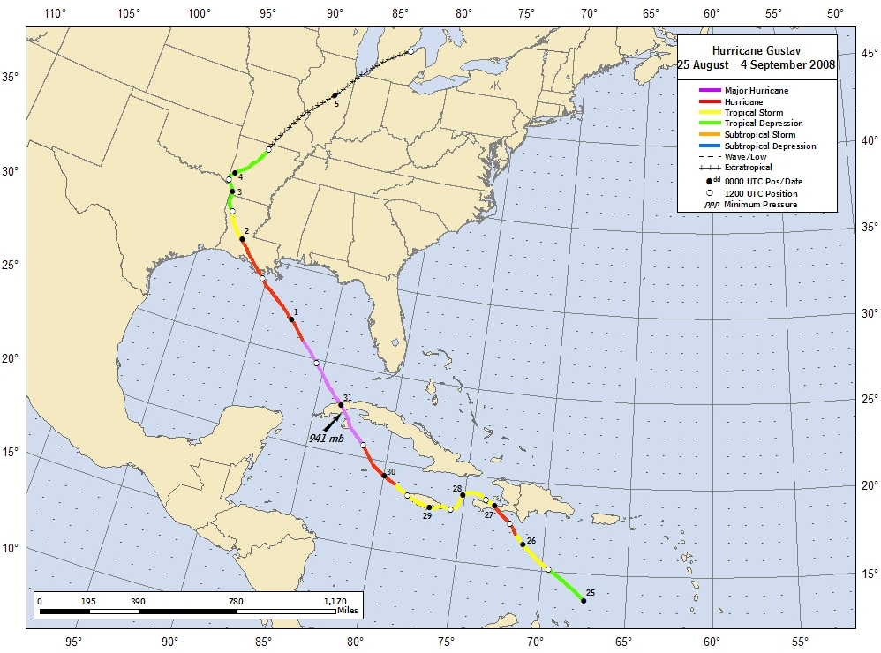
Figure 1. Best track positions for Hurricane Gustav, 25 August – 4 September 2008. Track during the extratropical stage is based on analyses from the NOAA Hydrometeorological Prediction Center.
Figure 2. Selected wind observations and best track maximum sustained surface wind speed curve for Hurricane Gustav, 25 August – 4 September 2008. Aircraft observations have been adjusted for elevation using 90%, 80%, and 75% adjustment factors for observations from 700 mb, 850 mb, and 925 mb, respectively. Dropwindsonde observations include actual 10 m winds (sfc), as well as surface estimates derived from the mean wind over the lowest 150 m of the wind sounding (LLM), and from the sounding boundary layer mean (MBL). Estimates during the extratropical stage are based on analyses from the NOAA Hydrometeorological Prediction Center. Dashed vertical lines correspond to 0000 UTC. Solid vertical lines denote landfalls.
Figure 3. Selected pressure observations and best track minimum central pressure curve for Hurricane Gustav, 25 August – 4 September 2008. Estimates during the extratropical stage are based on analyses from the NOAA Hydrometeorological Prediction Center. Dashed vertical lines correspond to 0000 UTC. Solid vertical lines denote landfalls.

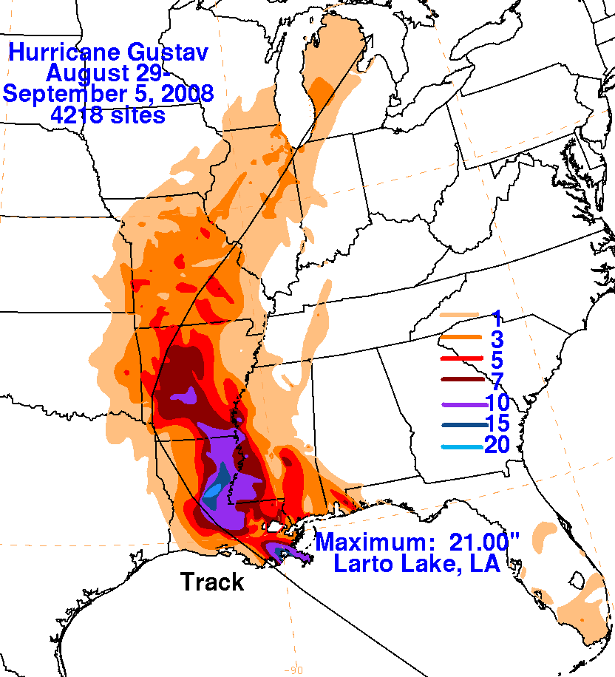
Figure 4. Storm total rainfall map for Hurricane Gustav, 25 August – 4 September 2008. The best track position is given by the black line.
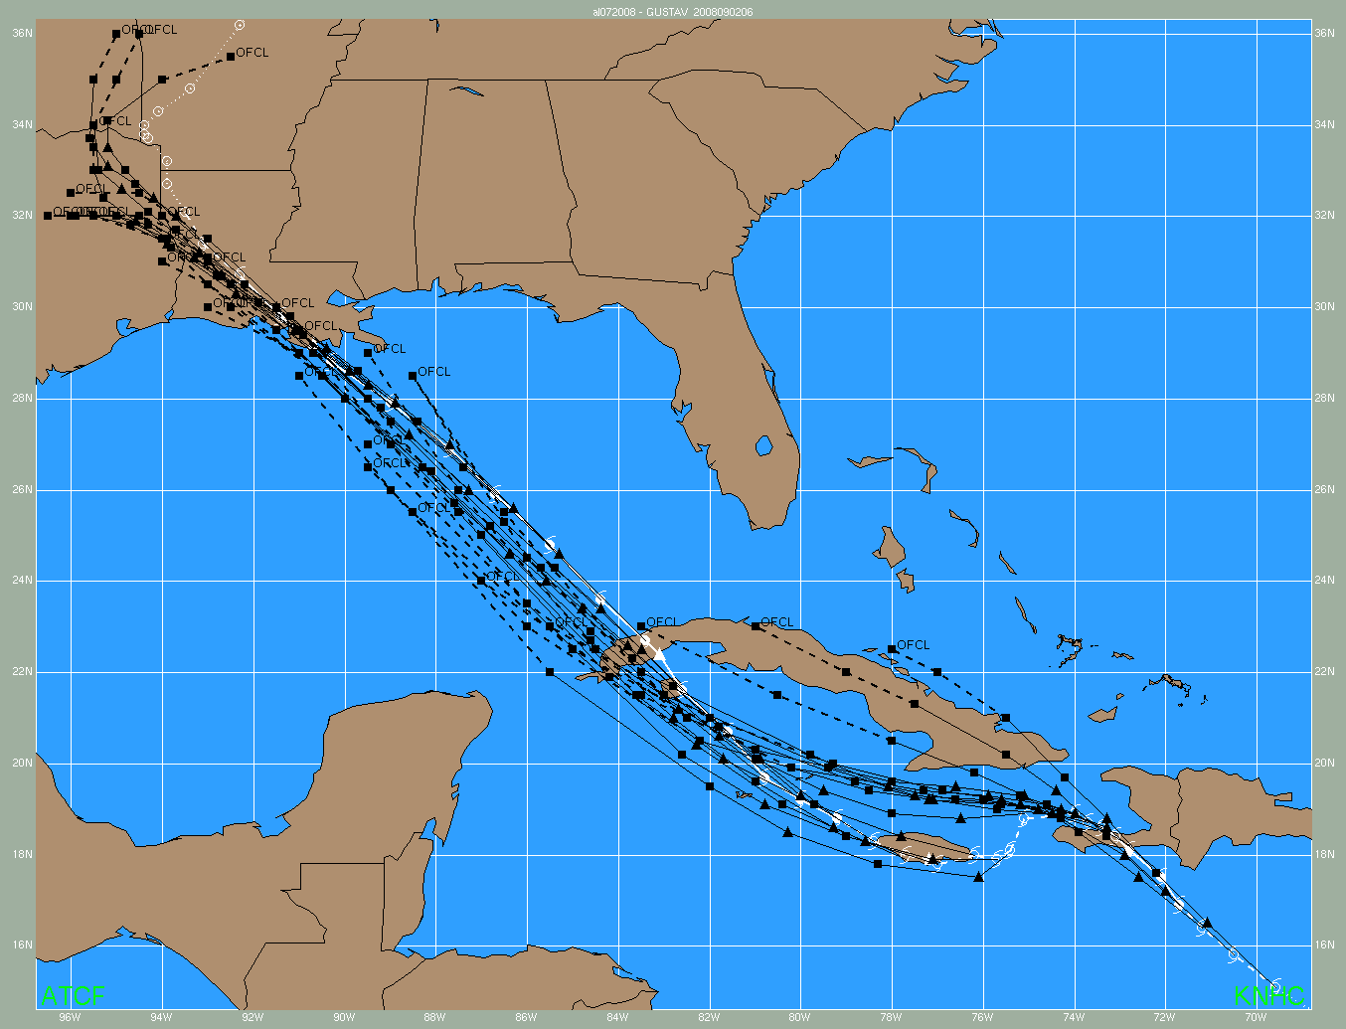
Figure 5. Selected official track forecasts (black lines, with 24, 48, 72, 96, and 120 h positions indicated by the squares and 12 and 36 hr positions indicated by the triangles) for Hurricane Gustav, 25 August – 4 September 2008. The best track is given by the white line with positions at 6 h intervals indicated by the cyclone symbols.
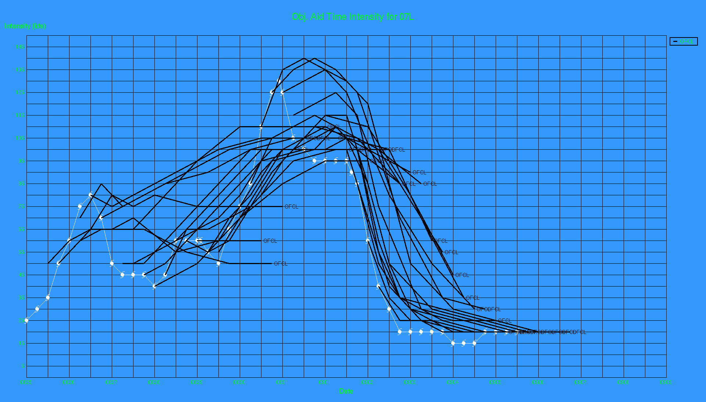
Figure 6. Selected official intensity forecasts (black lines) for Hurricane Gustav, 25 August – 4 September 2008. The best track intensity is given by the white line with the cyclone symbols.

A digital record of the complete best track, including wind radii, can be found on line at ftp://ftp.nhc.noaa.gov/atcf. Data for the current year’s storms are located in the btk directory, while previous years’ data are located in the archive directory.

