Tropical Cyclone Report
Hurricane Hanna
(AL082008)
28 August – 7 September 2008

Daniel P. Brown and Todd Kimberlain
National Hurricane Center
17 December 2008

Updated 27 March 2009 to include rainfall total from Camp Perrin, Haiti

Hanna was a tropical cyclone that was briefly a hurricane over the Caicos Islands. Hanna also made landfall in the United States as a strong tropical storm near the border between North and South Carolina. Impacts from Hanna were greatest in Haiti, where heavy rainfall and subsequent flooding resulted in a large loss of life.

- Synoptic History

Hanna formed from a tropical wave that entered the eastern Atlantic Ocean on 19 August. Associated shower and thunderstorm activity gradually increased as the wave progressed westward across the Atlantic, and on 26 August the wave spawned an area of low pressure about 475 n mi east-northeast of the northern Leeward Islands. Additional development continued during the next couple of days, which led to the formation of a tropical depression by 0000 UTC 28 August, about 275 n mi east-northeast of the northern Leeward Islands. The “best track” chart of the tropical cyclone’s path is given in Fig. 1, with the wind and pressure histories shown in Figs. 2 and 3, respectively. The best track positions and intensities are listed in Table 1.

It is estimated that the depression reached tropical storm strength 12 h later, as the overall organization of the system continued to improve. Visible satellite imagery later that day, however, indicated that the center of Hanna was located near the western edge of the deep convection due to westerly shear from an upper-level low to the northwest of the cyclone. Despite the moderate shear, the storm strengthened a little as it moved in a general west-northwestward direction to the south of a subtropical ridge extending over the western Atlantic. While passing a couple hundred miles to the north of Puerto Rico, Hanna moved close enough to the upper-level low that the satellite appearance of Hanna briefly resembled that of a sub-tropical storm on 30 August. The upper-level low shifted southward and gradually dissipated the next day, resulting in a low-shear environment conducive for strengthening. Deep convection began to form over the center of the storm around 0000 UTC 1 September. This continued overnight and into the next morning, when a period of rapid intensification (30 kt or more intensity increase in 24-h) began. During that time, a building deep-layer ridge over the eastern United States caused Hanna to turn southwestward and to slow its forward speed. Reconnaissance aircraft data indicate that Hanna reached hurricane strength by 1800 UTC 1 September, while centered just north of the Caicos Islands. Flight-level winds from the aircraft later that afternoon and a minimum surface pressure report of 978.9 mb (Table 3) from Pine Cay in the Caicos Islands suggest that Hanna reached an estimated peak intensity of 75 kt, while centered over Providenciales in the Caicos Islands around 0000 UTC 2 September. A passive microwave image around that time confirmed Hanna’s rapid increase in organization, revealing the presence of a well-defined banded eye feature (Fig. 4). However, no sooner had Hanna strengthened than it abruptly began to weaken, succumbing to the effects of moderate to strong northerly shear associated with the building ridge over the United States, and Hanna weakened to a tropical storm by 1200 UTC 2 September.

During the time of Hanna’s rapid weakening it moved on a general west-southwestward track, passing very near Great Inagua Island in the Southeastern Bahamas. Hanna turned southeastward later that day and passed less than 30 n mi from the north coast of Haiti early on 3 September. Later that day, Hanna interacted with another upper-level low over the Bahamas and once again exhibited a quasi-subtropical convective structure. The storm then turned northward and began to re-strengthen as it moved over Middle Caicos Island shortly after 1800 UTC 3 September. Hanna completed a counter-clockwise loop and began moving northwestward when a sub-tropical ridge built over the western Atlantic. During the next 24-36 hours, Hanna’s intensity remained between 55 and 60 kt while the center passed just east of the central and northwestern Bahamas. By 5 September, Hanna separated from the upper-low and reached the western periphery of the subtropical ridge. The cyclone turned northward, its center passing about 150 n mi east of the coast of northern Florida. Hanna continued northward and accelerated, making landfall as a 60 kt tropical storm near the border between North and South Carolina at 0720 UTC 6 September. Once inland over North Carolina the storm began to weaken while moving across the Mid-Atlantic region. Hanna turned northeastward and its center passed very close to New York City shortly after 0000 UTC 7 September. Shortly thereafter, the system became extratropical when it merged with a cold front over southern New England.

The extratropical remnant of Hanna continued moving northeastward toward the Canadian Maritimes. The low moved over Nova Scotia during the afternoon of 7 September before turning east-northeastward, passing over southern Newfoundland early on 8 September. After moving offshore just east-northeast of St. John’s, Newfoundland, the low-level circulation became ill-defined as it merged with a second frontal boundary. Shortly thereafter, another low, which may have contained a portion of Hanna formed along the front and became a very powerful low pressure area over the north Atlantic.

- Meteorological Statistics

Observations in Hanna (Figs. 2 and 3) include satellite-based Dvorak technique intensity estimates from the Tropical Analysis and Forecast Branch (TAFB) and the Satellite Analysis Branch (SAB). Microwave satellite imagery from NOAA polar-orbiting satellites, the NASA Tropical Rainfall Measuring Mission (TRMM), the NASA Aqua, the NASA QuikSCAT, the Department of Defense WindSat, and Defense Meteorological Satellite Program (DMSP) satellites were also useful in tracking Hanna. Eight reconnaissance missions by the U.S. Air Force Reserve and one by the NOAA Aircraft Operations Center were flown into Hanna. The NOAA G-IV aircraft conducted two synoptic surveillance missions. Observations from these missions include flight-level winds, dropwindsonde observations, and surface wind estimates from the Stepped-Frequency Microwave Radiometer (SFMR). WSR-88D radars along the east coast of the United States were also useful in tracking Hanna.

Reconnaissance data on 1 September helped to determine that Hanna attained hurricane strength. The 75 kt estimated peak intensity at 0000 UTC 2 September is partially based on a peak 850 mb flight-level wind of 90 kt that was measured during the afternoon of 1 September. Using a standard flight-level to surface wind reduction, this yields a surface wind estimate of 72 kt. An unofficial surface observing site on Pine Cay in the Caicos Islands measured a minimum pressure of 978.9 mb (Table 3) around 0000 UTC 2 September, which was 4-5 mb lower than the minimum pressure reported by the aircraft earlier in the afternoon.

The 60 kt intensity estimate at the time of landfall in the United States is based on a peak 850 mb flight-level wind of 72 kt and an SFMR surface wind measurement of 58 kt. The SFMR did record an isolated higher peak surface wind of 67 kt at 2339 UTC 5 September, however this estimate appears to have been inflated by heavy rainfall and not considered representative of the maximum sustained surface wind. The estimated minimum pressure of 981 mb at landfall in the United States is based on a minimum pressure of 981.9 mb reported at 0726 UTC 6 September from an unofficial site at Sunset Beach, North Carolina (Table 3).

Selected ship reports of winds of tropical storm force associated with Hanna are given in Table 2. Selected buoys that recorded winds of tropical storm force or greater in association with Hanna are provided in Table 3.

Selected surface observations from land stations and data buoys are given in Table 3. The highest sustained wind measured in the Caicos Islands was 54 kt, which was recorded at the unofficial site on Pine Cay. Unfortunately, the height and exposure of this anemometer are unknown, so it is unclear as to how representative this observation is of the actual wind experienced at that location. Sustained tropical storm force winds were reported at a few observing sites along the coast of the Carolinas and Mid-Atlantic region of the United States. The highest wind reported in the United States was 53 kt with a gust of 63 kt at the Johnny Mercer Pier on Wrightsville Beach, North Carolina.

Although rainfall amounts received from the southeastern Bahamas (Table 3) were relatively low (about 1-3 in), Hanna produced very heavy rainfall over Hispaniola and Puerto Rico as its center passed just north and northwest of those islands. Figure 5 shows that an area of 7 in or greater rainfall occurred over interior sections of Puerto Rico. Most of this rain was recorded between 1-3 September as Hanna’s outer rain bands moved across the island. The maximum rainfall received in Puerto Rico was 16.19 in near Adjuntas. The reported in Hispaniola was 14.17 in at Oviedo, Dominican Republic and 12.72 in at Camp Perrin, Haiti.

Hanna produced a large swatch of 3-5 in of rain over the eastern United States (Fig. 6). Some areas more directly along Hanna’s path received 5-7 in totals, with a maximum amount of 9.65 in at Woodbridge, Virginia. The extratropical remnant of Hanna produced 3-5 in of rain over southern Maine, southern Newfoundland, and portions of Nova Scotia. The highest rainfall total observed in southeastern Canada was 5.72 in at Saint John, New Brunswick.

Hanna produced one EF-1 tornado in the United States that touched down around 1900 UTC 6 September near Allentown, Pennsylvania.

- Casualty and Damage Statistics

Damage from Hanna appears to have been relatively minor in the southeastern Bahamas and the Turks and Caicos Islands. It should be noted, however, that damage assessments from the southeastern Bahamas and Turks and Caicos Islands were limited after the passage of Hanna, since the same area was struck by major Hurricane Ike less than a week later. A situation report from the Caribbean Disaster Emergency Response Agency (CDERA) on 3 September indicates that wind damage was mostly minor, with some roof damage to homes reported. In addition, considerable flooding was reported in Five Cays and Providenciales. The report also mentioned that several roads suffered damage from storm surge flooding, including major damage to a recently completed causeway linking North and Middle Caicos Islands. There were also reports of boats in and near the Caicos Islands that were washed ashore or sunk during the storm. No casualties were reported in the Bahamas or Turks and Caicos Islands from Hanna.

Heavy rainfall that occurred in Haiti as Hanna passed just north of the north coast of that island on 2-3 September was responsible for severe flooding and an estimated 500 fatalities. The heavy rains exacerbated the flooding situation caused by Tropical Storm Fay and Hurricane Gustav that passed near or over Haiti during the preceding 2-3 weeks. Although significant flooding occurred over much of Haiti, the hardest hit areas were in the northwestern portions of the country, particularly the city of Gonaives. Due to the flooding from the previous storms, and the subsequent impacts of Hurricane Ike the following week, it is difficult to determine the exact death toll in Haiti attributable to Hanna. Reports from the Haitian Red Cross indicate that 793 people perished from the four storms and that about 500 people died in Gonaives, most likely the result of the flooding rains from Hanna. Several hundred people remain missing from the storms and a final death toll from each of the storms will likely never be known.

In the mountainous regions of Puerto Rico, heavy rainfall produced a few mud slides that damaged some roads and bridges. Strong winds in some of the heavier squalls downed a few trees and power lines. There were no reports of injuries or deaths from Hanna in Puerto Rico.

In the United States, Hanna produced an estimated $80 million in insured losses according to the Property Claim Services of the Insurance Services Office, Inc. Using a doubling of insured losses to obtain the total damage gives an estimate of $160 million in damage. The damage over the eastern United States included downed trees and powerlines, which resulted in numerous electrical disruptions. There were some reports of trees that fell on homes, but there were no injuries or deaths as a result. Storm surge flooding in southeastern North Carolina caused minor beach erosion and some flooding in low-lying areas along the Pamlico River. Heavy rainfall produced minor flooding and some road closures along much of the east coast of the United States. More significant flooding was reported in some localized areas such as in Manchester, New Hampshire, where damage was estimated at about $3 million. One indirect drowning death occurred in Georgetown County, South Carolina, when an automobile left the roadway and ended up in a flooded drainage ditch.

The remnants of Hanna were responsible for producing power outages and numerous reports of flooding in southeastern Canada. Media reports indicate that some roads were washed out in southern New Brunswick and Nova Scotia.

- Forecast and Warning Critique

The tropical wave from which Hanna formed was first mentioned in the Tropical Weather Outlook (TWO) at 1200 UTC 22 August, a little more than five days prior to development. Most of the TWOs issued during the next few days accurately indicated that upper-level winds would inhibit development. The TWO issued at 0000 UTC 26 August, 48 h prior to genesis, was the first to indicate that conditions would become more conducive for development. However, the explicit mention of tropical depression formation did not occur until about the time that the system was designated a tropical cyclone in the final best track.

A verification of official and guidance model track forecasts is given in Table 4. Average official track errors for Hanna were 45, 83, 112, 125, 171, 201, and 213 n mi for the 12, 24, 36, 48, 72, 96, and 120 h forecasts, respectively. The number of forecasts ranged from 38 at 12 h to 20 at 120 h. These errors are greater than the average long-term official track errors through 72 h, but are lower than the 5-yr averages at 96- and 120-h. The dynamical model guidance also had large forecast errors, and the only dynamical model that consistently outperformed the official forecast through 72 h was the interpolated ECMWF model (EMXI). The official forecasts exhibited a fairly significant northwestward bias, having not accurately predicted Hanna’s southward motion or cyclonic loop on 2-3 September (Fig. 7). The dynamical guidance also had difficulty forecasting Hanna’s motion near the Turks and Caicos Islands. However, the GFDL and HWRF models should be commended for at least forecasting a small cyclonic loop to north of the Turks and Caicos Islands.

Average official intensity errors were 5, 9, 11, 14, 15, 9, and 12 kt for the 12, 24, 36, 48, 72, 96, and 120 h forecasts, respectively. For comparison, the average long-term official intensity errors are 7, 10, 12, 14, 18, 20, and 22 kt, respectively. The NHC intensity forecast errors were generally smaller than the 5-yr mean, except at 48 h where they were nearly equal to the long-term average. The official intensity forecasts did not accurately predict that Hanna would reach hurricane strength over the Caicos Islands, since most of the forecasts during that time anticipated little change in strength due to the effects of vertical wind shear. In fairness, however, it should be noted that Hanna was not able to maintain hurricane strength for very long and quickly weakened. Intensity forecasts prior to Hanna reaching the east coast of the United States had a high bias. In fact, official forecasts about three days prior to landfall in the Carolinas predicted that Hanna would reach the coast as a category 2 hurricane.

Watches and warnings associated with Hanna are given in Table 5. A hurricane watch was issued at 0900 UTC 4 September from Edisto Beach, South Carolina, to Surf City, North Carolina, while a tropical storm warning for the area where Hanna made landfall was issued at 2100 UTC that day. This resulted in a lead time for Hanna’s landfall of about 46 h for the hurricane watch and about 34 h for the tropical storm warning.

- Acknowledgements

The Meteorological Services of the Bahamas and the Dominican Republic provided rainfall data for their respective counties. Chris Fogarty of the Canadian Hurricane Center furnished surface data for the extratropical portion of Hanna’s life cycle. The National Data Buoy Center and the National Weather Service Offices along the east coast of the United States and in Puerto Rico supplied surface data and storm summaries. David Roth of the Hydrometeorological Prediction Center contributed additional rainfall information.

Table 1. Best track for Hurricane Hanna, 28 August-7 September 2008.

Date/Time  (UTC) | Latitude  (°N) | Longitude  (°W) | Pressure  (mb) | Wind Speed  (kt) | Stage
28 / 0000 | 19.4 | 57.3 | 1007 | 30 | tropical depression
28 / 0600 | 19.7 | 57.8 | 1004 | 30 | "
28 / 1200 | 20.1 | 58.6 | 1003 | 35 | tropical storm
28 / 1800 | 20.5 | 59.6 | 1003 | 35 | "
29 / 0000 | 20.8 | 60.5 | 1001 | 40 | "
29 / 0600 | 20.9 | 61.5 | 1000 | 45 | "
29 / 1200 | 21.1 | 62.4 | 1000 | 45 | "
29 / 1800 | 21.5 | 63.4 | 1000 | 45 | "
30 / 0000 | 21.7 | 64.5 | 1000 | 45 | "
30 / 0600 | 21.8 | 65.5 | 1000 | 45 | "
30 / 1200 | 21.9 | 66.2 | 1000 | 45 | "
30 / 1800 | 22.2 | 66.9 | 1000 | 45 | "
31 / 0000 | 22.6 | 67.5 | 999 | 50 | "
31 / 0600 | 23.1 | 68.5 | 999 | 45 | "
31 / 1200 | 23.5 | 69.8 | 999 | 40 | "
31 / 1800 | 23.6 | 71.0 | 997 | 40 | "
01 / 0000 | 23.5 | 71.7 | 997 | 45 | "
01 / 0600 | 23.2 | 72.0 | 996 | 50 | "
01 / 1200 | 22.8 | 72.2 | 990 | 60 | "
01 / 1800 | 22.3 | 72.4 | 985 | 70 | hurricane
02 / 0000 | 21.8 | 72.3 | 977 | 75 | "
02 / 0600 | 21.4 | 72.7 | 980 | 65 | "
02 / 1200 | 21.0 | 73.0 | 983 | 60 | tropical storm
02 / 1800 | 20.6 | 72.9 | 985 | 55 | "
03 / 0000 | 20.4 | 72.6 | 988 | 55 | "
03 / 0600 | 20.2 | 72.4 | 991 | 50 | "
03 / 1200 | 20.6 | 71.9 | 996 | 45 | "
03 / 1800 | 21.6 | 71.8 | 994 | 50 | "
04 / 0000 | 22.7 | 71.8 | 989 | 55 | "
04 / 0600 | 23.4 | 72.4 | 990 | 60 | "
04 / 1200 | 24.1 | 73.2 | 989 | 55 | "
04 / 1800 | 25.1 | 74.3 | 989 | 55 | "
05 / 0000 | 26.1 | 75.8 | 987 | 55 | "
05 / 0600 | 27.2 | 77.3 | 984 | 55 | "
05 / 1200 | 28.2 | 78.5 | 980 | 55 | "
05 / 1800 | 29.9 | 78.7 | 980 | 60 | "
06 / 0000 | 31.5 | 79.3 | 980 | 60 | "
06 / 0600 | 33.4 | 78.8 | 981 | 60 | "
06 / 1200 | 35.7 | 78.1 | 985 | 45 | "
06 / 1800 | 37.8 | 76.7 | 993 | 45 | "
07 / 0000 | 40.0 | 74.5 | 994 | 45 | "
07 / 0600 | 41.9 | 71.7 | 995 | 45 | extratropical
07 / 1200 | 43.8 | 68.0 | 995 | 45 | "
07 / 1800 | 45.7 | 63.7 | 995 | 45 | "
08 / 0000 | 47.0 | 59.1 | 996 | 40 | "
08 / 0600 | 47.5 | 55.4 | 996 | 40 | "
08 / 1200 | 47.8 | 52.1 | 996 | 35 | "
08 / 1800 |  |  |  |  | merged with front
02 / 0000 | 21.8 | 72.3 | 977 | 75 | maximum wind, minimum pressure, and landfall near Providencials Island, Caicos Islands
03 / 1900 | 21.7 | 71.8 | 994 | 50 | landfall near Middle Caicos Island
06 / 0720 | 33.8 | 78.7 | 981 | 60 | landfall near North Carolina / South Carolina border

Table 2. Selected ship reports with winds of at least 34 kt for Hurricane Hanna, 28 August-7 September 2008.

Date/Time (UTC) | Ship/Buoy ID | Latitude  (°N) | Longitude  (°W) | Wind  dir/speed (kt) | Pressure  (mb)
01/1500 | WDB325 | 20.3 | 71.9 | 200/38 | 1005.1
01/1900 | KCGH | 20.7 | 73.3 | 250/38 | 1011.0
03/1700 | KCGH | 19.7 | 69.7 | 180/38 | 998.0
04/0900 | WJBJ | 26.9 | 72.0 | 070/44 | 1001.0
04/1200 | VQBW2 | 28.0 | 70.3 | 090/35 | 1006.5
04/1600 | WJBJ | 25.9 | 70.5 | 150/36 | 1003.2
04/1800 | WJBJ | 25.3 | 70.2 | 160/37 | 1004.3
04/1900 | KIRH | 24.1 | 74.8 | 270/37 | 995.3
05/0000 | KIRH | 25.1 | 75.7 | 270/52 | 991.9
05/0400 | C6PT7 | 26.4 | 79.0 | 280/35 | 1000.0
05/0600 | KIRH | 25.7 | 77.2 | 240/37 | 996.0
05/0600 | C6TZ8 | 27.6 | 80.0 | 360/42 | 1010.0
05/1000 | C6FM8 | 26.2 | 79.9 | 230/43 | 1009.0
05/1800 | WFKW | 29.9 | 80.6 | 220/40 | 999.2
05/1800 | WNDP | 34.0 | 76.2 | 150/36 | 1009.0
06/1500 | WPKD | 33.3 | 74.7 | 190/40 | 1010.0
06/1800 | WPKD | 33.0 | 75.5 | 230/37 | 1010.0
06/1800 | WNDP | 36.1 | 75.0 | 190/36 | 1005.5
06/1800 | WPGK | 36.9 | 72.2 | 160/37 | 1010.0
06/2100 | DGAF | 38.2 | 74.3 | 200/43 | 996.5
06/2100 | WMVF | 38.6 | 74.9 | 180/40 | 996.8
07/0000 | A8IY6 | 38.1 | 73.0 | 230/45 | 1003.0
07/0000 | C6FT7 | 41.1 | 71.4 | 100/39 | 1004.0

Table 3. Selected surface observations for Hanna, 28 August-7 September 2008.

Location | Minimum Sea Level Pressure |  | Maximum Surface  Wind Speed |  |  | Storm surge  (ft)^{c} | Storm  tide  (ft)^{d} | Total  rain  (in)
Location | Date/  time  (UTC) | Press.  (mb) | Date/  time  (UTC)ª | Sustained  (kt)^{b} | Gust  (kt) | Storm surge  (ft)^{c} | Storm  tide  (ft)^{d} | Total  rain  (in)
Caicos Islands
Meteorological Assimilation Data Ingest System (MADIS)
Pine Cay (DW0758)  (Weather Underground IPINECAY2) | 01/2356 | 978.9 | 02/0216 | 54e | 56e
Pine Cay (MD0758) | 02/0012 | 979.6 | 02/0233 | 50
Haiti
Camp Perrin |  |  |  |  |  |  |  | 12.72
Bahamas
Provided by Bahamas Meteorological Service
Inagua Island (Pump #1) |  |  |  |  |  |  |  | 1.43
Inagua Island (Pump #3) |  |  |  |  |  |  |  | 2.54
Inagua Island (Pump #4) |  |  |  |  |  |  |  | 1.77
Inagua Island (Y-2) |  |  |  |  |  |  |  | 2.48
Inagua Island (G. Hill) |  |  |  |  |  |  |  | 2.12
Inagua Island (P. Point) |  |  |  |  |  |  |  | 1.80
Inagua Island (Y. House) |  |  |  |  |  |  |  | 2.12
Inagua Island (N. Dam) |  |  |  |  |  |  |  | 2.07
Puerto Rico
USGS and Cooperative Observer Program (COOP)
Adjuntas (2 ESE) |  |  |  |  |  |  |  | 16.19
Saltillo |  |  |  |  |  |  |  | 14.43
Rio Icacos |  |  |  |  |  |  |  | 12.45
Quebrada |  |  |  |  |  |  |  | 11.19
Rio Mameyes |  |  |  |  |  |  |  | 11.13
Barrio Apeadero |  |  |  |  |  |  |  | 10.02
Sabana Grande |  |  |  |  |  |  |  | 9.76
El Portal |  |  |  |  |  |  |  | 9.55
Rio Tanama |  |  |  |  |  |  |  | 9.08
Rio Bauta |  |  |  |  |  |  |  | 7.20
Rio Guanajibo |  |  |  |  |  |  |  | 5.69
Rio Grande De Loiza San Lorenzo |  |  |  |  |  |  |  | 5.24
Dominican Republic
Provided by Dominican Republic Meteorological Service
Oviedo |  |  |  |  |  |  |  | 14.17
Pednernales |  |  |  |  |  |  |  | 10.79
Polo |  |  |  |  |  |  |  | 8.99
San Jose Ocoa |  |  |  |  |  |  |  | 8.78
Las Americas |  |  |  |  |  |  |  | 8.54
Villa Vasquez |  |  |  |  |  |  |  | 8.02
Los Llanos |  |  |  |  |  |  |  | 7.97
Hato Mayor |  |  |  |  |  |  |  | 7.65
La Descubierta |  |  |  |  |  |  |  | 7.57
Bani |  |  |  |  |  |  |  | 7.51
La Romana |  |  |  |  |  |  |  | 6.84
Monte Plata |  |  |  |  |  |  |  | 6.78
Punta Cana |  |  |  |  |  |  |  | 6.53
Bayaguana |  |  |  |  |  |  |  | 6.42
Aerop. Joaquin B. |  |  |  |  |  |  |  | 6.10
Florida
National Ocean Service (NOS)
Fernandina Beach (FRDF1) | 05/1930 | 1002.8 | 05/1518 | 24 | 43
Georgia
NOS
Fort Pulaski (FPKG1) | 06/0012 | 1002.3 | 06/0224 |  | 29 | 2.26 | 4.77
South Carolina
International Civil Aviation Organization (ICAO) and Remote Automated Weather Stations (RAWS)
Florence Regional Airport (KFLO) | 06/0653 | 997.3 | 06/0637 | 21 | 37 |  |  | 4.53
Myrtle Beach Grandstand (KMYR) | 06/0635 | 988.5 | 06/0735 | 25 | 36 |  |  | 4.28
North Myrtle Beach (KCRE) | 06/0653 | 984.2 | 06/0643 | 27 | 46
Charleston International Airport (KCHS) | 06/0456 | 998.9 | 05/1718 | 19 | 27 |  |  | 3.54
NOS
MROS1 – Springmaid Pier SC 33.7°N 78.9°W | 06/0836 | 987.1 | 06/0148 | 36 | 42 | 3.50 | 7.25
Oyster Landing |  |  |  |  |  | 2.20 | 6.63
COOP and Community Collaborative Rain, Hail & Snow Network (CoCoRaHS)
McClellanville  33.08N 79.46W |  |  |  |  |  |  |  | 4.97
McClellanville (0.5 ESE)  33.08N 79.45W |  |  |  |  |  |  |  | 4.47
Mount Pleasant (8NNE)  32.89N 79.481W |  |  |  |  |  |  |  | 4.42
McClellanville (0.2 ESE)  33.08N 79.46W |  |  |  |  |  |  |  | 4.41
Mount Pleasant (5.7 NE)  32.85N 79.79W |  |  |  |  |  |  |  | 4.32
Huger (3 NNE)  33.13N 79.78W |  |  |  |  |  |  |  | 4.30
Mount Pleasant (4.1 NE)  32.83N 79.81W |  |  |  |  |  |  |  | 4.14
Mount Pleasant (2.5 SW)  32.76N 79.89W |  |  |  |  |  |  |  | 4.07
North Carolina
ICAO
Laurinburg Maxton Airport (KMEB) | 06/0852 | 996.1 | 06/0552 | 25 | 35
Raleigh Durham International Airport (KRDU) | 06/1151 | 995.5 | 06/1333 | 16 | 28 |  |  | 4.77
Fayetteville Regional Airport/Grannis Field (KFAY) | 06/0953 | 991.7 | 06/0953 | 23 | 35 |  |  | 4.62
Simmons AAF | 06/1018 | 993.0 | 06/1158 | 28 | 38
Seymour-Johnson AFB (KGSB) | 06/1051 | 987.1 | 06/1049 | 32 | 45
Rocky-Mount Wilson Airport (KRWI) | 06/1253 | 988.3 | 06/1609 | 17 | 34
Horace Williams Airport (KIGX) | 06/1056 | 997.5 | 06/1247 | 18 | 37
Beaufort Airport (KMRH) | 06/1027 | 998.9 | 06/1406 | 36 | 48 |  |  | 1.08
New Bern (KEWN) | 06/1111 | 995.5 | 06/1122 | 31 | 49 |  |  | 0.81
Frisco Airport (KHSE) | 06/1204 | 1001.9 | 06/1144 | 37 | 47 |  |  | 1.04
Jacksonville Airport (KOAJ) | 06/1043 | 993.5^{f} | 06/1002 | 37 ^{f} |  |  |  | 1.32
Wilmington International (KILM) | 06/0853 | 993.2 | 06/0953 | 27 | 47
Lumberton (KLBT) | 06/0854 | 992.1 | 06/0844 | 30 | 40 |  |  | 4.60
Southport (KSUT) | 06/0740 | 992.5 | 06/0940 | 29 | 49
Whiteville (KCPC) | 06/0820 | 986.1 | 06/0940 | 16 | 30
Elizabeth City USCG (KECG) | 06/1554 | 999.7 | 06/1654 | 32 | 46
Edenton (KEDE) |  |  | 06/1517 | 32 | 42
RAWS
Sunny Point (SUNN7) 34.00°N 77.96°W |  |  | 06/0418 | 28 | 49
Back Island (BKIN7)  34.53°N 77.72°W |  |  | 06/1118 | 19 | 50
Nature Conservancy (NATN7)  34.05°N 78.29°W |  |  | 06/0818 | 21 | 46
Turnbull Creek (TURN7)  34.68°N 78.58°W |  |  | 06/0818 | 15 | 40
Whiteville (WHIN7)  34.34°N 78.73°W |  |  | 06/0918 | 12 | 42
NOS
Johnny Mercer Pier (JMPN7) Wrightsville, NC  34.2°N 77.8°W | 06/0836 | 993.1 | 06/0912 | 53 | 63 | 2.5 | 5.45
Wilmington |  |  |  |  |  | 5.00 | 6.75
Ocean Isle Beach |  |  |  |  |  | 4.00 | 7.00
Beaufort |  |  |  |  |  | 2.00 | 3.20
Oregon Inlet (ORIN7) | 06/1354 | 1004.1 | 06/1742 | 39 | 51 | 2.40 | 3.40
Public Report
Sunset Beach  (Weather Underground) | 06/0726 | 981.9 | 06/0607 |  | 37
Wrightstville Beach NC  34.22°N 77.79°W |  |  | 06/0700 | 37 | 58
Southport  33.92°N 78.04°W |  |  | 06/0600 | 29 | 37
Surf City NC  34.4°N 77.57°W |  |  | 06/0230 | 36 | 51
COOP and CoCoRAHs
Goldston (4 N)  35.7°N 79.3°W |  |  |  |  |  |  |  | 6.28
Fort Bragg  35.1°N 79.0°W |  |  |  |  |  |  |  | 6.19
Durham (1 NW)  36.0°N 78.9°W |  |  |  |  |  |  |  | 5.33
Raeford  35.0°N 79.2°W |  |  |  |  |  |  |  | 6.29
Emit  35.7°N 78.3°W |  |  |  |  |  |  |  | 5.42
Southern Pines  35.2°N 79.4°W |  |  |  |  |  |  |  | 6.68
Whispering Pines  35.3°N 79.4°W |  |  |  |  |  |  |  | 6.60
Hillsborough (4 SSW)  36.0°N 79.1°W |  |  |  |  |  |  |  | 5.61
Laurinburg  34.8°N 79.5°W |  |  |  |  |  |  |  | 5.74
Laurinburg (8 N)  34.9°N 79.5°W |  |  |  |  |  |  |  | 5.76
Fuquay-Varina (3 NE)  35.6°N 78.8°W |  |  |  |  |  |  |  | 6.00
Raleigh (10 S)  35.7°N 78.6°W |  |  |  |  |  |  |  | 5.21
Apex (3.5 W)  35.7°N 78.9°W |  |  |  |  |  |  |  | 6.02
Apex (1.5 E)  35.7°N 78.8°W |  |  |  |  |  |  |  | 5.00
Cary  35.8°N 78.8°W |  |  |  |  |  |  |  | 5.05
Apex  35.7°N 78.8°W |  |  |  |  |  |  |  | 5.17
Virgina
ICAO and RAWS
Quantico Marine Corps Base (KNYG) | 06/1856 | 997.3 | 06/2005 | 24 | 36
Reagan National Airport (KDCA) | 06/1852 | 998.2 | 06/1937 | 27 | 36 |  |  | 3.90
Manassas Municipal Airport (KHEF) | 06/1855 | 1000.0 | 06/1740 | 30 | 38
Warrenton Airport (KHWY) | 06/1800 | 1000.3 | 06/1740 | 21 | 34 |  |  | 2.89
Shannon Aiport /Fredericksburg (KEZF) | 06/1840 | 999.3 | 06/2000 | 26 | 35
Richmond International Airport (KRIC) | 06/1654 | 996.8 | 06/1907 | 22 | 35
Norfolk International Airport (KORF) | 06/1851 | 998.7 | 06/1836 | 29 | 41
Newport News/Patrick Henry (KPHF) | 06/1654 | 994.4 | 06/1554 | 24 | 37
Wallops Island (KWAL) | 06/1954 | 995.4 | 06/1910 | 34 | 47
Langley AFB (KLFI) |  | 999.9 | 06/2032 | 22 | 36
Norfolk NAS (KNGU) | 06/1653 | 996.8 | 06/1353 | 26 | 41
Oceana NAS (KNTU) | 06/1656 | 998.2 | 06/1156 | 26 | 41
Wakefield Airport (KAKQ) | 06/1554 | 994.2 | 06/1931 | 13 | 29 |  |  | 2.34
James City/Williamsburg Airport (KJGG) |  |  | 06/1620 | 22 | 40
Accomack Airport (KMFV) |  |  | 06/1722 | 25 | 44
Fort Belvoir (KDAA) | 06/1903 | 998.3 | 06/2116 | 18 | 30 |  |  | 5.96
Leesburg (KJYO) |  |  |  |  |  |  |  | 5.23
NOS
Cape Henry (CHYV2)  36.91°N 75.78°W | 06/1642 | 996.1 | 06/1636 | 40 | 53
Money Point (MNPV2)  36.78°N 76.30°W | 06/1606 | 996.9 | 06/1330 | 25 | 40 | 0.74 | 2.78
Dominion Terminal (DOMV2)  36.96°N 76.42°W | 06/1624 | 994.6 | 06/1636 | 36 | 47
Kiptopeke (KPTV2)  37.17°N 75.99°W |  |  | 06/1706 | 38 | 50 | 1.08 | 3.32
Yorktown USCG Station (YKTV2)  37.23°N 76.48°W | 06/1712 | 993.8 | 06/1236 | 28 | 38 | 1.76 | 3.26
York River Range Light (YRKV2)  37.25°N 76.33°W | 06/1718 | 993.6 | 06/1330 | 43 | 54
Rappahannock Light Tower (RPLV2)  37.54°N 76.02°W | 06/1812 | 993.4 | 06/1806 | 42 | 50
Lewisetta VA (LWTV2)  38.00°N 76.47°W | 06/1854 | 993.8 | 06/1424 | 35 | 43 | 2.04 | 2.92
Wachapreague (WAHV2)  37.61°N 75.69°W | 06/1848 | 996.3 | 06/1754 | 38 | 52 | 1.36 | 5.74
Vienna |  |  |  |  |  | 2.55 | 4.00
COOP and CoCoRaHS
Woodbridge (2.6 SSW)  38.58°N 77.28°W |  |  |  |  |  |  |  | 9.65
Manassas  38.74°N 77.48°W |  |  |  |  |  |  |  | 7.78
Oakton  38.89°N 77.30°W |  |  |  |  |  |  |  | 8.29
Fairfax City  38.85°N 77.30°W |  |  |  |  |  |  |  | 8.33
Arlington  38.87°N 77.10°W |  |  |  |  |  |  |  | 7.93
Fredericksburg  38.29°N 77.49°W |  |  |  |  |  |  |  | 7.02
Sterling  39.00°N 77.43°W |  |  |  |  |  |  |  | 7.00
Quantico  38.52°N 77.29°W |  |  |  |  |  |  |  | 5.58
Public
Willoughby Degaussing  36.96°N 76.33°W | 06/1518 | 994.9 | 06/1536 | 40 | 50
District of Columbia
NOS
Washington DC (WASD2)  38.87°N 77.02°W | 06/1845 | 998.2 | 06/2148 | 21 | 27 | 3.50 | 4.10
Maryland
ICAO and RAWS
Baltimore/Washington International Airport (KBWI) | 06/2054 | 998.1 | 06/1540 | 25 | 36 |  |  | 1.72
Washington Dulles Airport (KIAD) | 06/1952 | 1000.7 | 06/1945 | 26 | 35 |  |  | 5.42
Andrews AFB (KADW) | 06/1940 | 997.2 | 06/2029 | 26 | 34 |  |  | 2.26
Martin State Airport (MTN) | 06/2045 | 998.6 | 06/2245 | 20 | 28
U.S. Naval Academy (KNAK) | 06/1954 | 996.9 | 06/1554 | 22 | 41 |  |  | 1.89
Patuxent River NAS (KNHK) | 06/1852 | 994.2 | 06/1523 | 28 | 39 |  |  | 1.70
St. Inigoes (KNUI) | 06/1853 | 993.3 | 06/1443 | 22 | 33 |  |  | 1.97
Leonardtown (K2W6) | 06/1907 | 994.2 | 06/1431 | 19 | 32
Salisbury-Wicomico Airport (KSBY) | 06/1954 | 994.8 | 06/1738 | 27 | 39
Ocean City Airport (KOXB) | 06/2053 | 995.3 | 06/2335 | 19 | 38
NOS
Piney Point (PPTM2)  38.13°N 76.53°W |  |  | 06/2200 | 35 | 43
Baltimore MD (BLTM2)  39.27°N 76.58°W | 06/2106 | 997.7 | 06/2112 | 27 | 35 | 1.80 | 2.20
Francis Scott Key Bridge (FSKM2)  39.22°N 76.53°W | 06/2106 | 996.8 | 06/2030 | 29 | 37
Bishops Head (BISM2)  38.22°N 76.04°W | 06/1906 | 992.6 | 06/1800 | 33 | 44 | 2.73 | 3.90
Cambridge (CAMM2)  38.57°N 76.07°W | 06/1954 | 994.0 | 06/2342 | 24 | 38 | 3.08 | 4.36
Ocean City Inlet (OCIM2)  38.32°N 75.09°W | 06/2118 | 995.5 | 06/1854 | 33 | 46
McCreadys Creek  38.3°N 76.0°W |  |  |  |  |  | 2.97 | 4.31
COOP and CoCoRaHS
Potomac  39.02°N 77.20°W |  |  |  |  |  |  |  | 6.23
Nanjemoy  38.45°N 77.22°W |  |  |  |  |  |  |  | 5.00
Gaithersburg  39.14°N 77.22°W |  |  |  |  |  |  |  | 5.22
Delaware
ICAO and RAWS
Georgetown/Sussex (KGED) | 06/2054 | 994.6 | 06/1547 | 23 | 38 |  |  | 2.07
Dover (KDOV) | 06/2137 | 994.7 | 06/1525 | 23 | 38 |  |  | 1.25
Wilmington (KILG) | 06/2109 | 996.6 | 06/2100 | 23 | 29 |  |  | 3.32
COOP and CoCoRaHS
Newark |  |  |  |  |  |  |  | 3.69
Glasgow |  |  |  |  |  |  |  | 3.33
Bear |  |  |  |  |  |  |  | 3.22
Hockessin |  |  |  |  |  |  |  | 3.13
New Jersey
ICAO and RAWS
Newark International Airport (KEWR) | 07/0151 | 998.4 | 07/0047 | 30 | 39 |  |  | 3.75
Millville (KMIV) | 06/2140 | 994.5 | 06/1930 | 20 | 36
Atlantic City (KACY) | 06/2254 | 995.3 | 06/2050 | 24 | 37 |  |  | 2.89
Teterboro (KTEB) | 07/0151 | 998.2 | 07/0034 | 18 | 33 |  |  | 4.10
COOP and CoCoRaHS
River Edge  40.92°N 74.04°W |  |  |  |  |  |  |  | 5.50
West Paterson  40.88°N 74.19°W |  |  |  |  |  |  |  | 5.32
East Brunswick |  |  |  |  |  |  |  | 5.00
Morris Plains |  |  |  |  |  |  |  | 6.00
Public Reports
Brant Beach  39.62°N 74.18°W |  |  | 06/2250 | 28 | 43
Avalon  39.09°N 74.74°W | 06/2229 | 993.6 | 06/2020 | 32 | 46
Ocean Grove  39.36°N 74.44°W | 07/0119 | 994.9 | 06/2010 | 25 | 44
Atlantic City  40.20°N 74.01°W |  |  | 06/2220 | 23 | 42
Pennsylvania
COOP and CoCoRaHS
Fredericksville |  |  |  |  |  |  |  | 4.52
New York
ICAO and RAWS
Islip (KISP) | 07/0456 | 999.5 | 07/0430 | 22 | 32
Westhampton Beach (KFOK) | 07/0353 | 996.1 | 07/0530 | 22 | 32
Shirley/Brookhaven (KHWV) | 07/0356 | 996.0 | 07/0556 | 22 | 34
Newburg (KSWF) |  |  |  |  |  |  |  | 2.86
Montauk Airport (KMTP) | 07/0454 | 996.3 | 07/0654 | 15 | 26
Laguardia Airport (KLGA) | 07/0151 | 997.2 | 06/2141 | 23 | 38 |  |  | 3.29
New York Kennedy Airport (KJFK) |  |  |  |  |  |  |  | 2.89
Central Park (KNYC) | 07/0151 | 997.9 | 06/2147 | 14 | 24 |  |  | 3.54
White Plains (KHPN) | 07/0156 | 997.9 | 07/0256 | 20 | 32 |  |  | 4.42
COOP and CoCoRaHS
New City  41.15°N 73.99°W |  |  |  |  |  |  |  | 5.92
Connecticut
ICAO and RAWS
Hartford/Brainard (KHFD) | 07/0453 | 999.1 | 07/0351 | 20 | 31 |  |  | 4.55
Willimantic (KIJD) | 07/0452 | 998.2 | 07/0652 | 15 | 27
Bridgeport/Sikorski (KBDR) | 07/0252 | 997.3 | 07/0343 | 25 | 33 |  |  | 2.90
Groton (KGON) | 07/0456 | 995.8 | 07/0203 | 26 | 34 |  |  | 2.76
New Haven (KHVN) | 07/0253 | 997.6 | 07/0351 | 20 | 30 |  |  | 3.31
Meriden (KMMK) | 07/0253 | 998.9 | 07/0403 | 17 | 34 |  |  | 3.89
COOP and CoCoRaHS
New Canaan  41.14°N 73.49°W |  |  |  |  |  |  |  | 6.45
Danbury  41.40°N 73.47°W |  |  |  |  |  |  |  | 6.22
Brookfield  41.46°N 73.42°W |  |  |  |  |  |  |  | 5.43
East Hartford  41.76°N 72.61°W |  |  |  |  |  |  |  | 6.19
Windsor Locks  41.92°N 72.34°W |  |  |  |  |  |  |  | 5.23
Staffordsville  41.98°N 72.28°W |  |  |  |  |  |  |  | 5.95
Rhode Island
ICAO and RAWS
T.F. Green Airport (KPV) | 07/0551 | 996.0 | 07/0218 | 25 | 35
Newport (KUUU) | 07/0553 | 995.9 | 07/0825 | 21 | 36
Westerly State Airport (KWST) | 07/0553 | 996.1 | 07/0253 | 18 | 28
NOS
Conimicut Light (CPTR1) | 07/0600 | 994.5 | 07/0136 | 38 | 48
Providence (FOXR1) | 07/0142 | 995.3 | 07/0800 | 30 | 37 | 2.00 | 4.90
Quonset (QPTR1) | 07/0600 | 994.8 | 07/0130 | 27 | 34
COOP and CoCoRaHS
Warren  41.71°N 71.27°W |  |  |  |  |  |  |  | 5.59
Coventry  41.68°N 71.65°W |  |  |  |  |  |  |  | 5.03
Massachusetts
ICAO and RAWS
Nantucket Airport (KACK) | 07/0753 | 996.8 | 07/0556 | 27 | 36
Bedfords Hanscom Airport (KBED) | 07/0656 | 998.7 | 07/0741 | 20 | 35
Boston Logan Airport (KBOS) | 07/0654 | 996.2 | 07/0754 | 22 | 33
Beverly Municipal Airport (KBVY) | 07/0653 | 996.3 | 07/1953 | 16 | 32
Chatham (KCQX) | 07/0752 | 996.4 | 07/1032 | 16 | 33
New Bedford (KEWB) | 07/0653 | 995.4 | 07/0408 | 24 | 33
Fitchburg (KFIT) | 07/0652 | 999.9 | 07/1252 | 18 | 33
Falmouth(Otis) Ang Base (KFMH) | 07/0755 | 995.6 | 07/0916 | 20 | 30
Hyannis (KHYA) | 07/0756 | 996.0 | 07/0956 | 20 | 31
Lawrence (KLWM) | 07/0654 | 999.1 | 07/0654 | 22 | 32
East Milton/Blue Hill Observatory (KMQE) | 07/0654 | 997.2 | 07/0754 | 21 | 37
Martha’s Vineyard (KMVY) | 07/0653 | 996.0 | 07/0534 | 22 | 33
Worcester (KORH) | 07/0554 | 999.4 | 07/0054 | 20 | 34
Norwood (KOWD) | 07/0653 | 996.1 | 07/0740 | 16 | 23
Provincetown (KPVC) |  |  | 07/1435 | 14 | 23
Plymouth (KPYM) | 07/0652 | 995.6 | 07/0852 | 18 | 36
Taunton (KTAN) | 07/0652 | 995.1 | 07/0144 | 21 | 35 |  |  | 4.35
COOP and CoCoRaHS
Southwick  42.05°N 72.77°W |  |  |  |  |  |  |  | 5.40
Agawam  42.06°N 72.62°W |  |  |  |  |  |  |  | 5.25
Brimfield  42.11°N 72.20°W |  |  |  |  |  |  |  | 5.17
Easthampton  42.26°N 72.68°W |  |  |  |  |  |  |  | 5.54
Tyngsboro  42.68°N 71.42°W |  |  |  |  |  |  |  | 5.53
Lowell  42.63°N 71.32°W |  |  |  |  |  |  |  | 5.51
Westford  42.58°N 71.43°W |  |  |  |  |  |  |  | 5.36
Pepperell  42.66°N 71.59°W |  |  |  |  |  |  |  | 5.00
Needham  42.28°N 71.24°W |  |  |  |  |  |  |  | 6.10
Grafton  42.20°N 71.68°W |  |  |  |  |  |  |  | 6.41
Westborough  42.26°N 71.62°W |  |  |  |  |  |  |  | 6.25
Leicester  42.25°N 71.90°W |  |  |  |  |  |  |  | 5.50
New Hampshire
COOP and CoCoRaHS
Nashua  42.74°N 71.49°W |  |  |  |  |  |  |  | 6.56
Merrimack  42.86°N 71.48°W |  |  |  |  |  |  |  | 6.55
Goffstown  43.01°N 71.60°W |  |  |  |  |  |  |  | 6.18
Bennington  43.00°N 71.93°W |  |  |  |  |  |  |  | 6.12
Hudson  43.00°N 71.93°W |  |  |  |  |  |  |  | 5.60
Wilton  42.84°N 71.74°W |  |  |  |  |  |  |  | 5.57
Buoys and Coastal Marine Automated Network (C-MAN)
41043– SW Atlantic  21.0°N 67.0°W | 30/0750 | 1002.1 | 06/0705 | 31 | 39
41046– E of Bahamas  23.9°N 70.9°W | 04/0506 | 993.8 | 01/1027 | 43 | 49
41047– NE of Bahamas  27.5°N 71.5°W | 04/1750 | 1004.2 | 04/1350 | 35 | 66
41010– 120 nm E of Cape Canaveral  28.9°N 78.5°W | 05/1550 | 979.6 | 05/0920 | 37 | 49
41009- 20 nm E Cape Canaveral  28.5°N 80.2°W | 05/1320 | 997.4 | 05/1620 | 31 | 41
41012– ENE of St. Augustine FL  30.0°N 80.6°W | 05/1950 | 997.9 | 05/2120 | 34 | 45
SAUF1- St. Augustine  29.9°N 81.3°W | 05/2000 | 1002.8 | 05/1340 | 34 | 41
SPAG1– Skidaway Institute of Oceanography R2 Tower  31.38°N 80.57°W |  |  | 05/2132 | 43 | 51
41008– Grays Reef  31.4°N 80.9°W | 05/2150 | 1000.9 | 05/1800 | 31 | 39
SKMG1– Skidaway Institute of Oceanography M2R6 Tower  31.53°N 80.24°W | 06/0135 | 999.8 | 06/0135 | 37 | 43
41004– Edisto  32.5°N 79.1°W | 06/0350 | 982.3 | 06/0410 | 40 | 51
FBIS1- Folly Beach SC  32.68°N 79.89°W | 06/0400 | 998.9 | 05/0800 | 23 | 29
41029 – Caro Coops Capers Nearshore Buoy  32.81°N 79.63°W | 06/0400 | 987.8 | 06/0200 | 32 | 37
41013– Frying Pan Shoals  33.4°N 77.7°W | 06/0650 | 995.1 | 06/0650 | 41 | 52
41038– 5 SE Wrightsville Beach NC 34.1°N 77.7°W | 06/1000 | 991.8 | 06/1000 | 35 | 51
41036– Onslow Bay  34.2°N 77.0°W | 06/0850 | 999.5 | 06/0740 | 38 | 49
41035– Onslow Bay  34.5°N 77.2°W | 06/0950 | 996.8 | 06/1120 | 39 | 56
CLKN7– Cape Lookout NC  34.6°N 76.5°W | 06/1000 | 1002.0 | 06/1000 | 39 | 46
41025– Diamond Shoals  35.0°N 75.4°W | 06/1050 | 1004.8 | 06/1220 | 36 | 49
DUCN7– Duck Pier NC  36.2°N 75.8°W | 06/1212 | 1001.6 |  | 38
44014– E of Virginia Beach 36.6°N 74.8°W | 06/1850 | 1003.0 | 06/1900 | 37 | 47
CHLV2– Chesapeake VA Light 36.9°N 75.7°W | 06/1700 | 996.3 | 06/1740 | 45 | 54
Jamestown VA (Chesapeake Bay Interpretive Buoy System (CBIBS)  37.20°N 76.78°W | 06/1700 | 993.8 | 06/1840 | 25 | 37
Stingray Point VA (CBIBS) 37.55°N 76.25°W | 06/1750 | 993.2 | 06/1720 | 33 | 40
CAMM2 – Cambridge MD  38.56N 76.08W | 06/1954 | 994.0 | 06/2324 | 24 | 38
LWSD1 – Lewes DE  38.78N 75.15W | 06/2130 | 993.8 | 07/0018 | 32 | 38
44009– Delaware Bay  38.5°N 74.7°W | 06/2050 | 994.9 | 06/2050 | 37 | 45
BRND1 – Brandywine Shoal Light DE  38.89N 75.11W | 06/2130 | 994.0 | 06/2048 | 33 | 49
TPLM2– Thomas Point  38.9°N 76.4°W | 06/2100 | 996.7 | 06/1500 | 33 | 47
CMAN4 – Cape May NJ  38.94N 74.97W | 06/2206 | 994.1 | 06/1954 | 25 | 39
SJSN4 – Ship John Shoal NJ  39.12N 75.25W | 06/2142 | 994.6 | 06/1748 | 37 | 50
TCBM2 – Tolchester MD  39.12N 76.25W | 06/2030 | 996.4 | 06/2148 | 33 | 42
44025– S of Long Island  40.25°N 73.17°W | 07/0150 | 995.1 | 07/0050 | 33 | 39
SDHN4 – Sandy Hook NJ  40.44N 73.99W |  |  | 07/0300 | 23 | 32
44017– SW of Montauk Point  40.7°N 72.0°W | 07/0350 | 995.7 | 07/0150 | 29 | 37
44008– SE of Nantucket  40.5°N 69.4°W | 07/0750 | 999.1 | 07/0610 | 33 | 43
44018– E of Nantucket  41.3°N 69.3°W | 07/0850 | 997.0 | 07/0650 | 29 | 37
44013– E of Boston  42.3°N 70.7°W | 07/0750 | 995.3 | 07/0850 | 34 | 41
44039– Central Long Island Sound  41.14°N 72.66°W | 07/0423 | 996.5 | 07/0523 | 27 | 37
44040– Western Long Island Sound  40.96°N 73.58°W | 07/0215 | 998.2 | 07/0319 | 23 | 31
44060– Eastern Long Island Sound  41.26°N 72.07°W | 07/0515 | 996.1 | 07/0215 | 25 | 33
LDLC3– New London Ledge 41.31°N 72.08°W | 07/0515 | 995.3 | 07/0730 | 33 | 43
IOSN3– Isle of Shoals  43.0°N 70.6°W | 07/0800 | 997.7 | 07/0750 | 39 | 51
Weatherflow
Virginia Beach Pier VA  36.84°N 75.97°W | 06/1645 | 997.2 | 06/1450 | 40 | 50
Cape Henry VA  36.92°N 76.01°W | 06/1645 | 994.3 | 06/1640 | 36 | 46
Lynnhaven Pier/Virgina Beach VA  36.92°N 76.08°W | 06/1650 | 994.8 | 06/2030 | 30 | 37
Little Creek/Norfolk VA  36.93°N 76.18°W | 06/1630 | 994.3 | 06/1705 | 35 | 45
Lafayette River/Norfolk VA  36.89°N 76.32°W | 06/1635 | 995.7 | 06/1630 | 31 | 41
Monitor Merrimac Bridge Tunnel VA  36.94°N 76.40°W | 06/1635 | 993.8 | 06/1655 | 34 | 45
Hampton Flats/Hampton VA  36.98°N 76.35°W | 06/1635 | 994.3 | 06/1635 | 35 | 45
Thimble Shoals/ Chesapeake Bay VA  37.05°N 76.26°W | 06/1645 | 996.2 | 06/1540 | 38 | 46
3rd Island Bay Bridge Tunnel VA  37.03°N 76.08°W | 06/1635 | 990.5 | 06/1640 | 48 | 59
Messick Point VA  37.11°N 76.32°W | 06/1700 | 994.8 | 06/1140 | 35 | 43
New Point Comfort VA  37.33°N 76.27°W | 06/1730 | 993.4 | 06/1720 | 38 | 48
Plantation Flats/Cape Charles VA  37.26°N 76.03°W | 06/1710 | 996.2 | 06/1715 | 40 | 48
Silver Beach VA  37.49°N 75.97°W | 06/1810 | 993.4 | 06/1855 | 38 | 44
Deltaville VA  37.56°N 76.30°W | 06/1755 | 992.9 | 06/2225 | 20 | 31
Great Wicomico Light VA  37.80°N 76.27°W |  | 991.5 | 06/1440 | 36 | 46
Tangier Island VA  37.78°N 75.99°W | 06/1850 | 993.4 | 06/1605 | 36 | 47
Onanock VA  37.66°N 75.87°W | 06/1835 | 993.8 | 06/2135 | 38 | 47
Crisfield MD  37.97°N 75.88°W | 06/1905 | 992.4 | 06/1810 | 36 | 47
Raccoon Point MD  38.14°N 75.79°W | 06/1930 | 991.9 | 06/2235 | 27 | 38
Bishops Head MD  38.22°N 76.04°W | 06/1920 | 991.0 | 06/1805 | 37 | 48
Ocean City MD)  38.33°N 75.08°W | 06/2020 | 992.9 | 06/2035 | 32 | 57
Assateague Island MD  38.21°N 75.20°W | 06/2020 | 994.8 | 06/2000 | 30 | 48

ª Date/time is for sustained wind when both sustained and gust are listed.
^{b} Except as noted, sustained wind averaging periods for C-MAN and land-based ASOS reports are 2 min; buoy averaging periods are 8 min.
^{c} Storm surge is water height above normal astronomical tide level.
^{d} Storm tide is water height above National Geodetic Vertical Datum (1929 mean sea level).
^{e} Incomplete data. Data missing on 2 September between 0323 and 1706 UTC.
^{f} Incomplete data.

Table 4. Track forecast evaluation (heterogeneous sample) for Hurricane Hanna, 28 August-7 September 2008. Forecast errors (n mi) are followed by the number of forecasts in parentheses. Errors smaller than the NHC official forecast are shown in boldface type.

Forecast Technique | Forecast Period (h)
Forecast Technique | 12 | 24 | 36 | 48 | 72 | 96 | 120
CLP5 | 63 (39) | 139 (37) | 219 (35) | 286 (33) | 396 (29) | 488 (25) | 546 (21)
GFNI | 52 (35) | 92 (33) | 124 (31) | 140 (29) | 192 (25) | 234 (22) | 287 (18)
GFDI | 54 (39) | 95 (37) | 126 (35) | 147 (33) | 201 (29) | 259 (25) | 265 (21)
HWFI | 50 (39) | 91 (37) | 124 (35) | 153 (33) | 198 (29) | 266 (25) | 345 (21)
GFSI | 48 (39) | 86 (37) | 121 (35) | 150 (33) | 208 (29) | 278 (25) | 311 (20)
AEMI | 49 (39) | 86 (37) | 117 (35) | 137 (33) | 152 (27) | 148 (21) | 189 (17)
NGPI | 50 (39) | 95 (37) | 131 (35) | 155 (33) | 216 (29) | 257 (25) | 292 (21)
UKMI | 47 (36) | 88 (34) | 116 (32) | 125 (30) | 161 (26) | 247 (22) | 351 (18)
EGRI | 48 (36) | 89 (34) | 117 (32) | 127 (30) | 162 (26) | 248 (22) | 375 (18)
EMXI | 41 (28) | 65 (27) | 76 (25) | 94 (24) | 150 (21) | 176 (18) | 199 (16)
BAMD | 43 (39) | 67 (37) | 83 (35) | 98 (33) | 143 (29) | 201 (25) | 217 (21)
BAMM | 46 (39) | 75 (37) | 97 (35) | 118 (33) | 158 (29) | 186 (25) | 207 (21)
BAMS | 69 (38) | 116 (36) | 153 (34) | 181 (32) | 220 (29) | 253 (25) | 299 (21)
LBAR | 47 (38) | 84 (36) | 119 (34) | 155 (32) | 222 (29) | 300 (25) | 370 (21)
TVCN | 45 (39) | 81 (37) | 108 (35) | 127 (33) | 167 (29) | 220 (25) | 242 (21)
GUNA | 46 (36) | 83 (34) | 109 (32) | 121 (30) | 155 (26) | 192 (22) | 200 (18)
FSSE | 48 (36) | 85 (35) | 112 (33) | 132 (31) | 180 (27) | 230 (23) | 240 (18)
OFCL | 45 (38) | 83 (36) | 112 (34) | 125 (32) | 171 (28) | 201 (24) | 213 (20)
NHC Official  (2003-2007 mean) | 34.0 (1742) | 58.2 (1574) | 82.2 (1407) | 106.2 (1254) | 154.2 (996) | 207.5 (787) | 272.5 (627)

Table 5. Intensity forecast evaluation (heterogeneous sample) for Hurricane Hanna, 28 August-7 September 2008. Forecast errors (kt) are followed by the number of forecasts in parentheses. Errors smaller than the NHC official forecast are shown in boldface type.

Forecast Technique | Forecast Period (h)
Forecast Technique | 12 | 24 | 36 | 48 | 72 | 96 | 120
OCD5 | 6.7 (39) | 9.2 (37) | 10.9 (35) | 11.9 (33) | 9.7 (29) | 9.0 (25) | 12.0 (21)
GHMI | 6.9 (39) | 9.4 (37) | 14.9 (35) | 19.5 (33) | 27.0 (29) | 23.2 (25) | 22.2 (21)
HWFI | 6.3 (39) | 9.5 (37) | 12.8 (35) | 16.3 (33) | 22.2 (29) | 17.8 (25) | 15.1 (21)
LGEM | 6.9 (39) | 9.0 (37) | 10.9 (35) | 11.6 (33) | 12.4 (29) | 11.5 (25) | 15.0 (21)
DSHP | 6.8 (39) | 9.5 (37) | 11.8 (35) | 12.8 (33) | 15.3 (29) | 14.9 (25) | 16.5 (21)
FSSE | 6.9 (36) | 10.1 (35) | 13.3 (33) | 14.3 (31) | 17.2 (27) | 18.7 (23) | 23.0 (18)
ICON | 6.2 (39) | 8.4 (37) | 10.5 (35) | 12.6 (33) | 17.4 (29) | 16.3 (25) | 16.5 (21)
OFCL | 5.1 (38) | 8.5 (36) | 11.2 (34) | 14.4 (32) | 14.6 (28) | 9.2 (24) | 12.0 (20)
NHC Official  (2003-2007 mean) | 6.7 (1742) | 10.0 (1574) | 12.3 (1407) | 14.3 (1254) | 18.2 (996) | 19.7 (787) | 21.8  (627)

Table 6. Watch and warning summary for Hurricane Hanna, 28 August-7 September 2008.

Date/Time (UTC) | Action | Location
30/1500 | Tropical Storm Watch issued | Southeast Bahamas and Turks and Caicos
31/0900 | Tropical Storm Watch changed to Tropical Storm Warning | Turks and Caicos
31/1500 | Tropical Storm Watch changed to Tropical Storm Warning | Southeast Bahamas
31/1500 | Tropical Storm Watch issued | Central Bahamas
31/2100 | Tropical Storm Watch changed to Tropical Storm Warning | Central Bahamas
01/1500 | Hurricane Watch issued | Central Bahamas
01/1800 | Tropical Storm Warning changed to Hurricane Warning | Central Bahamas, Southeast Bahamas, and Turks and Caicos
01/1800 | Hurricane Watch discontinued | Central Bahamas
02/1500 | Tropical Storm Warning issued | N coast of Haiti from Le Mole St. Nicholas to N Haiti/Dominican Republic border
02/2100 | Tropical Storm Warning extended | N and W coast of Haiti Port Au Prince to N Haiti/Dominican Republic border
02/2100 | Tropical Storm Warning issued | N coast of Dominican Republic from Puerto Plata westward to Bahia de Manzanillo
03/0300 | Hurricane Watch issued | Northwest Bahamas
03/2100 | Hurricane Watch changed to  Hurricane Warning | Northwest Bahamas
03/2100 | Hurricane Warning changed to  Tropical Storm Warning | Southeast Bahamas and Turks and Caicos
04/0300 | Hurricane Warning changed to  Tropical Storm Warning | Central and Northwest Bahamas
04/0300 | Tropical Storm Warning discontinued | All of Haiti and the Dominican Republic
04/0900 | Tropical Storm Watch issued | Altamaha Sound, Georgia to Edisto Beach, South Carolina
04/0900 | Hurricane Watch issued | Edisto Beach, South Carolina to Surf City, North Carolina
04/1200 | Tropical Storm Warning discontinued | Southeast Bahamas and  Turks and Caicos
04/1500 | Hurricane Watch extended | Edisto Beach, South Carolina to Ocracoke Inlet, North Carolina
04/2100 | Tropical Storm Warning issued | Savannah River, Georgia to North Carolina/Virginia border including Pamlico and Albemarle Sounds
4/2100 | Hurricane Watch extended | Edisto Beach, South Carolina to Currituck Beach Light, Virginia including Pamlico Sound
04/2100 | Tropical Storm Watch issued | North Carolina/Virginia border to Great Egg Inlet including the Chesapeake Bay, the tidal Potomac, Washington, D.C., and Delaware Bay
05/0900 | Tropical Storm Warning modified | Altamaha Sound, Georgia to Chincoteague Virginia including Pamlico and Albemarle Sounds and northward into Chesapeake Bay to Smith Point
05/0900 | Tropical Storm Watch extended | Chincoteague, Virginia to Sandy Hook, New Jersey
05/0900 | Tropical Storm Watch discontinued | all south of Chincoteague, Virginia
05/1500 | Tropical Storm Watch changed to Tropical Storm Warning | Chincoteague, Virginia to Sandy Hook, New Jersey including the Chesapeake Bay, the tidao Potomac, Washington, D.C., and Delaware Bay
05/1500 | Tropical Storm Watch extended | Sandy Hook, New Jersey to  Watch Hill, Rhode Island
05/1800 | Tropical Storm Warning discontinued | Northwest Bahamas
05/2100 | Tropical Storm Watch extended | Watch Hill, Rhode Island to Merrimack River, Massachusetts
06/0300 | Tropical Storm Watch changed to Tropical Storm Warning | Sandy Hook, New Jersey to Watch Hill, Rhode Island
06/0300 | Tropical Storm Warning discontinued | south of Edisto Beach, South Carolina
06/0300 | Hurricane Watch discontinued | south of South Santee River,  South Carolina
06/0900 | Tropical Storm Watch changed to Tropical Storm Warning | Watch Hill, Rhode Island to Merrimack River, Massachusetts
06/0900 | Hurricane Watch discontinued | All
06/0900 | Tropical Storm Warning discontinued | south of South Santee River,  South Carolina
06/1200 | Tropical Storm Warning discontinued | south of Cape Fear, North Carolina
06/1500 | Tropical Storm Warning discontinued | south of Surf City, North Carolina
06/1800 | Tropical Storm Warning discontinued | south of Cape Hatteras,  North Carolina
06/2100 | Tropical Storm Warning discontinued | south of the North Carolina/Virginia border
07/0000 | Tropical Storm Warning discontinued | south of Cape Henlopen, Delaware
07/0300 | Tropical Storm Warning discontinued | south of Sandy Hook, New Jersey
07/0600 | Tropical Storm Warning discontinued | south of Watch Hill, Rhode Island
07/0900 | Tropical Storm Warning discontinued | all

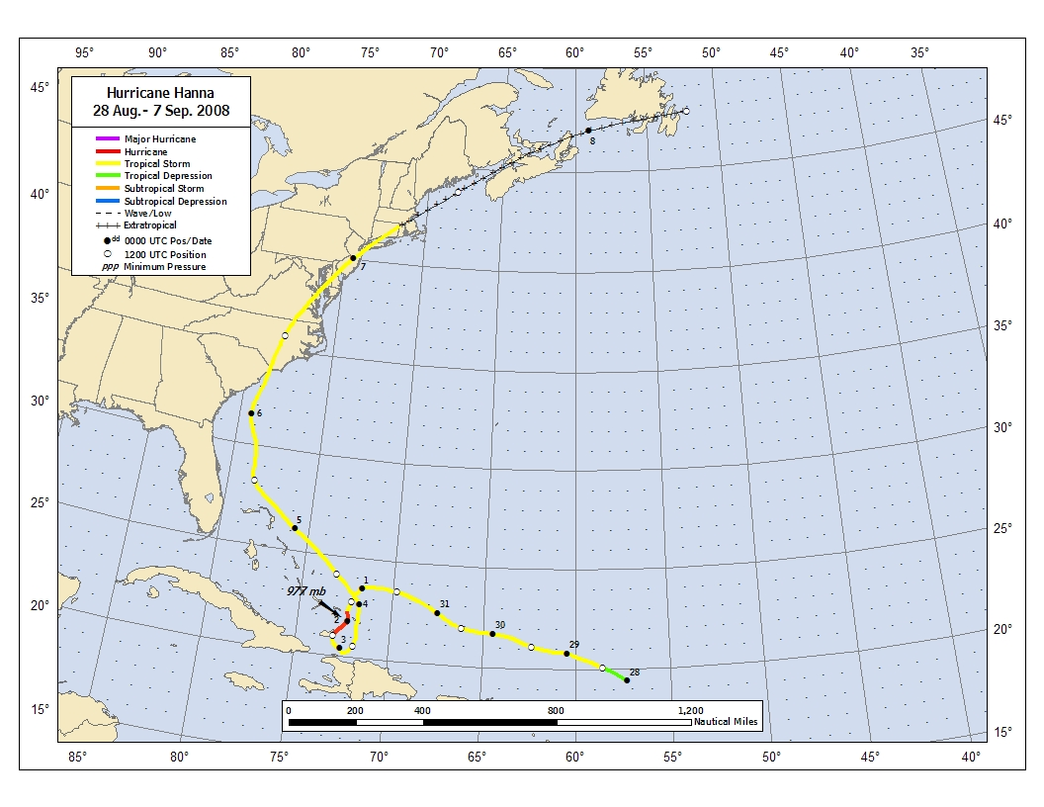
Figure 1. Best track positions for Hurricane Hanna, 28 August-7 September 2008. Track during the extratropical stage is based partially on analyses from the NOAA Ocean Prediction Center and the Canadian Hurricane Center.

Figure 2. Selected wind observations and best track maximum sustained surface wind speed curve for Hurricane Hanna, 28 August-7 September 2008. Aircraft observations have been adjusted for elevation using 90%, 80%, and 80% reduction factors for observations from 700 mb, 850 mb, and 1500 ft, respectively. Dropwindsonde observations include actual 10 m winds (sfc), as well as surface estimates derived from the mean wind over the lowest 150 m of the wind sounding (LLM), and from the sounding boundary layer mean (MBL). Estimates during the extratropical stage are based on analyses from the Ocean Prediction Center and the Canadian Hurricane Center. Dashed vertical lines correspond to 0000 UTC. Thin solid vertical lines denote landfalls.

Figure 3. Selected pressure observations and best track minimum central pressure curve for Hurricane Hanna, 28 August-7 September 2008. Estimates during the extratropical stage are based on analyses from the Ocean Prediction Center and the Canadian Hurricane Center. Dashed vertical lines correspond to 0000 UTC. Thin vertical lines denote landfalls.
a) b)
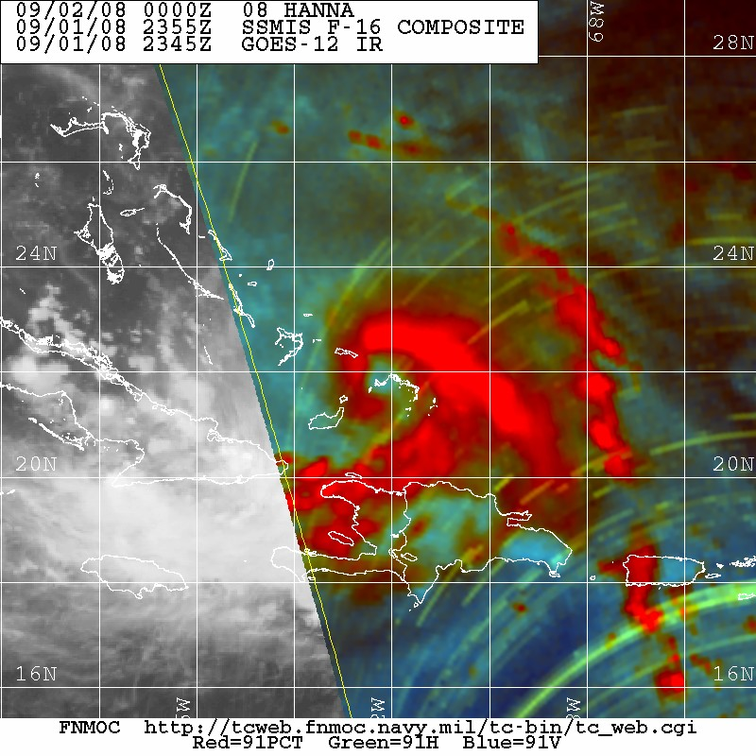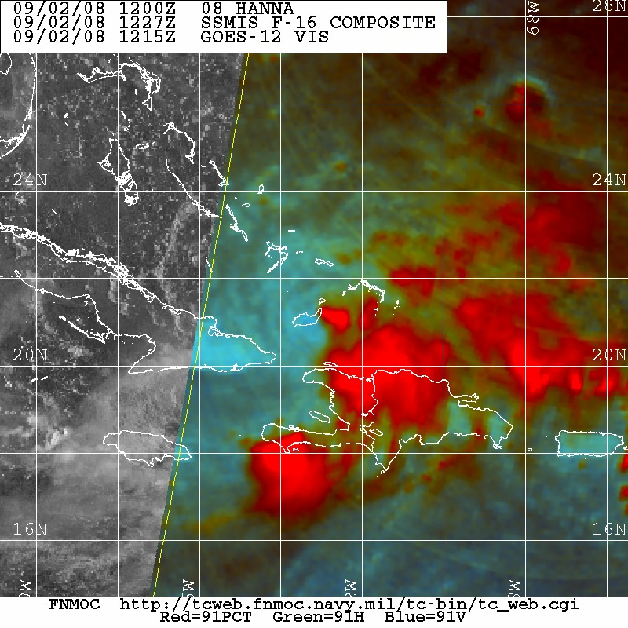

Figure 4. Composite 91 GHz passive microwave images showing Hanna near peak intensity (a) and 12 h later (b). Note the banding eye-feature seen in the first image and how the convection is displaced to the south and east of the low-level center (located near Great Inagua Island in the southeastern Bahamas) just 12 h later. Images courtesy of the Fleet Numerical Meteorology and Oceanography Center (FNMOC).

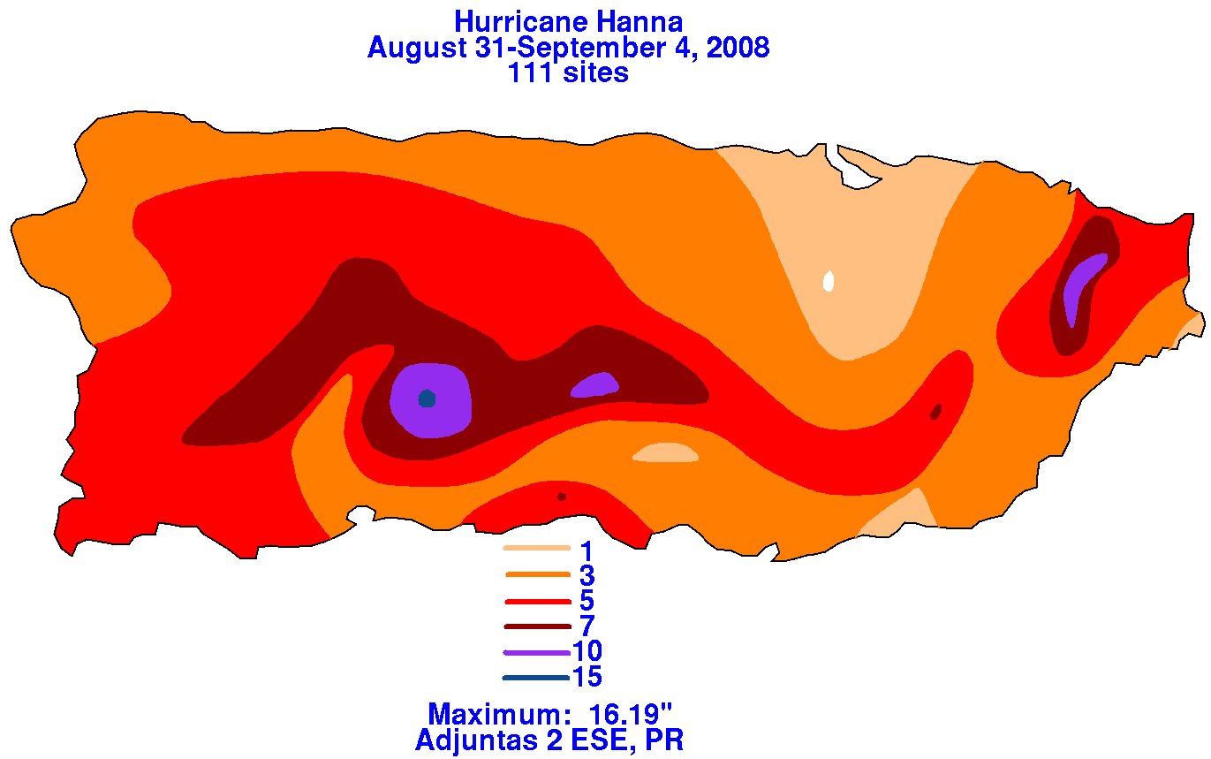

Figure 5. Rainfall associated with Hanna over Puerto Rico. Image courtesy of the Hydrometeorological Prediction Center.

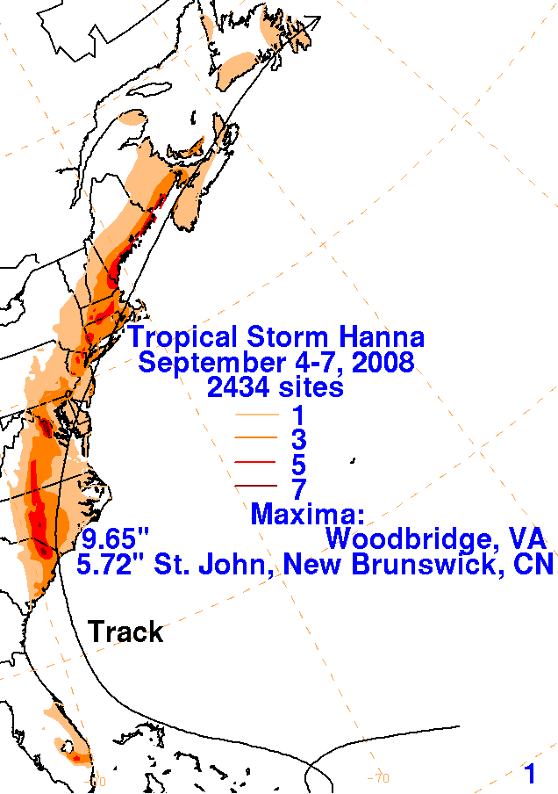

Figure 6. Rainfall associated with Hanna over the eastern United States and southeastern Canada. Image courtesy of the Hydrometeorological Prediction Center.

a. official NHC forecasts (OFCL) d. EMXI and EMX2

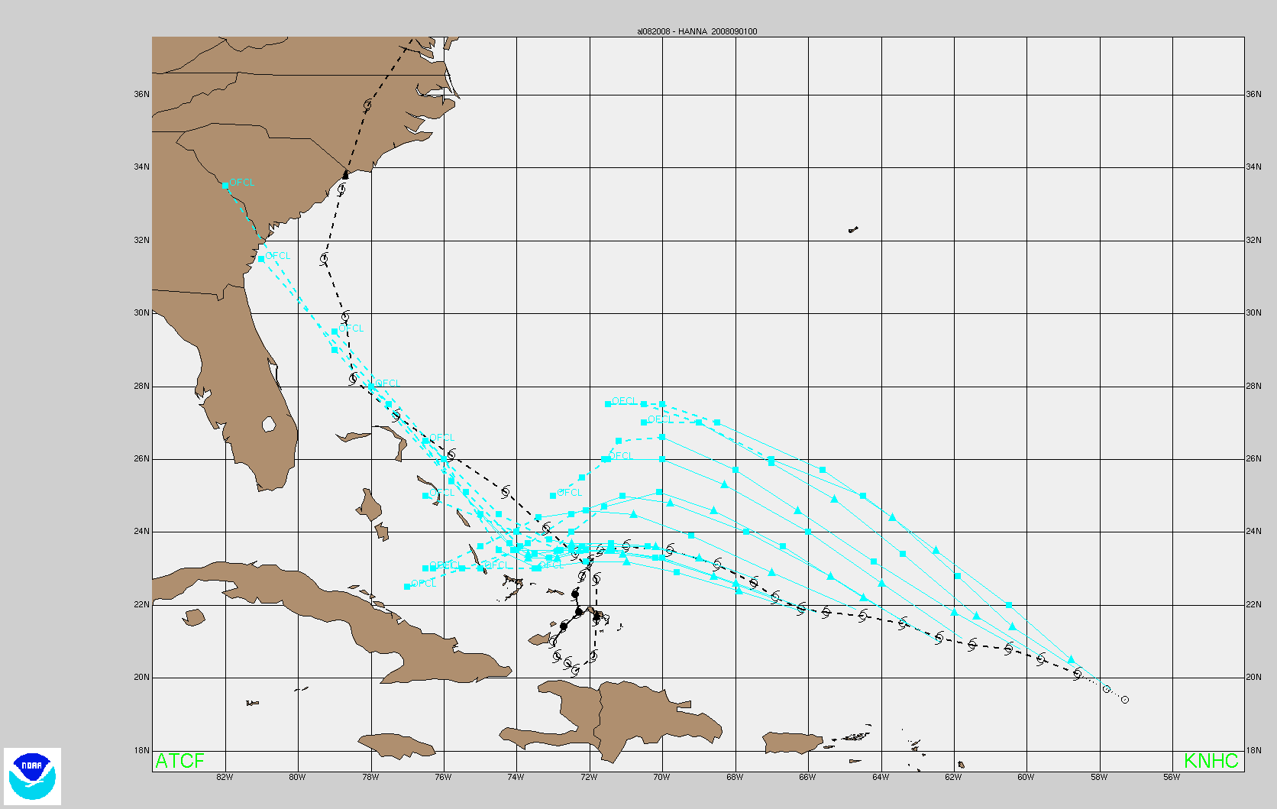
b. HWFI
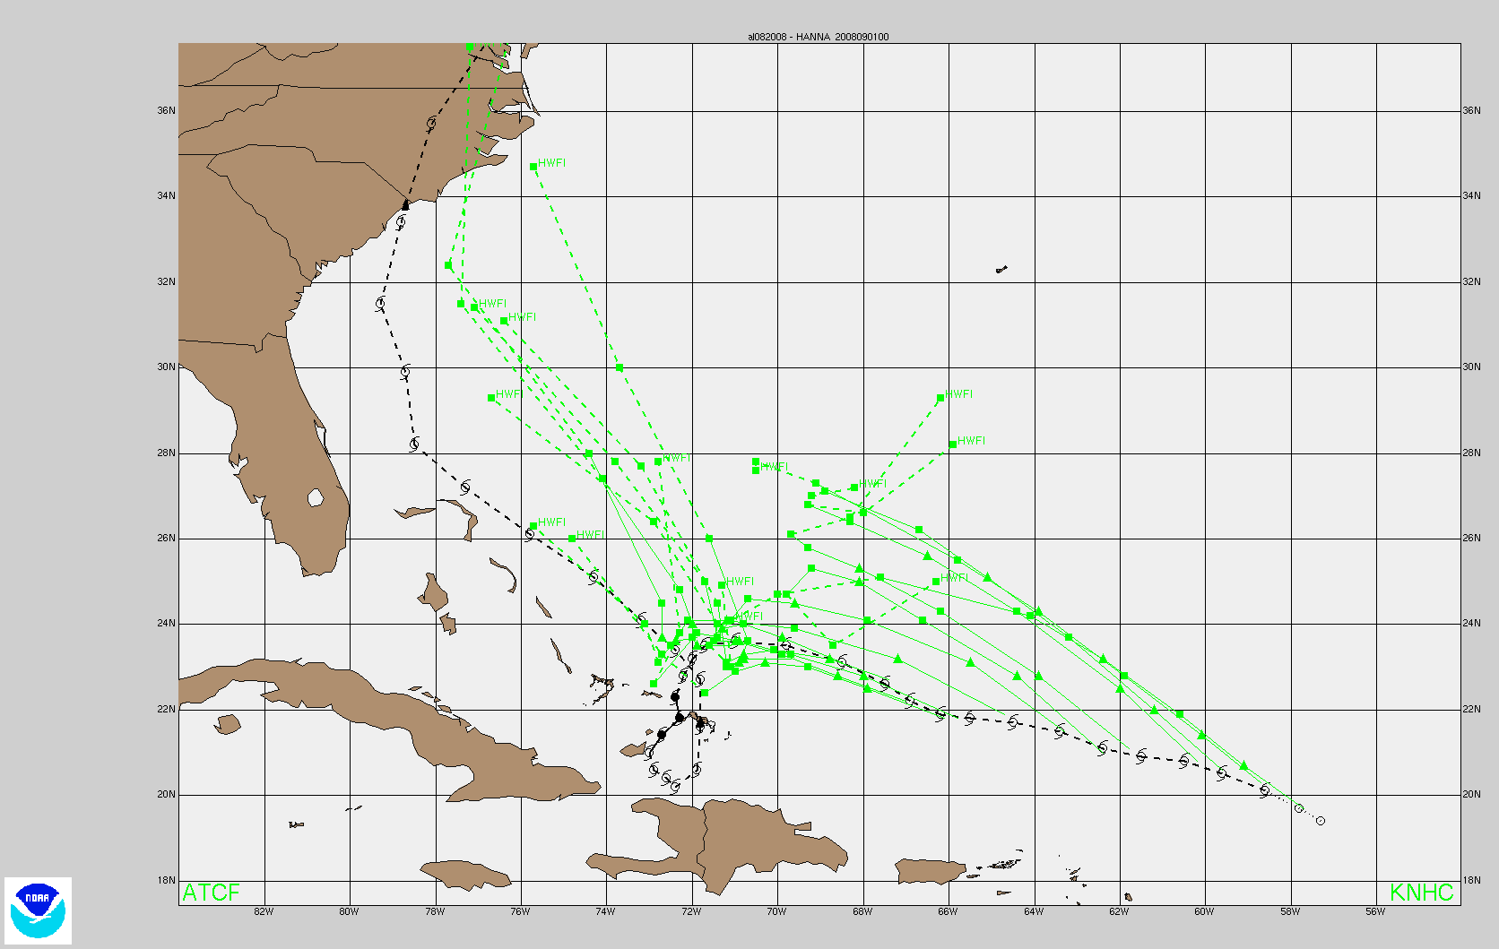
c. GFDI
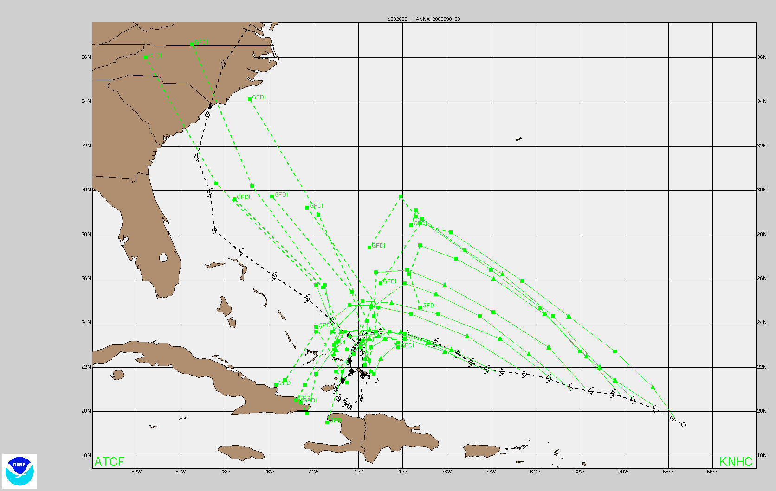
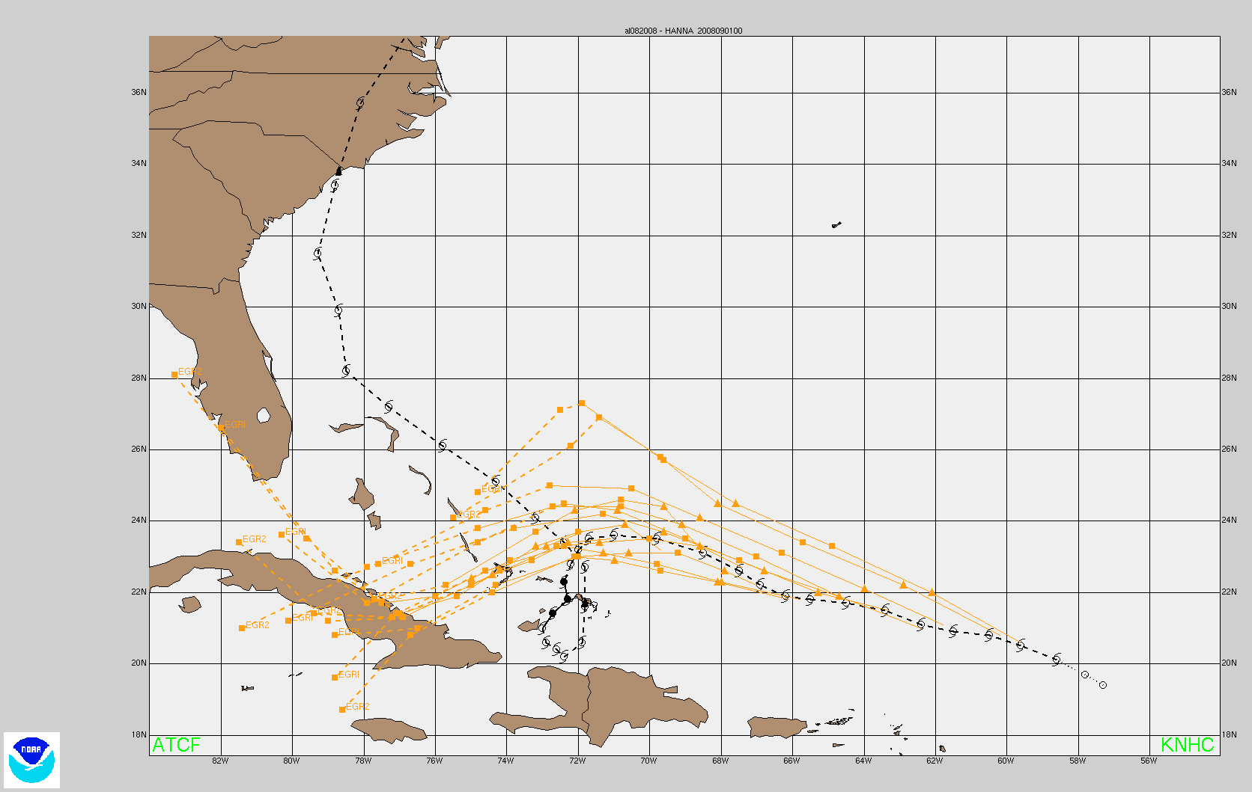
e. GFSI
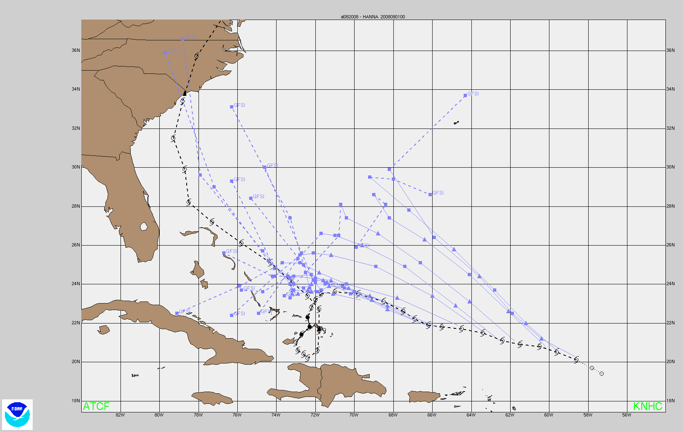
f. UKMI and UKM2

Figure 7. Official NHC and model track forecasts from 0600 UTC 28 August to 0000 UTC 1 September. Note that neither the NHC official forecasts (OFCL) nor any of the individual track models predicted Hanna’s cyclonic loop that occurred on 2-3 September. The GFDI model (c), however, did predict a more southward turn toward eastern Cuba or the Windward Passage than the remainder of the guidance forecast.

A digital record of the complete best track, including wind radii, can be found on line at ftp://ftp.nhc.noaa.gov/atcf. Data for the current year’s storms are located in the btk directory, while previous years’ data are located in the archive directory.

