Tropical Cyclone Report
Tropical Storm Josephine
(AL102008)
2-6 September 2008

Eric S. Blake
National Hurricane Center
5 December 2008

Josephine formed in the far eastern Atlantic Ocean and dissipated just a few days later over open waters due to strong vertical wind shear.

- Synoptic History

A strong tropical wave with an associated surface low left the west coast of Africa late on 31 August. Convection associated with the low was already starting to become organized on 1 September, with well-defined upper-level outflow, and a tropical depression formed by 0000 UTC 2 September, centered about 275 n mi south-southeast of Sal in the Cape Verde Islands. The system became a tropical storm six hours later when a strong burst of convection formed near the center. The “best track” chart of the tropical cyclone’s path is given in Fig. 1, with the wind and pressure histories shown in Figs. 2 and 3, respectively. The best track positions and intensities are listed in Table 1.

Josephine generally moved on a heading between west and west-northwest at about 10 kt due to mid-tropospheric ridging to the north of the tropical cyclone. The cyclone continued to strengthen on 2 September, reaching a peak intensity of 55 kt on 3 September. However, an upper-level trough between Josephine and Hurricane Ike caused vertical wind shear to increase late on 3 September, and Josephine began to weaken. This trough was stronger than average for early September, perhaps aided by upper-level outflow from intensifying Ike to the west. Deep convection associated with Josephine sputtered during the next couple of days as the tropical cyclone encountered slightly cooler waters and more stable air, while the shear remained strong. The system briefly moved northwestward on 5 September and slowed its forward motion. After a flare-up of convection overnight, thunderstorms diminished during the day, and Josephine weakened to a tropical depression early on 6 September, about 725 n mi west of Sal. Six hours later, absent of deep convection, the system had degenerated into a remnant low. The low turned toward the west and accelerated, briefly producing some convection on 7 September. The thunderstorms soon dissipated, and only a weak low-level swirl remained by late in the day. The low moved westward for a couple of days, sped up and turned southwestward on 9 September. Satellite images suggest that the low dissipated early on 10 September, about 450 n mi east of Guadeloupe.

- Meteorological Statistics

Observations in Josephine (Figs. 2 and 3) include satellite-based Dvorak technique intensity estimates from the Tropical Analysis and Forecast Branch (TAFB) and the Satellite Analysis Branch (SAB). Microwave satellite imagery from NOAA polar-orbiting satellites, the NASA Tropical Rainfall Measuring Mission (TRMM), the NASA QuikSCAT, and Defense Meteorological Satellite Program (DMSP) satellites, among others, were also useful in tracking the storm. The peak intensity of 55 kt is based on satellite estimates from TAFB and QuikSCAT. The ship PFC William B. Baugh, call sign KRPW, reported 35 kt winds at 1800 UTC 3 September, and was the only tropical storm force wind report received for this storm.

- Casualty and Damage Statistics

There were no reports of damage or deaths related to Josephine.

- Forecast and Warning Critique

The genesis forecasts for Josephine were relatively good. Almost immediately after the wave that spawned Josephine left Africa, it was included in the Tropical Weather Outlooks, and judged to have either a medium or high likelihood of developing within 48 hours. An explicit mention of tropical depression formation was included 12 hours before genesis.

The average official track errors for Josephine were 35, 78, 131, 199 and 307 n mi for the 12, 24, 36, 48, 72 h forecasts, respectively. The number of forecasts ranged from 14 at 12 h to 4 at 72 h. These forecast errors were considerably higher the five-year average official track errors (Table 2) beyond 12 h. The European Center (EMXI) model and the NOGAPS (NGPI) had particularly low errors for Josephine—much lower than the official forecast. This appears to be due to the NHC forecast tending to follow the Global Forecast System (GFS)-based guidance, including the GFDL, HWRF and the BAMS models, which had a poor track performance during this storm with a marked westward bias.

Average official intensity errors were 4, 6, 12, 11, and 21 kt for the 12, 24, 36, 48, 72 h forecasts, respectively. These errors are lower than the long-term averages (Table 3), except at 72 h. However, the official forecasts had a high bias, and the tropical cyclone dissipated much earlier than anticipated. Most statistical guidance had reasonably good forecasts for this system. The HWRF model had particularly skillful intensity forecasts for Josephine, while the GFDL had much higher errors than the official forecast and a large high bias.

Table 1. Best track for Tropical Storm Josephine, 2-6 September 2008.

Date/Time  (UTC) | Latitude  (°N) | Longitude  (°W) | Pressure  (mb) | Wind Speed  (kt) | Stage
02 / 0000 | 12.3 | 21.9 | 1007 | 30 | tropical depression
02 / 0600 | 12.7 | 23.2 | 1005 | 35 | tropical storm
02 / 1200 | 13.0 | 24.2 | 1005 | 35 | "
02 / 1800 | 13.3 | 25.3 | 1000 | 45 | "
03 / 0000 | 13.5 | 26.3 | 997 | 50 | "
03 / 0600 | 13.6 | 27.2 | 994 | 55 | "
03 / 1200 | 13.7 | 28.2 | 994 | 55 | "
03 / 1800 | 13.8 | 29.2 | 994 | 55 | "
04 / 0000 | 13.9 | 30.0 | 997 | 50 | "
04 / 0600 | 14.1 | 30.9 | 997 | 50 | "
04 / 1200 | 14.4 | 31.9 | 1000 | 45 | "
04 / 1800 | 14.6 | 32.7 | 1002 | 40 | "
05 / 0000 | 15.0 | 33.4 | 1002 | 40 | "
05 / 0600 | 15.4 | 34.0 | 1002 | 40 | "
05 / 1200 | 15.6 | 34.5 | 1003 | 40 | "
05 / 1800 | 15.8 | 34.9 | 1004 | 35 | "
06 / 0000 | 16.2 | 35.5 | 1006 | 30 | tropical depression
06 / 0600 | 16.5 | 36.4 | 1006 | 30 | remnant low
06 / 1200 | 16.7 | 37.3 | 1007 | 25 | "
06 / 1800 | 16.8 | 38.3 | 1007 | 25 | "
07 / 0000 | 16.9 | 39.2 | 1007 | 25 | "
07 / 0600 | 17.0 | 40.1 | 1007 | 30 | "
07 / 1200 | 17.1 | 40.9 | 1007 | 30 | "
07 / 1800 | 17.2 | 41.6 | 1007 | 25 | "
08 / 0000 | 17.3 | 42.4 | 1007 | 25 | "
08 / 0600 | 17.5 | 43.3 | 1007 | 25 | "
08 / 1200 | 18.0 | 44.2 | 1009 | 25 | "
08 / 1800 | 18.1 | 45.6 | 1010 | 25 | "
09 / 0000 | 17.8 | 47.3 | 1010 | 25 | "
09 / 0600 | 16.8 | 49.3 | 1010 | 25 | "
09 / 1200 | 16.3 | 51.4 | 1010 | 25 | "
09 / 1800 | 16.3 | 52.5 | 1010 | 25 | "
10 / 0000 | 16.3 | 53.6 | 1011 | 20 | "
10 / 0600 |  |  |  |  | dissipated
03 / 0600 | 13.6 | 27.2 | 994 | 55 | minimum pressure

Table 2. Track forecast evaluation (heterogeneous sample) for Tropical Storm Josephine, 2-6 September 2008. Forecast errors (n mi) are followed by the number of forecasts in parentheses. Errors smaller than the NHC official forecast are shown in boldface type.

Forecast Technique | Forecast Period (h)
Forecast Technique | 12 | 24 | 36 | 48 | 72 | 96 | 120
CLP5 | 35 (15) | 67 (13) | 103 (11) | 155 ( 9) | 282 ( 5) | 403 ( 1)
GFNI | 28 ( 8) | 42 ( 6) | 55 ( 4) | 108 ( 2)
GFDI | 40 (15) | 91 (13) | 153 (11) | 226 ( 9) | 321 ( 5) | 349 ( 1)
HWFI | 39 (15) | 84 (13) | 146 (11) | 222 ( 9) | 318 ( 5) | 350 ( 1)
GFSI | 65 (15) | 126 (13) | 185 (11) | 253 ( 9) | 321 ( 5) | 384 ( 1)
AEMI | 77 (15) | 145 (13) | 222 (11) | 309 ( 9) | 424 ( 5) | 534 ( 1)
NGPI | 23 (12) | 29 (10) | 35 ( 8) | 56 ( 6) | 76 ( 3) | 129 ( 1)
EGRI | 42 (12) | 84 (10) | 137 ( 8) | 189 ( 6) | 385 ( 2)
EMXI | 17 (13) | 23 (11) | 30 ( 9) | 58 ( 7) | 83 ( 3) | 27 ( 1)
BAMD | 56 (15) | 116 (13) | 203 (11) | 304 ( 9) | 438 ( 5) | 576 ( 1)
BAMM | 56 (15) | 117 (13) | 194 (11) | 283 ( 9) | 389 ( 5) | 413 ( 1)
BAMS | 78 (14) | 175 (12) | 291 (10) | 425 ( 8) | 533 ( 5) | 388 ( 1)
LBAR | 37 (14) | 82 (12) | 136 (10) | 205 ( 8) | 326 ( 5) | 462 ( 1)
TVCN | 30 (15) | 59 (13) | 94 (11) | 150 ( 9) | 241 ( 5) | 236 ( 1)
TVCC | 29 (15) | 55 (13) | 86 (11) | 135 ( 9) | 224 ( 5) | 216 ( 1)
GUNA | 32 ( 9) | 59 ( 7) | 94 ( 5) | 175 ( 3)
FSSE | 32 (13) | 74 (11) | 135 ( 9) | 214 ( 7) | 357 ( 3)
OFCL | 35 (14) | 78 (12) | 131 (10) | 199 ( 8) | 307 ( 4)
NHC Official  (2003-2007 mean) | 34.0 (1742) | 58.2 (1574) | 82.2 (1407) | 106.2 (1254) | 154.2 (996) | 207.5 (787) | 272.5 (627)

Table 3. Intensity forecast evaluation (heterogeneous sample) for Tropical Storm Josephine, 2-6 September 2008. Forecast errors (kt) are followed by the number of forecasts in parentheses. Errors smaller than the NHC official forecast are shown in boldface type.

Forecast Technique | Forecast Period (h)
Forecast Technique | 12 | 24 | 36 | 48 | 72 | 96 | 120
OCD5 | 7.1 (15) | 9.9 (13) | 14.9 (11) | 17.6 ( 9) | 22.2 ( 5) | 31.0 ( 1)
GHMI | 5.1 (15) | 7.2 (13) | 15.4 (11) | 17.4 ( 9) | 33.2 ( 5) | 30.0 ( 1)
HWFI | 4.6 (15) | 5.4 (13) | 6.5 (11) | 7.8 ( 9) | 9.4 ( 5) | 0.0 ( 1)
LGEM | 6.4 (15) | 8.2 (13) | 10.9 (11) | 9.3 ( 9) | 8.6 ( 5) | 1.0 ( 1)
DSHP | 5.4 (15) | 6.5 (13) | 11.1 (11) | 13.8 ( 9) | 20.8 ( 5) | 18.0 ( 1)
FSSE | 5.0 (13) | 7.2 (11) | 13.1 ( 9) | 16.6 ( 7) | 31.0 ( 3)
ICON | 5.1 (15) | 5.2 (13) | 8.5 (11) | 8.6 ( 9) | 14.4 ( 5) | 12.0 ( 1)
OFCL | 3.9 (14) | 6.3 (12) | 11.5 (10) | 11.3 ( 8) | 21.3 ( 4)
NHC Official  (2003-2007 mean) | 6.7 (1742) | 10.0 (1574) | 12.3 (1407) | 14.3  (1254) | 18.2 (996) | 19.7 (787) | 21.8 (627)

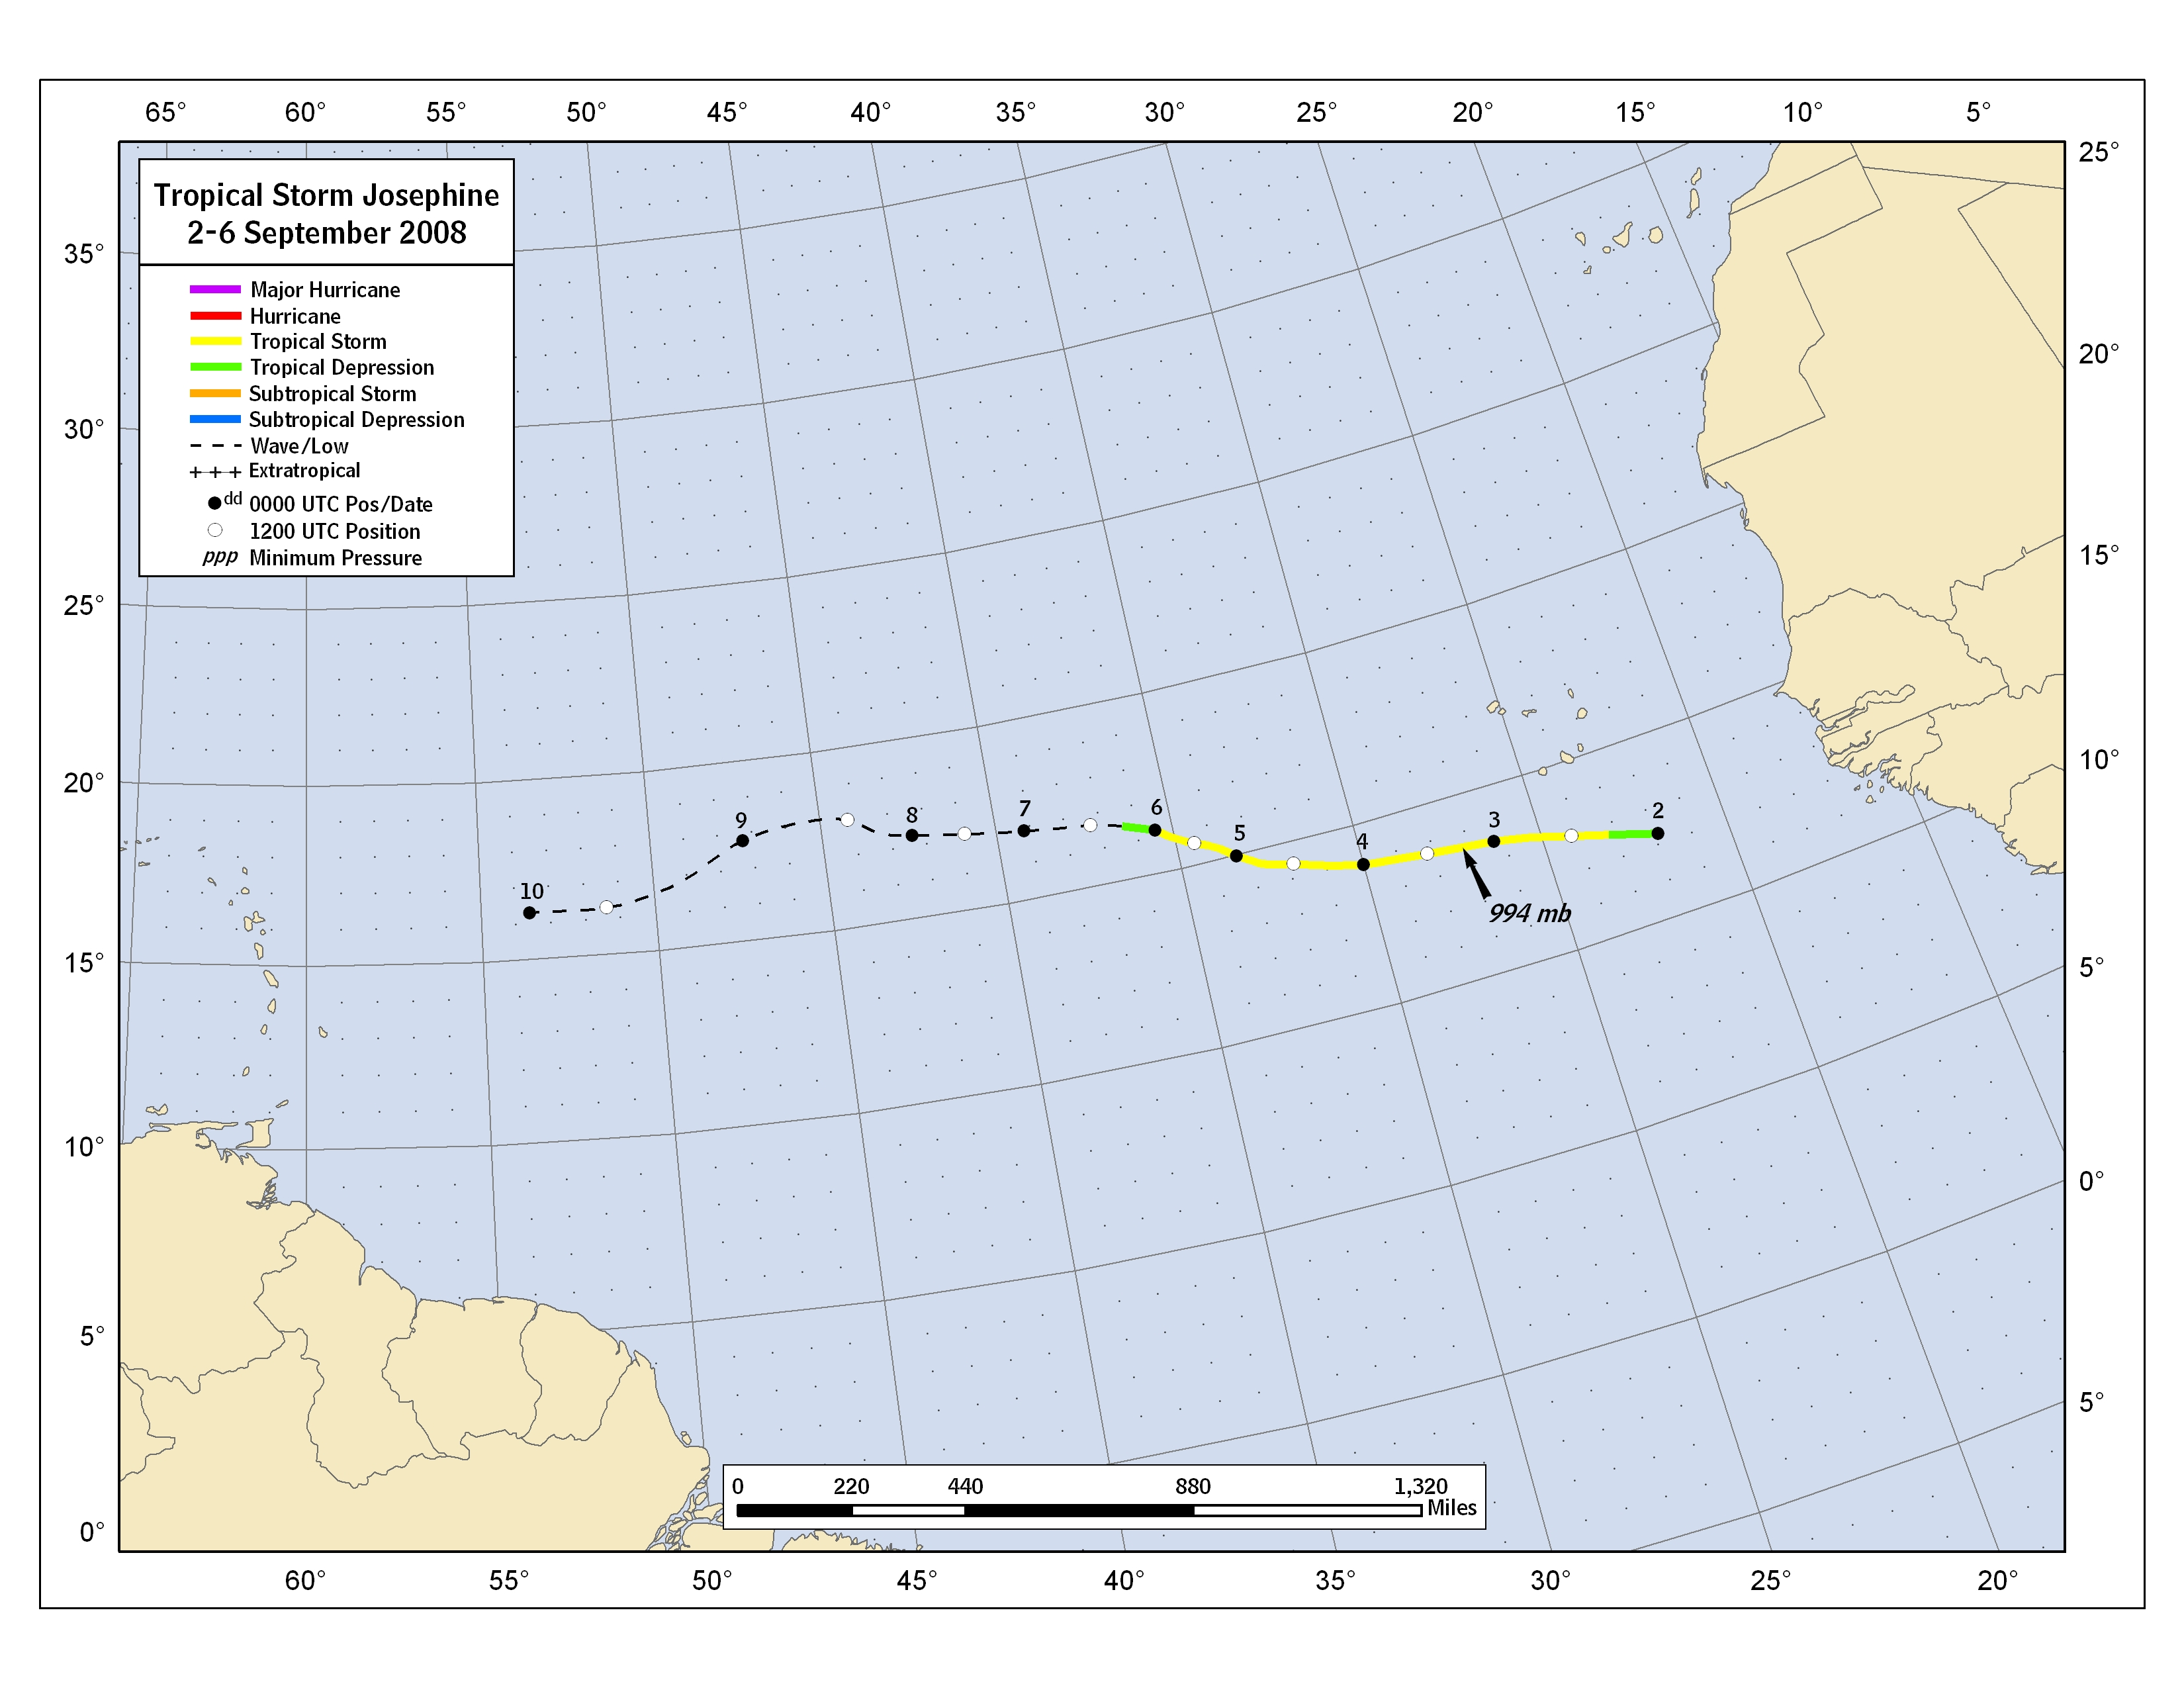

Figure 1. Best track positions for Tropical Storm Josephine, 2-6 September 2008.
Figure 2. Selected wind observations and best track maximum sustained surface wind speed curve for Tropical Storm Josephine, 2-6 September 2008.

Figure 3. Selected pressure observations and best track minimum central pressure curve for Tropical Storm Josephine, 2-6 September 2008.

A digital record of the complete best track, including wind radii, can be found on line at ftp://ftp.nhc.noaa.gov/atcf. Data for the current year’s storms are located in the btk directory, while previous years’ data are located in the archive directory.

