Tropical Cyclone Report
Hurricane Kyle
(AL11008)
25-29 September 2008

Lixion A. Avila
National Hurricane Center
5 December 2008

Kyle was a category one hurricane on the Saffir-Simpson Hurricane Scale that made landfall in southwestern Nova Scotia.

- Synoptic History

The development of Kyle was associated with a tropical wave that moved off the coast of Africa with some convective organization on 12 September. There was a weak low pressure area associated with the wave and the system moved westward and west-southwestward for a few days. As the tropical wave was approaching the Lesser Antilles, it began to interact with a strong upper-level trough over the eastern Caribbean Sea, resulting in an increase in cloudiness and thunderstorms. The surface area of low pressure became better defined as it crossed the Windward Islands and began to develop a larger surface circulation on 19 September. The low pressure area turned toward the northwest and became separated from the wave, which continued its westward track across the Caribbean Sea. The upper-level trough moved westward and weakened, causing small relaxation of westerly shear and allowing the convection associated with the low to become a little more concentrated. The low was near Puerto Rico on 21 September, and continued drifting northwestward. It then spent two days crossing Hispaniola, producing disorganized thunderstorms and a large area of squalls within a convective band over the adjacent Caribbean Sea. During this period, the system lacked a well-defined circulation center as indicated by reconnaissance and local surface data.

The low moved northeastward away from Hispaniola, and finally developed a well-defined surface circulation center. It is estimated that a tropical depression formed at 0000 UTC 25 September about 100 n mi north of the Dominican Republic. Westerly wind shear kept the center to the west of the convection, but as the shear relaxed further, convective bands began to wrap around the center and the system became a tropical storm at 0600 UTC 25 September.

Kyle then moved on a northward track and gradually intensified, becoming a hurricane at 1200 UTC 27 September about 300 n mi west of Bermuda. Kyle continued moving between north and north-northeastward and reached its peak intensity of 75 knots with a central pressure of 989 mb at 1200 UTC 28 September. Thereafter, the cyclone began to lose tropical characteristics as the convection started to become elongated and asymmetric, but it made landfall as a 65-kt hurricane on the western tip of Nova Scotia just north of Yarmouth at 0000 UTC 29 September. Kyle continued rapidly northward and northeastward, developed a frontal structure and became fully extratropical. It was absorbed by a large extratropical low at 1800 UTC 30 September.

The “best track” chart of the tropical cyclone’s path is given in Fig. 1, with the wind and pressure histories shown in Figs. 2 and 3, respectively. The best track positions and intensities are listed in Table 1.

- Meteorological Statistics

Observations in Kyle (Figs. 2 and 3) include satellite-based Dvorak technique intensity estimates from the Tropical Analysis and Forecast Branch (TAFB) and the Satellite Analysis Branch (SAB), as well as flight-level, stepped frequency microwave radiometer (SFMR), and dropwindsonde observations from flights of the 53rd Weather Reconnaissance Squadron of the U. S. Air Force Reserve Command and NOAA P3 reconnaissance missions. Data and imagery from NOAA polar-orbiting satellites, the NASA Tropical Rainfall Measuring Mission (TRMM), the NASA QuikSCAT, and Defense Meteorological Satellite Program (DMSP) satellites, among others, were also useful in tracking Kyle. Post-analysis of data from a NOAA P3 genesis research mission indicate that by 0000 UTC 25 September the circulation was well-defined enough to classify the system as a tropical depression as indicated in the final best track. However, operational Dvorak classifications did not support tropical depression status at that time.

Ship reports of winds of tropical storm force associated with Kyle are given in Table 2, and selected surface observations from land stations and data buoys are given in Table 3. The ship with call sign HPYE located about 100 n mi south of the developing center of Kyle reported winds of 40 knots at 1000 UTC 25 September. This observation was crucial in determining that Kyle had become a tropical storm by that time. The peak intensity of 75 knots was estimated from data from a dropsonde launched from a reconnaissance aircraft. The estimate of 984 mb minimum pressure of Kyle occurred a little bit after the hurricane reached its peak intensity. The minimum pressure was based on the 44011 NOAA buoy, which reported 987.1 mb and winds of 31 knots as the center of Kyle moved nearby. However, although Kyle’s pressure was still falling, the winds were already decreasing. This has been observed in past systems as they transition to an extratropical low.

- Casualty and Damage Statistics

The low pressure that preceded Kyle produced torrential rains (up to 30 inches) and numerous flash floods and mud slides in Puerto Rico resulting in six deaths. Winds from Kyle caused minor damage over Nova Scotia primarily in the form of some uprooted trees and broken limbs resulting in power outages. Storm surge and waves produced minor street flooding in Shelburne as well.

- Forecast and Warning Critique

A description of the weather system from which Kyle originated was included in Tropical Weather Outlook (TWO) products beginning at 1200 UTC 18 September. The possibility of tropical cyclone formation was then included in the TWO issued at 1800 UTC 20 September. This was well in advance about five days prior to genesis. The experimental genesis forecast probability reached the high category (> 50%) at 1200 UTC 21 September but the cyclone did not form within the subsequent 48 hours. In fact, the probabilities decreased to the medium category (20 to 50 %) at 1800 UTC 22 September, but then again increased to the high category at 1200 UTC 23 September, about 36 hours before formation. Advisories were initiated 18 hours after the time of formation estimated in the post-analysis.

A verification of official and guidance model track forecasts is given in Table 4. Average official track errors for Kyle were 32, 44 59, 73, and 68 n mi for the 12, 24, 36, and 72 h forecasts, respectively. The number of forecasts ranged from 12 at 12 h to 2 at 72 h. These errors are lower than the average long-term official track errors (Table 4). Also note in Table 4 that both the European (EMXI) and Geophysical Fluid Dynamic (GFDI) models performed extremely well and their track errors were lower than the average official track errors at most of the time periods.

Average official intensity errors were 4, 4, 3, 3 and 5 kt for the 12, 24, 36, 48 and 72 h forecasts, respectively. For comparison, the average long-term official intensity errors are 7, 10, 12, 14, and 18 kt, respectively. Note that the average official intensity errors are lower than the intensity guidance errors at all forecast times (Table 5).

Watches and warnings associated with Hurricane Kyle are given in Table 5. Given the uncertainty in the forecast track and wind radii, watches and warnings were issued for a portion of the northeast coast of the United States. However, Kyle turned toward the north-northeast with most of the associated weather located north and east of the center. There were no reports of significant weather associated with Kyle along the U.S. northeast coast.
Table 1. Best track for Hurricane Kyle, 25-29 September 2008.
Date/Time  (UTC) | Latitude  (°N) | Longitude  (°W) | Pressure  (mb) | Wind Speed  (kt) | Stage
25 / 0000 | 21.5 | 70.0 | 1005 | 30 | tropical depression
25 / 0600 | 22.0 | 69.4 | 1003 | 35 | tropical storm
25 / 1200 | 22.4 | 68.7 | 1002 | 40 | "
25 / 1800 | 23.1 | 68.4 | 1001 | 40 | "
26 / 0000 | 24.0 | 68.0 | 998 | 45 | "
26 / 0600 | 25.0 | 68.2 | 996 | 50 | "
26 / 1200 | 26.0 | 68.6 | 998 | 50 | "
26 / 1800 | 26.9 | 68.6 | 1000 | 50 | "
27 / 0000 | 28.7 | 68.6 | 998 | 55 | "
27 / 0600 | 29.9 | 69.3 | 996 | 60 | "
27 / 1200 | 31.2 | 69.5 | 996 | 65 | hurricane
27 / 1800 | 33.3 | 69.7 | 995 | 70 | "
28 / 0000 | 35.3 | 69.7 | 995 | 70 | "
28 / 0600 | 37.4 | 69.3 | 992 | 70 | "
28 / 1200 | 39.4 | 68.2 | 989 | 75 | "
28 / 1800 | 41.6 | 66.7 | 984 | 70 | "
29 / 0000 | 43.8 | 66.2 | 985 | 65 | "
29 / 0600 | 45.6 | 65.0 | 990 | 50 | extratropical
29 / 1200 | 47.7 | 63.5 | 994 | 45 | "
29 / 1800 | 48.2 | 62.6 | 999 | 40 | "
30 / 0000 | 48.4 | 61.5 | 1002 | 35 | "
30 / 0600 | 48.2 | 61.0 | 1004 | 30 | "
30 / 1200 | 48.1 | 60.8 | 1005 | 25 | "
30 / 1800 |  |  |  |  | absorbed
28 / 1800 | 41.6 | 66.7 | 984 | 70 | minimum pressure
28 / 1200 | 39.4 | 68.2 | 989 | 75 | maximum intensity
29 / 0000 | 43.8 | 66.2 | 985 | 65 | landfall near Yarmouth, NS

Table 2. Selected ship reports with winds of at least 34 kt for Hurricane Kyle, 25-29 September 2008.

Date/Time (UTC) | Ship call sign | Latitude  (°N) | Longitude  (°W) | Wind  dir/speed (kt) | Pressure  (mb)
25 / 1000 | HPYE | 20.3 | 68.1 | 190 / 40 | 1002.0
25 / 1800 | KS049 | 21.9 | 67.3 | 240 / 39
25 / 1900 | H3VS | 24.9 | 67.3 | 180 / 40 | 1007.0
26 / 0000 | P3GY9 | 25.0 | 66.6 | 090 / 35 | 1011.0
26 / 0500 | MKYJ8 | 25.3 | 68.5 | 050 / 45 | 1006.7
26 / 0600 | P3GY9 | 25.8 | 65.7 | 100 / 35 | 1013.0
26 / 0900 | MKYJ8 | 25.1 | 67.8 | 180 / 48 | 1004.3
26 / 1500 | MKYJ8 | 25.7 | 66.2 | 160 / 40 | 1013.3
26 / 1800 | MKYJ8 | 26.2 | 65.4 | 140 / 47 | 1014.5
26 / 2100 | MKYJ8 | 26.4 | 64.6 | 140 / 35 | 1015.6
28 / 2100 | CGUM | 42.9 | 63.5 | 150 / 37 | 1008.8
28 / 2100 | ZCBU3 | 43.9 | 62.1 | 150 / 40 | 1017.0
29 / 0000 | ZCBU3 | 43.6 | 61.3 | 150 / 37 | 1017.8
29 / 0600 | VAAP | 44.9 | 61.4 | 160 / 37 | 1006.9
29 / 1800 | VOCZ | 47.1 | 59.5 | 140 / 35 | 1010.7

Table 3. Selected surface observations for Hurricane Kyle, 25-29 September 2008.
Location | Minimum Sea Level Pressure |  | Maximum Surface  Wind Speed |  |  | Storm surge  (ft)^{c} | Storm  tide  (ft)^{d} | Total  rain  (in)
Location | Date/  time  (UTC) | Press.  (mb) | Date/  time  (UTC)ª | Sustained  (kt)^{b} | Gust  (kt) | Storm surge  (ft)^{c} | Storm  tide  (ft)^{d} | Total  rain  (in)
Canada ( provided by Environmental Canada)
Yarmouth, NS | 29/0000 | 988.1 | 28/2200 | 26 | 38 | 1.7 |  | 1.69
Baccaro Point, NS | 22/2246 | 992.1 | 28/2146 | 52 | 67
Brier Island, NS | 29/0100 | 993.9 | 29/0400 | 33 | 40
Western Head, NS | 29/0200 | 997.0 | 29/0300 | 37 | 55
Lunenburg, NS | 29/0400 | 998.1 | 28/2300 | 35 | 44
McNabs Island, NS | 29/0500 | 1001.5 | 29/0400 | 45 | 55
Halifax Dockyard, NS |  |  | 29/0030 | 34
Osborne Head, NS |  |  | 29/0600 | 35 | 47
Grand Etang, NS | 29/1100 | 1005.0 | 29/0500 | 36 | 56
Halifax, NS |  |  |  |  |  | 1.3
Dartmouth, NS |  |  |  |  |  | 1.5
North Cape, PE | 29/1000 | 997.3 | 29/0700 | 34 | 45 |  |  | 0.97
Wreckhouse, NF |  |  | 29/1800 | 49 | 50
Bon Accord, NB |  |  |  |  |  |  |  | 2.82
Havre-Saint-Pierre, QU |  |  |  |  |  |  |  | 2.76
Buoys/C-MAN
41011 Georges Bank, MA  41.1° N 66.6°W | 28/1450 | 994.6 | 28/1550 | 52 | 72
44024  42.3 0°N 65.9°W | 28/2004 | 991.2 | 28/2004 | 47
44753  32.0°N 69.7°W | 29/0500 | 1017.9 | 29/0500 | 39
41048 west of Bermuda  32.0°N 69.7°W | 27/1321 | 999.1 | 27/1217 | 49 | 55
44753  43.60°N 61.3°W | 27/0500 | 1017.9 | 27/0500 | 39
41027 Jonesport, Maine  44.3° N 67.3°W | 29/0050 | 999.1 | 28/2250 | 33 | 40

ª Date/time is for sustained wind when both sustained and gust are listed.
^{b} Except as noted, sustained wind averaging periods for C-MAN and land-based ASOS reports are 2 min; buoy averaging periods are 8 min; Canada averaging periods are 10 min.
^{c} Storm surge is water height above normal astronomical tide level.
^{d} Storm tide is water height above National Geodetic Vertical Datum (1929 mean sea level).

Table 4. Track forecast evaluation (heterogeneous sample) for Hurricane Kyle, 25-29 September 2008. Forecast errors (n mi) are followed by the number of forecasts in parentheses. Errors smaller than the NHC official forecast are shown in boldface type.
Forecast Technique | Forecast Period (h)
Forecast Technique | 12 | 24 | 36 | 48 | 72 | 96 | 120
CLP5 | 57 (13) | 135 (11) | 261 ( 9) | 378 ( 7) | 610 ( 3)
GFNI | 26 ( 7) | 48 ( 7) | 69 ( 6) | 66 ( 4)
GFDI | 49 (13) | 86 (11) | 143 ( 9) | 211 ( 7) | 337 ( 3)
HWFI | 40 (13) | 67 (11) | 102 ( 9) | 126 ( 7) | 172 ( 3)
GFSI | 44 (13) | 62 (11) | 100 ( 9) | 131 ( 7) | 185 ( 3)
AEMI | 52 (13) | 90 (11) | 140 ( 9) | 207 ( 7) | 257 ( 2)
NGPI | 47 (12) | 70 (10) | 107 ( 8) | 185 ( 6) | 442 ( 2)
UKMI | 44 (10) | 77 ( 8) | 113 ( 6) | 161 ( 4)
EGRI | 44 (10) | 77 ( 8) | 113 ( 6) | 161 ( 4)
EMXI | 28 (10) | 35 ( 9) | 48 ( 7) | 46 ( 5) | 169 ( 1)
BAMD | 40 (13) | 68 (11) | 119 ( 9) | 205 ( 7) | 432 ( 3)
BAMM | 49 (13) | 89 (11) | 132 ( 9) | 204 ( 7) | 399 ( 3)
BAMS | 75 (13) | 125 (11) | 159 ( 9) | 203 ( 7) | 307 ( 3)
LBAR | 44 (13) | 85 (11) | 155 ( 9) | 231 ( 7) | 393 ( 3)
TVCN | 38 (13) | 56 (11) | 85 ( 9) | 112 ( 7) | 184 ( 3)
GUNA | 37 (10) | 49 ( 8) | 66 ( 6) | 73 ( 4)
FSSE | 35 (12) | 51 (10) | 83 ( 8) | 115 ( 6) | 198 ( 2)
OFCL | 32 (12) | 44 (10) | 59 ( 8) | 73 ( 6) | 68 ( 2)
NHC Official  (2003-2007 mean) | 34.0 (1742) | 58.2 (1574) | 82.2 (1407) | 106.2 (1254) | 154.2 (996) | 207.5 (787) | 272.5 (627)

Table 5. Intensity forecast evaluation (heterogeneous sample) for Hurricane Kyle, 25-29 September 2008. Forecast errors (kt) are followed by the number of forecasts in parentheses. Errors smaller than the NHC official forecast are shown in boldface type.

Forecast Technique | Forecast Period (h)
Forecast Technique | 12 | 24 | 36 | 48 | 72 | 96 | 120
OCD5 | 6.3 (15) | 7.9 (13) | 7.3 (11) | 9.1 ( 9) | 15.6 ( 5)
GHMI | 5.3 (15) | 5.1 (13) | 7.7 (11) | 7.2 ( 9) | 25.8 ( 5)
HWFI | 6.8 (15) | 6.3 (13) | 3.5 (11) | 6.6 ( 9) | 23.2 ( 5)
LGEM | 7.9 (15) | 10.8 (13) | 11.2 (11) | 14.9 ( 9) | 23.2 ( 5)
DSHP | 6.7 (15) | 7.0 (13) | 6.1 (11) | 5.7 ( 9) | 9.4 ( 5)
FSSE | 5.5 (12) | 6.2 (10) | 5.3 ( 8) | 6.7 ( 6) | 8.0 ( 2)
ICON | 6.6 (15) | 6.3 (13) | 3.6 (11) | 5.2 ( 9) | 17.2 ( 5)
OFCL | 4.2 (12) | 4.0 (10) | 3.1 ( 8) | 3.3 ( 6) | 5.0 ( 2)
NHC Official  (2003-2007 mean) | 6.7 (1742) | 10.0 (1574) | 12.3 (1407) | 14.3 (1254) | 18.2 (996) | 19.7 (787) | 21.8 (627)

Table 6. Watch and warning summary for Hurricane Kyle, 25-29 September 2008.
Date/Time (UTC) | Action | Location
26 / 0900 | Tropical Storm Watch issued | Bermuda
26 / 1500 | Tropical Storm Watch changed to Tropical Storm Warning | Bermuda
27 / 1500 | Tropical Storm Watch issued | Cape Elizabeth to Stonington, Maine
27 / 1500 | Tropical Storm Watch issued | Queens NS to Digby NS
27 / 1500 | Tropical Storm Watch issued | Charlotte NB to St. John NB
27 / 1500 | Hurricane Watch issued | Stonington to Eastport
27 / 1800 | Tropical Storm Watch modified to | Lunenberg NS to Queens NS
27 / 1800 | Tropical Storm Warning issued | Shelburne NS to Digby NS
27 / 1800 | Hurricane Watch issued | Shelburne NS to Digby NS
27 / 2100 | Tropical Storm Watch modified to | Cape Elizabeth to Port Clyde
27 / 2100 | Tropical Storm Warning discontinued | Bermuda
27 / 2100 | Tropical Storm Warning issued | Port Clyde to Eastport, Maine
28 / 0600 | Tropical Storm Watch changed to Tropical Storm Warning | Charlotte NB to St. John NB
28 / 0600 | Tropical Storm Watch discontinued | Lunenberg NS to Queens NS
28 / 1500 | Tropical Storm Watch discontinued | All
28 / 1500 | Tropical Storm Warning discontinued | Charlotte NB to St. John NB
28 / 1500 | Tropical Storm Warning modified to | Stonington to Eastport
28 / 1800 | Tropical Storm Warning changed to Hurricane Warning | Shelburne NS to Digby NS
28 / 1800 | Hurricane Watch changed to Tropical Storm Warning | Stonington to Eastport
28 / 1800 | Tropical Storm Warning issued | Lunenberg NS to Queens NS
28 / 1800 | Tropical Storm Warning issued | Annapolis NS
28 / 1800 | Tropical Storm Warning issued | Charlotte NB to Westmorland NB
28 / 1800 | Hurricane Watch discontinued | All
29 / 0000 | Tropical Storm Warning discontinued | Stonington to Eastport
29 / 0400 | Tropical Storm Warning discontinued | All
29 / 0400 | Hurricane Warning discontinued | All

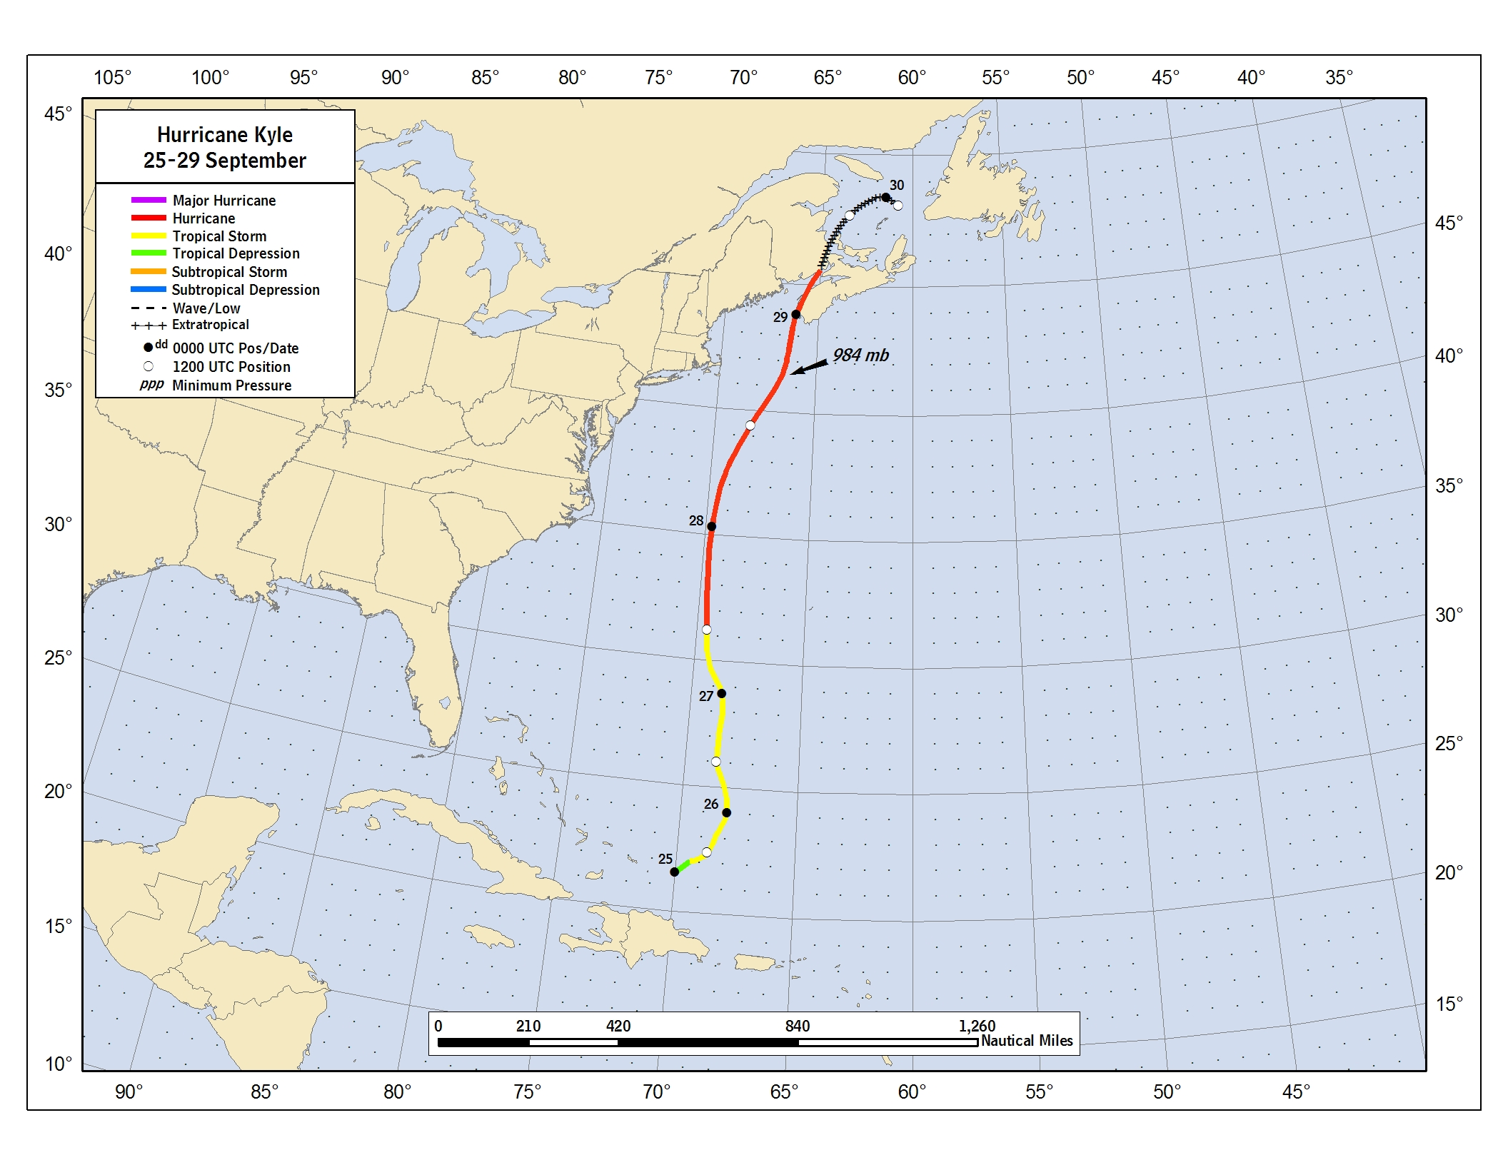

Figure 1. Best track positions for Hurricane Kyle, 25-29 September, 2008. Track during the extratropical stage is based on analyses from the NOAA Ocean Prediction Center.

Figure 2. Selected wind observations and best track maximum sustained surface wind speed curve for Kyle, 25-29 September 2008. Aircraft observations have been adjusted for elevation using 90%, 80%, and 80% reduction factors for observations from 700 mb, 850 mb, and 1500 ft, respectively. Dropwindsonde observations include actual 10 m winds (sfc), as well as surface estimates derived from the mean wind over the lowest 150 m of the wind sounding (LLM), and from the sounding boundary layer mean (MBL). Estimates during the extratropical stage are based on analyses from the NOAA Ocean Prediction Center. Dashed vertical lines correspond to 0000 UTC.

Figure 3. Selected pressure observations and best track minimum central pressure curve for Kyle, 25-29 September 2008. Estimates during the extratropical stage are based on analyses from the NOAA Ocean Prediction Center. Dashed vertical lines correspond to 0000 UTC.

A digital record of the complete best track, including wind radii, can be found on line at ftp://ftp.nhc.noaa.gov/atcf. Data for the current year’s storms are located in the btk directory, while previous years’ data are located in the archive directory.

