Tropical Cyclone Report
Tropical Storm Marco
(AL132008)
6-7 October 2008

James L. Franklin
National Hurricane Center
14 November 2008

Marco was an extremely small tropical cyclone that made landfall on the Gulf coast of Mexico between Tuxpan and Veracruz.

- Synoptic History

Marco formed out of a broad area of low pressure that had persisted over the northwestern Caribbean Sea and Yucatan Peninsula for several days at the end of September. By 4 October, when a tropical wave reached the southwestern Caribbean Sea, a small circulation center became better defined near Belize. The area of low pressure then moved inland over the Yucatan Peninsula, temporarily hindering development. As the low approached the Bay of Campeche, however, convection increased and it is estimated that a tropical depression formed around 0000 UTC 6 October, when the system was centered over the Terminos Lagoon in the state of Campeche.

The “best track” chart of the tropical cyclone’s path is given in Fig. 1, with the wind and pressure histories shown in Figs. 2 and 3, respectively. The best track positions and intensities are listed in Table 1. The depression moved westward and entered the Bay of Campeche proper several hours later. The cyclone, whose convective cloud shield measured no more than about 75 n mi across, quickly developed banding features and strengthened, becoming a tropical storm by 1200 UTC about 60 n mi northeast of Coatzacoalcos, Mexico. With a favorable anticyclonic flow aloft, Marco continued to strengthen as it moved west-northwestward over the Bay of Campeche, and reached its peak intensity of 55 kt at 0000 UTC 7 October when it was about 65 n mi east-northeast of Veracruz. Marco then turned west with little apparent change in strength, making landfall east of Misantla between Tuxpan and Veracruz, at 1200 UTC that day. The tiny circulation quickly weakened after landfall, and dissipated shortly after 1800 UTC.

- Meteorological Statistics

Observations in Marco (Figs. 2 and 3) include satellite-based Dvorak technique intensity estimates from the Tropical Analysis and Forecast Branch (TAFB) and the Satellite Analysis Branch (SAB), as well as flight-level, and stepped frequency microwave radiometer (SFMR observations from a flight of the 53rd Weather Reconnaissance Squadron of the U. S. Air Force Reserve Command. Data and imagery from the NASA Tropical Rainfall Measuring Mission (TRMM), and the NASA QuikSCAT satellites were also useful in tracking Marco.

Reconnaissance observations on the afternoon of 6 October revealed a potent but tiny circulation. The estimated peak intensity of 55 kt is based on SFMR and flight-level reconnaissance observations. A peak flight-level wind of 61 kt (from 925 mb) was observed about 5 n mi from the center at 2021 UTC 6 October, with a peak SFMR observation of 53 kt. Data from the reconnaissance flight indicate that the radial extent of tropical storm force winds was certainly no more than 15 n mi, and high-resolution QuikSCAT data from a few hours later (0052 UTC 7 October) suggest that the tropical storm force wind radii at that time were no larger than 10 n mi.

The National Hurricane Center began including storm size (the maximum radial extent of 64, 50, and 34 kt winds in each of four quadrants surrounding the cyclone) in its best track database beginning in 2004. A digital record of comparable operational estimates for the Atlantic basin is available beginning in 1988. Using as a metric for size the largest non-zero 34 kt wind radius, Marco’s 10 n mi radial extent of tropical storm force winds makes it the smallest tropical storm in this admittedly short record. Figure 4, an estimate of the distribution of instantaneous rainfall rate based on microwave imagery near the time of maximum intensity, illustrates both the convective structure and the extremely small size of Marco.

There were no ship or land-based reports of winds of tropical storm force associated with Marco.

- Casualty and Damage Statistics

The effects from Marco were relatively minor. There was a media report of rivers overflowing their banks and flooding in some coastal areas. There were no reports of casualties associated with Marco.

- Forecast and Warning Critique

The genesis of Marco was not well forecast. This is perhaps not surprising, given that the precursor disturbance had moved over land and was not expected to emerge into the Gulf of Mexico. Prior to genesis, the experimental genesis forecasts remained in the “low” category.

A verification of the very small sample of official and guidance model track forecasts is given in Table 2. Average official track errors for Marco were 24, and 28 n mi for the 12, and 24 h forecasts, respectively. The number of forecasts ranged from 4 at 12 h to 2 at 24 h. These errors are lower then the 5-yr average official track errors (Table 2).

Average official intensity errors were 15 and 23 kt for the 12 and 24 h forecasts, respectively (Table 3). For comparison, the average long-term official intensity errors are 7 and 10 kt, respectively.

Watches and warnings associated with Marco issued by the government of Mexico are given in Table 4.
Table 1. Best track for Tropical Storm Marco, 6-7 October 2008.

Date/Time  (UTC) | Latitude  (°N) | Longitude  (°W) | Pressure  (mb) | Wind Speed  (kt) | Stage
06 / 0000 | 18.5 | 91.7 | 1006 | 25 | tropical depression
06 / 0600 | 18.6 | 92.7 | 1005 | 30 | "
06 / 1200 | 18.9 | 93.7 | 1002 | 40 | tropical storm
06 / 1800 | 19.4 | 94.5 | 999 | 50 | "
07 / 0000 | 19.7 | 95.2 | 998 | 55 | "
07 / 0600 | 19.8 | 95.9 | 998 | 55 | "
07 / 1200 | 19.9 | 96.5 | 998 | 55 | "
07 / 1800 | 19.9 | 96.9 | 1007 | 30 | tropical depression
08 / 0000 |  |  |  |  | dissipated
07 / 1200 | 19.9 | 96.5 | 998 | 55 | landfall east of Misantla, Mexico
07 / 0000 | 19.7 | 95.2 | 998 | 55 | minimum pressure

Table 2. Track forecast evaluation (heterogeneous sample) for Tropical Storm Marco, 6-7 October 2008. Forecast errors (n mi) are followed by the number of forecasts in parentheses

Forecast Technique | Forecast Period (h)
Forecast Technique | 12 | 24 | 36 | 48 | 72 | 96 | 120
CLP5 | 34 ( 6) | 56 ( 4) | 95 ( 2)
GFDI | 42 ( 6) | 85 ( 4) | 144 ( 2)
HWFI | 27 ( 6) | 54 ( 4) | 79 ( 2)
GFSI | 40 ( 4) | 29 ( 1) | 31 ( 1)
AEMI | 32 ( 2)
NGPI | 24 ( 2)
UKMI | 34 ( 3) | 64 ( 1)
EGRI | 32 ( 3)
BAMD | 22 ( 6) | 39 ( 4) | 68 ( 2)
BAMM | 25 ( 6) | 50 ( 4) | 86 ( 2)
BAMS | 32 ( 6) | 66 ( 4) | 108 ( 2)
LBAR | 38 ( 6) | 73 ( 4) | 92 ( 2)
TVCN | 26 ( 6) | 42 ( 4) | 55 ( 2)
FSSE | 20 ( 3) | 29 ( 1)
OFCL | 24 ( 4) | 28 ( 2)
NHC Official  (2003-2007 mean) | 34.0 (1742) | 58.2 (1574) | 82.2 (1407) | 106.2 (1254) | 154.2 (996) | 207.5 (787) | 272.5 (627)

Table 3. Intensity forecast evaluation (heterogeneous sample) for Tropical Storm Marco, 6-7 October 2008. Forecast errors (kt) are followed by the number of forecasts in parentheses.

Forecast Technique | Forecast Period (h)
Forecast Technique | 12 | 24 | 36 | 48 | 72 | 96 | 120
OCD5 | 12.7 ( 6) | 14.8 ( 4) | 10.5 ( 2)
GHMI | 13.7 ( 6) | 22.3 ( 4) | 3.0 ( 1)
HWFI | 9.0 ( 6) | 20.0 ( 4) | 12.0 ( 2)
LGEM | 14.5 ( 6) | 21.8 ( 4) | 12.5 ( 2)
DSHP | 12.5 ( 6) | 19.0 ( 4) | 11.0 ( 2)
FSSE | 7.7 ( 3) | 34.0 ( 1)
ICON | 10.7 ( 6) | 20.8 ( 4) | 16.0 ( 2)
OFCL | 15.0 ( 4) | 22.5 ( 2)
NHC Official  (2003-2007 mean) | 6.7 (1742) | 10.0 (1574) | 12.3 (1407) | 14.3 (1254) | 18.2 (996) | 19.7 (787) | 21.8 (627)

Table 4. Watch and warning summary for Tropical Storm Marco, 6-7 October 2008.

Date/Time (UTC) | Action | Location
6 / 1500 | Tropical Storm Warning issued | Tuxpan to Punta El Lagarto
6 / 2100 | Tropical Storm Warning modified to | Cabo Rojo to Punta El Lagarto
6 / 2100 | Hurricane Watch issued | Cabo Rojo to Veracruz
7 / 0900 | Tropical Storm Warning modified to | Cabo Rojo to Veracruz
7 / 1500 | Hurricane Watch discontinued | Cabo Rojo to Veracruz
7 / 2100 | Tropical Storm Warning discontinued | All

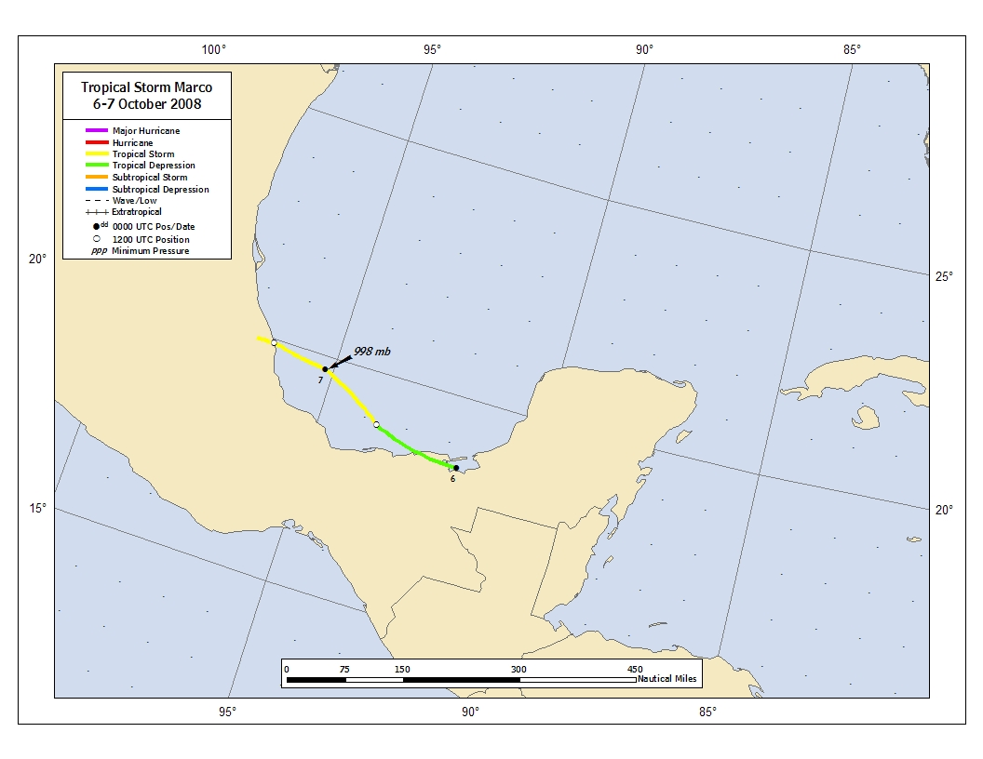
Figure 1. Best track positions for Tropical Storm Marco, 6-7 October 2008.
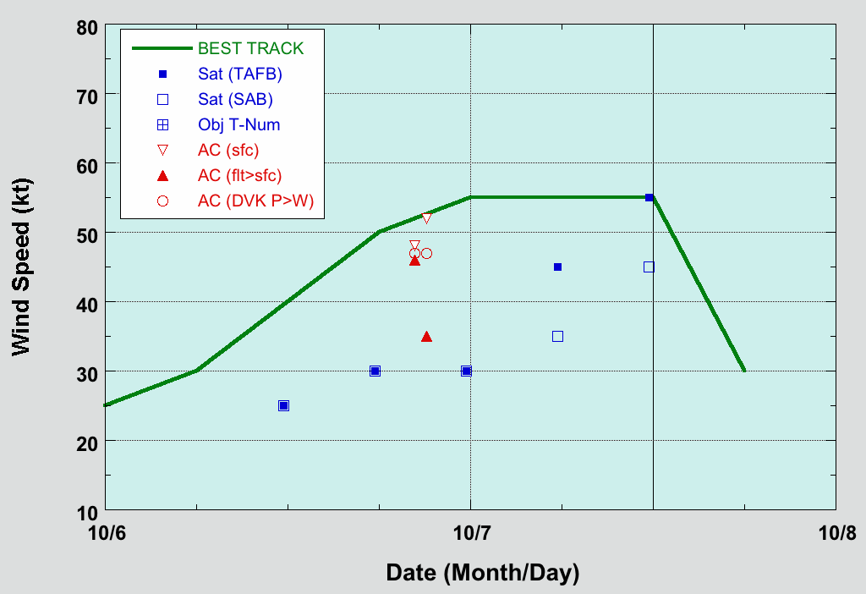
Figure 2. Selected wind observations and best track maximum sustained surface wind speed curve for Tropical Storm Marco, 6-7 October 2008. Aircraft observations have been adjusted for elevation using a 75% adjustment factors for observations from 925 mb. Dashed vertical line corresponds to 0000 UTC. Landfall is indicated by the thin solid vertical line.
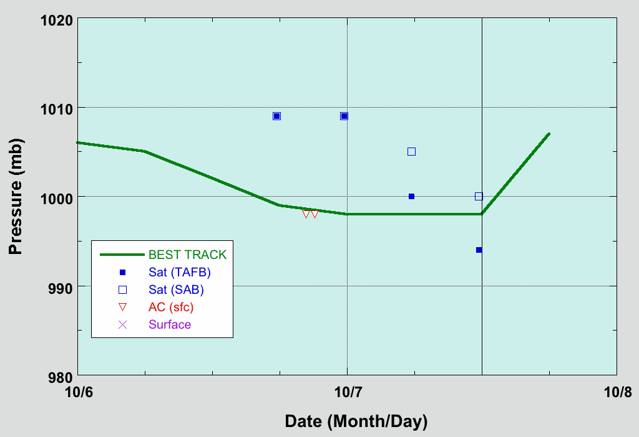
Figure 3. Selected pressure observations and best track minimum central pressure curve for Tropical Storm Marco, 6-7 October 2008. Dashed vertical line corresponds to 0000 UTC. Landfall is indicated by the thin solid vertical line.
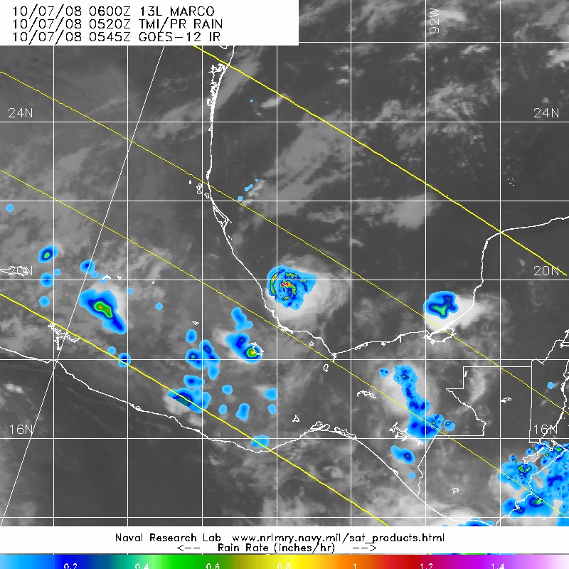
Figure 4. TRMM Microwave Imager depiction of rainfall rate associated with Marco at 0520 UTC 7 October 2008. Image obtained from Naval Research Laboratory Marine Meteorology Division Tropical Cyclone Page (http://www.nrlmry.navy.mil/tc_pages/tc_home.html).

A digital record of the complete best track, including wind radii, can be found on line at ftp://ftp.nhc.noaa.gov/atcf. Data for the current year’s storms are located in the btk directory, while previous years’ data are located in the archive directory.

