Tropical Cyclone Report
Tropical Depression Sixteen
(AL162008)
14-15 October 2008

Daniel P. Brown
National Hurricane Center
19 November 2008

Tropical Depression Sixteen was a large and sprawling depression that formed over the northwestern Caribbean Sea and made landfall about 24 h later in northeastern Honduras.

- Synoptic History

A tropical wave that departed the west coast of Africa on 27 September appears to have played a role in the development of Tropical Depression Sixteen. The wave produced intermittent and disorganized shower and thunderstorm activity while traversing the Atlantic and eastern Caribbean waters. As the wave moved into the southwest Caribbean Sea on 10 October a broad area of low pressure formed. During the next couple of days, the low moved slowly westward over the extreme southwestern Caribbean Sea. On 13 October the low turned northward, passing about 90 n mi east of the coast of Nicaragua. On that day, the first Dvorak classifications were performed on the system. Thunderstorm activity continued to become organized around the low overnight and early the next morning, and it is estimated that a tropical depression formed by 1200 UTC 14 October, about 45 n mi northeast of the coast at the Nicaragua/Honduras border. The “best track” chart of the tropical cyclone’s path is given in Fig. 1, and the best track positions and intensities are listed in Table 1.

Convection near the center of the depression decreased a little later that afternoon. Around 2100 UTC, reconnaissance mission found a low-level vortex about 45 n mi to the west-northwest of the center of the large-scale cyclonic circulation evident in visible satellite imagery. It is likely that the center found by the aircraft was a smaller vortex that was rotating within the broader circulation. The depression did not strengthen and turned westward, then west-southwestward early on 15 October. The center of the poorly-organized depression is estimated to have made landfall shortly after 1200 UTC 15 October along the northeast coast of Honduras, just west of Punta Patuca. The depression continued to move slowly west-southwestward, degenerating to a remnant low by 0000 UTC 16 October. A few hours later the low-level center dissipated over the mountains of east-central Honduras.

- Meteorological Statistics

Observations in Tropical Depression Sixteen include satellite-based Dvorak technique intensity estimates from the Tropical Analysis and Forecast Branch (TAFB) and the Satellite Analysis Branch (SAB), as well as flight-level and stepped frequency microwave radiometer (SFMR) observations from one flight of the 53rd Weather Reconnaissance Squadron of the U. S. Air Force Reserve Command. Data and imagery from NOAA polar-orbiting satellites, the NASA Tropical Rainfall Measuring Mission (TRMM), the NASA QuikSCAT, and Defense Meteorological Satellite Program (DMSP) satellites, among others, were also useful in tracking the short-lived depression.

The 25-kt estimated intensity of the depression throughout its existence is based on Dvorak estimates from SAB and TAFB. The reconnaissance mission on 15 October found peak 1500 ft flight-level winds of 25-30 kt in some of the stronger bands of convection, which also support the estimated intensity.

The depression and its remnants produced locally heavy rainfall over portions of Nicaragua, Honduras, eastern Guatemala, and Belize. The largest rainfall amounts in Honduras appear to have fallen over the northern and northwestern portions of the country. Between 14-19 October, numerous locations in Honduras received more than 7 in of rain (Table 2), with a maximum amount of 14.19 in reported on Roatan Island. In Belize, several locations received 10-20 in of rain between 13-20 October. The maximum rainfall amount observed in Belize during the period was 21.52 in at Baldy Beacon.

- Casualty and Damage Statistics

Nine deaths in Central America are directly attributed to the depression. An Agence France-Presse (AFP) media report from 19 October indicates that 16 people lost their lives in Central America due to flooding from heavy rains produced in part by Tropical Depression Sixteen. The media report lists seven deaths in Costa Rica, four in Nicaragua, three in Honduras, and one each in El Salvador and Guatemala. However, the deaths in Costa Rica were likely the result of flooding rainfall that can be attributed to the disturbance from which the depression formed. Therefore, they are not included in the final casualty count attributed to the cyclone. In addition, six people remained missing at the time of the report. A report from the Caribbean Disaster Emergency Response Agency (CDERA) indicates that the heavy rains also produced flooding in southern Belize; however, no deaths or injuries were noted in that country.

- Forecast and Warning Critique

The area of disturbed weather from which the depression developed was first discussed in National Hurricane Center products in a Special Tropical Disturbance Statement issued at 1530 UTC 13 October, a little less than 24 h prior to development. Experimental probabilistic genesis forecasts indicated a high chance (>50%) of formation beginning at 1800 UTC 13 October.

Average official track errors for Tropical Depression Sixteen (with number of cases in parenthesis) were 17 (4) and 30 (2) n mi for the 12 and 24 h forecasts, respectively. Average official intensity errors were 5 and 15 kt for the 12 and 24 h forecasts, respectively. Due to the small number of forecasts, a meaningful comparison of the official forecasts with the various track and intensity models is not possible.

Watches and warnings associated with Tropical Depression Sixteen are given in Table 3.
Table 1. Best track for Tropical Depression Sixteen, 14-15 October 2008.

Date/Time  (UTC) | Latitude  (°N) | Longitude  (°W) | Pressure  (mb) | Wind Speed  (kt) | Stage
14 / 1200 | 15.5 | 82.8 | 1004 | 25 | tropical depression
14 / 1800 | 15.9 | 83.2 | 1005 | 25 | "
15 / 0000 | 16.0 | 83.6 | 1005 | 25 | "
15 / 0600 | 16.0 | 84.0 | 1005 | 25 | "
15 / 1200 | 15.9 | 84.4 | 1005 | 25 | "
15 / 1800 | 15.6 | 85.0 | 1006 | 25 | "
16 / 0000 | 15.3 | 85.6 | 1006 | 25 | low
16 / 0600 |  |  |  |  | dissipated
14 / 1200 | 15.5 | 82.8 | 1004 | 25 | minimum pressure
15/ 1230 | 15.85 | 84.5 | 1005 | 25 | landfall just west of Punta Patuca, Honduras

Table 2. Selected rainfall totals from Honduras and Belize. These totals also include rainfall received from the incipient area of disturbed weather and from the remnants of the Depression.

Location | Total  rain  (in) | Location | Total  rain  (in)
Honduras ª |  | Belize ^{b}
Roatan  16.32° 86.53° | 14.19 | Philip Goldson | 11.59
El Empalme  15.64° 87.33° | 10.47 | La Democracia | 9.68
La Ceiba  15.74° 86.86° | 10.11 | Belmopan | 9.82
Las Mangas  15.71° 86.72° | 9.62 | Central Farm | 9.04
Lago Yojoa  14.93° 88.03° | 9.19 | Baldy Beacon | 21.52
Las Lajas  14.89° 87.57° | 9.00 | Caracol | 7.81
Trujillo  15.92° 85.95° | 8.76 | Chaa Creek | 11.73
Choluteca  13.24° 87.16° | 8.08 | Spanish Outlook | 8.29
Flores  14.29° 87.57° | 7.75 | Hershey Hummingbird | 16.08^{c}
El Jaral  14.94° 88.00° | 7.40 | Pomona | 11.30
Marchala  14.13° 87.39° | 7.21 | Melinda | 10.48
 |  | Maya King | 14.30
 |  | Savannah | 18.22
 |  | Big Falls Plantations | 7.67
 |  | Punta Gorda Agstat | 10.96
 |  | Libertad | 6.42
 |  | Rio Bravo | 8.24
 |  | Towerhill | 6.89

ª Total rainfall between 14-19 October 2008.
^{b} Total rainfall between 13-20 October 2008.
^{c} Incomplete.
Table 3. Watch and warning summary for Tropical Depression Sixteen, 14-15 October 2008.

Date/Time (UTC) | Action | Location
14/1500 | Tropical Storm Warning issued | Honduras/Nicaragua border westward to Limon, Honduras
14/2100 | Tropical Storm Watch issued | Limon, Honduras westward to the Honduras/Guatemala border
15/0000 | Tropical Storm Watch issued | Belize City, Belize southward to the Belize/Guatemala border
15/0900 | Tropical Storm Watch upgraded to Tropical Storm Warning | Limon, Honduras westward to the Honduras/Guatemala border
15/0900 | Tropical Storm Watch issued | east coast of Guatemala
15/1500 | Tropical Storm Watch upgraded to a Tropical Storm Warning | entire coast of Belize
15/2100 | Tropical Strom Warning discontinued | all of Honduras and Belize north of Belize City
16/0000 | Tropical Storm Warning discontinued | All
16/0000 | Tropical Storm Watch discontinued | All

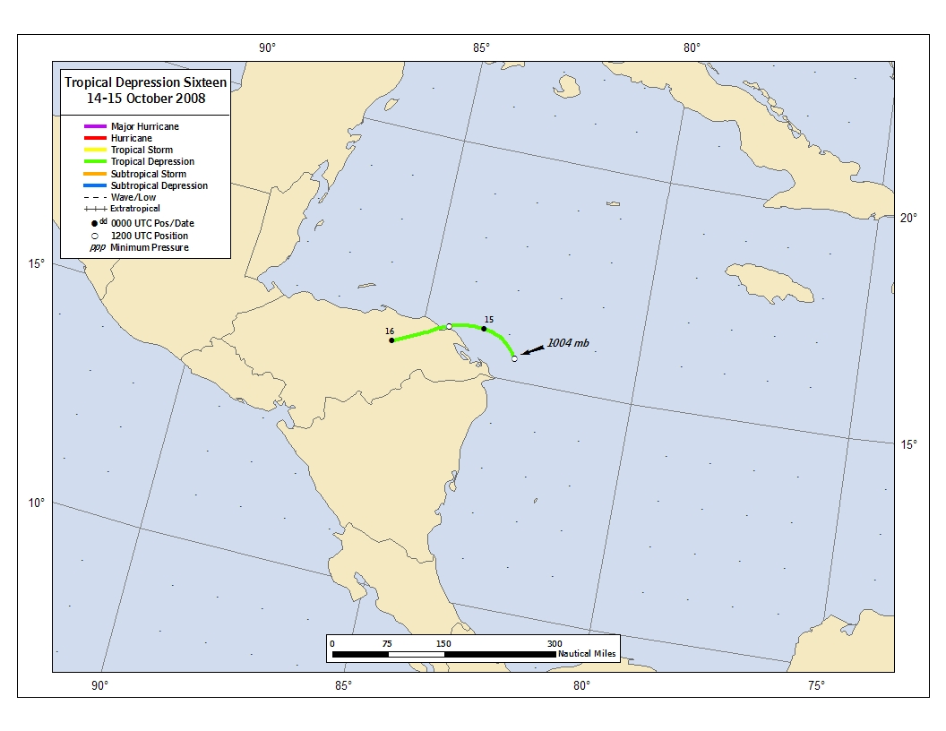
Figure 1. Best track positions for Tropical Depression Sixteen, 14-15 October 2008.

A digital record of the complete best track, including wind radii, can be found on line at ftp://ftp.nhc.noaa.gov/atcf. Data for the current year’s storms are located in the btk directory, while previous years’ data are located in the archive directory.

